

IT-214 Database management System

Team ID :G5 - S6 - 6.10

Project title : Olympic web application

**Mentor name: Prof. Rachit Chhaya**

|  |  |  |
| --- | --- | --- |
| **sr.No** | **student ID** | **Names** |
| 1 | 202001278 | shraddha doshi |
| 2 | 202001255 | aniruddh damor |

final version : 22 nov ,2022

Index

**1.** section 1 : Final Version of SRS

**2.** section 2 : Noun Analysis

**3**. section 3 : ER diagram

**4** .section 4 : ER diagram to relational model

**5.** section 5 : Normalization and Schema Refinement

**5.** section 6 : DDL script, 20 Queries,insert statement

**7.** section 7 : Front end related and back end related document

# Introduction

1. Understand and Complete the Description of the Case Study/Problem Domain given to you.

## 1. Purpose

This document provides details about Olympic Games and related data from 1900 year to the present. It provides the details of every game that was played in the Olympics and players who won the medals and prizes in the particular sports.

Sports is necessary for the development of humankind and with a view of promoting society concerned with the preservation of human dignity. To indulge the people more towards sports for having good health and also for showing integrity amongst the nations of the world with different languages and religions.

Database gives you accurate information about all the sports being played in the past, which country is dominating in the particular sport, the strength and weakness of the individual players etc.

Other than this it also provides vital information like marketing and branding of products, event sponsoring, advertising the products for the companies by the best and popular players etc.

**2.** **Intended Audience and Reading Suggestions**

From this database the main advantage will be taken by the organising committee, it will provide all kinds of information along with the climatic conditions of the place, where the event will be held, from past records.

It plays a great role to have new athletes who are now a student pursuing a sport as an occupation.

It provides knowledge to the people who are giving any quiz about sports or government exams like UPSC or TV shows like KBC.

It can also give ideas to the people who are sports fans, who regularly watch their favourite sports, players.

It can give knowledge to the people who are just hungry for external knowledge.

It can also help host country to know about how were past Olympics ,what should be done unique this time how big should venue ,how far should venue and what type of arrangements can be needed or what can be done for better opening event.

It can give information to social media influencers, writers, photographers, reporters who are reporting that event, film producers and other promoters.

**3.** **Product Scope**

**1.** It can be sold to people who are reporting an event about the Olympics so that they can come up with great new questions to ask and know about current players who are good and whom to interview.

**2.** It can be sold to people who are making documentaries to inspire new athletes.

**3.** It can be useful for the media colleges or schools who have mostly trained students and helped them to make projects or analysis about sports, players etc.

**4.** It can be sold to the people who decide how much money the country should spend after things like kit, costumes, coach etc.

**5.** It can be useful for the organising committee for inaugural activities with the best events and the chief guest to be invited for the event. Other than this it will provide data of expenditure of the past years through which the approximate amount needed for the current event can be estimated.

**6.** It can be sold to people who broadcast the information, highlights of past events on TV or at live streaming platforms.

**4.** **Description**

This database has tables, relation, entities, roles and provides insight into the Olympics in great detail. We will start by providing an overview of the Olympics since 1900 and slowly getting into information according to the requirements.

* **Host country**

It provides information of the various countries that have hosted the Olympic Games since 1900, in summer, winter, youth Olympic having country id, country name, year and type of Olympic.

* **Participating countries**

The countries that have participated in a particular year. We will have country id, name, particular year, game id. We can have many table distinguishing years or only one table.

* **Country with highest medal and type of metal like gold and silver**

Here we will have country id, player id, game id , bronze, gold, silver and total medal.

* **Different players that have been added or removed over the years**

For this we will have columns stating added or removed, player id and with different years to know whether he/shet is removed or added.

* **Game/sports**

We will have a game id,game name and year ,year added ,year removed

for getting details about when the sport removed or added

* **Number of attendees in a particular year**

We will have year, player id, gender, height, weight, age /date of birth.,playername,rank,since

* **Details about starting ,opening ceremony, closing ceremony**

When it started,when it ended, the host country id, year for the opening ceremony. and closing ceremony with date and time

* **Chief Guest of the event in a particular year in an Olympics**
* Country id ,chief guest name, particular year,gender
* **Winners of a particular sport and their past 3 winners**

Having last 3 winners and current winner of the game, player id, game id, year.

* **cost distribution details**

Analyzing cost towards the medal, making cost,security ,services so we will get to know how to manage it and honoring athletes.

* **Budget of country spent**

How much cost, how is revenue divided and other related information. Other than this, social media influencers, marketing team information such as which company sponsored the event and for how much money etc.in particular olympic year by host country will be provided.

* **revenue of country**

How much revenue gained and other related information. Other than this, social media influencers, brand promotion details ,broadcast rights details ,through selling tickets or products

* **medal information**

who was designer of medal how much diameter ,thickness or weight thai information can be known

**function** :

we are planning to make one function to concat state and city in host country which will give us both information in one column,second for profit revenue -cost and third for checking player availability status

**workflow :** first homepage with two option will be shown game or country database and then by clicking you can see relation tuples and then you can insert update or delete and you can see some useful information by running query

**2. Document the Requirements Collection/ Fact Finding Phase**

**ii. Background Reading/s**

**The First database :** Olympic Game record

**Introduction:**

This dataset provides Olympic records by women and men, game name, country name, participant name, date of birth of player, venue, time and wind velocity which may affect the Olympic game.

This database looks over the highest performance record in particular game and particular rank in global of all Olympic Games.

**Content**:

Date of birth, venue details, game name, wind velocity, rank of the player, participant name, country name, time and ground constraints.

**Advantage**:

It provides detailed analysis report like how much performance has improved over the years by the country and even details about wind and ground constraints. This can be helpful to writers for making a movie. Reporters can easily look at data and can change the location of the event if bad weather takes place.

**Disadvantage:**

It will not be helpful to know how many medal won by which player, how many sports

have been added or removed, how many countries removed from the particular game and what was reason for it, budget info, revenue info etc.

**The second database** : Sports in the Olympics

**Introduction:**

This database takes a look at all the Olympic events that have taken place. It is partitioned in sports, nation and result and in result select olympic, event, sport. Each of these contains the following information :

**Content:**

Every sport played in the Olympics provides information about medals won by a team and the name of the particular place where the medal is won. Country wise information, which country has played and performed well in the particular sport and analyse its result and make a record of it.

**Advantage :**

It provides detail about every sport that has been played, qualifying round, final round, country’s improvement, country’s strength in particular sport.

Also it shows the overall performance of the countries in the Olympics as per the total number of medals.It also contains the number of male and female participants that takes part according to the gender of the athlete in each year.

**Disadvantage :**

Details of the attendees that played a particular game are not given making it difficult to know how much attendees have improved.

It is difficult to select venues and infrastructure too for the host country, difficult to predict about cost, budget, so this type of information can tempt users not to see and even the host country would find it difficult because of insufficient information.

This database is not useful for event organizers and for others like sponsorship related, reporter related, news media related.

**Third database:** Olympic medal winners (since 1896)

**Introduction:**

This database tells us about Olympic events that have occurred from 1896 to 2012. It takes a look at all the athletes that have won at least one medal,

either silver, bronze or gold. It then arranges the athletes by total number of medals with the player name and medal he won.

**Content :**

* Name of the athletes that have won at least one medal
* Total number of medals
* Type of metal of medal like gold medal, bronze medal, silver medal

**Advantage:**

It shows the performance of the country has been improved or not, how many medals won and in which sport.

It also gives information for a particular country in which they are lagging behind so they can improve it.

**Disadvantage :**

It does not tell you for which game you won a medal, opening and closing ceremony winners of last 3 games and chief guest details.

It also doesn't provide the budget information, how many sports have been removed, ratio of participants that have increased over the years etc.

**The forth database** : 120 years of Olympic history: athletes and results

**Introduction :**

This dataset provides an opportunity to ask questions about how the Olympics have evolved over time, including questions about the participation and performance of women, different nations, different sports and events.

This database looks at all the athletes from the Olympics since 1896 in Athens to 2016 in Rio. One thing is that the summer and winter Olympics were the same until 1992. It was then they staggered starting with the Winter Olympics in 1994 and Summer Olympics in 1996.

This database has 271116 rows and 15 columns. Through this database we will know what is the flaw and feature of their database, how much users liked it and review and what can be changed or improved to make it better.

**Content :**

This database takes into account the following attributes:

* ID : Unique number for each athlete
* Name : Athlete’s name
* Sex : M or F
* Age : Integer
* Height : In centimeters
* Weight : In kilograms
* Team : Team name
* NOC : National Olympic Committee 3-letter code
* Games : Year and season
* Year : Integer
* Season : Summer or Winter
* City : Host city
* Sport : Sport name
* Event : Event
* Medal : Gold, Silver, Bronze, or NA

**Advantage :**

This database helps us know how much women have evolved in sport in olympics and honoring participants.

It inspires new athletes to make sport an occupation and represent their country at international level.

Random changes in every olympic like number of athletes, participating countries, sport being added or removed.

#### Disadvantage :

#### This data does not analyze how a country has performed in a year, how many athletes were inspired and new athletes that have been added, what type of sport event has been done to inspire the athletes.

It does not show the overall performance of the countries and players, in which particular game they are lagging behind etc.

It does not provide information about the budget in a particular year, how the host country manages cost burden, how they manage to get it back etc.

It may help us to predict how many more medals can be won by each country next year.

It does not help to look over infrastructure that has to be improved to win bids.

None of these provide budget information, medal prediction, chief guest, opening/closing ceremony details.

**References:**

1. <https://www.worldathletics.org/records/by-category/olympic-games-records>

2. https://[www.olympiandatabase.com/index.php?id=6899&L=1](http://www.olympiandatabase.com/index.php?id=6899&amp;L=1)

3.https://[www.theguardian.com/sport/datablog/2012/jun/25/olympic-medal-winner-list-data](http://www.theguardian.com/sport/datablog/2012/jun/25/olympic-medal-winner-list-data)

4.https://[www.kaggle.com/datasets/heesoo37/120-years-of-olympic-history-athletes-and-](http://www.kaggle.com/datasets/heesoo37/120-years-of-olympic-history-athletes-and-) results?resource=download

**Summary of readings**

We can summarize from the above data that the following things are required apart from the data provided : Country of the athletes, expenditure in particular Olympics, list of sports that have been added or removed from the Olympics, budget information, medal prediction, reason for removing the country and even why person did not get medal even if he won the game .

**requirement**

1. Most importantly, this data needs to be available and accessible to all, so we can have more users and this can also be helpful to others. The Internet can be the perfect medium for this as most people prefer the use of the internet for accessing the data.
2. We want to have some medal information like who is the designer and then how much diameter ,thickness and weight .
3. details about chief guest and opening ceremony brand promotion broadcast details
4. we want to have info of cost and revenue and profit of host country how he gained revenue from which source
5. having info of player ,game,countries ,past 3 winner ,medal basic info

* .

**iii. Interview/s**

**First interview**

**Interview plan**

**System**: Olympic database

**Participants**: Doshi Shraddha (Olympic database)

Aniruddh Damor (Olympic database)

Vyom Patel (Sport committee member)

**Date:** 24/09/2022 **Time:** 21:00

**Duration:** 30 Minutes **Place:** Google meet

**Purpose of Interview:**

Preliminary meeting for collecting and identifying the requirements of Olympic database and understanding the issues while organising any sport event and to know how the sports committee manages budget and other kinds of sport activities.

**Agenda:**

To know how revenue generated from the event is used, estimation of the budget for the sport events, hospitality, sales and marketing aspects of Olympics and other related sport events.

Discuss problems related to use of drugs illegally by the players, boycotting the country and its impact on the event, political aspects of the Olympics and other related things.

Discuss about existing apps for the Olympic database and suggestions for adding more features to it.

**Documents to be brought to the interview:**

Any documents related to existing system analysis.

The committee’s management idea for the budget and other kinds of sport activity.

**Interview summary**

**System**: Olympic database

**Participants**:

**Interviewer** : Doshi Shraddha (Olympic database)

**Interviewer** : Aniruddh Damor (Olympic database)

**Interviewee** : Vyom Patel (Sport committee member)

**Date:** 24/09/2022 **Time:** 21:00

**Duration:** 30 Minutes  **Place:** Google meet

**Why are there fewer participants in the Olympics from our country?**

Most parents in India do not allow their children to make sport an occupation because they think they will not have career opportunities and it is a waste of time. They engage their child more towards studies rather than sports.

**What do you think about People’s opinions for sports and related events?**

Most people do not like watching sport events and they think that it is just passing the time. This is not going to help in their career.

**What is the effect of the Budget session on the people?**

Watching the Olympic budget management ,some case studies like political issues happened in Olympic or production related news, people may excite or rather tempt them.

**Why are there fewer countries and candidates involved in the Olympics?** Most people cannot go ahead in sport because resources are not available and people are not aware of their capability to reach the Olympics and how to reach there.

**How to engage more people in sports activities?**

We should make more participants go from our country by encouraging them through various events, campaigns and sports festivals.

**Does illegal use of drugs affect the countries and people’s opinion towards sports?**

Use of Drugs or boycotting countries is a major issue that decreases the People’s interest towards the sports and values for their favourite players.

**How the revenue generated should be used by the host country?**

Most revenue should go to the sports department of the host country to make more people participate in the sports and because of this they will have sportsmanship spirit. Also their moral values towards their country will increase.

**Do politicians take advantage of popular sports players?**

Some use sport as a political advantage to create a fight between countries or gain more votes from people.

**What do you think about why all people must be involved in sports activities?**

Sport can be used as Therapy for getting involved more with the people, managing the activities like volunteering and taking more responsibilities.

**Second interview**

**Interview plan**

**System:** Olympic database

**Participants:** Doshi Shraddha (Olympic database)

Aniruddh Damor (Olympic database)

Mohan Prakash (Film Director / Screenplay Writer)

**Date:** 25/09/2022 **Time:** 21:00

**Duration:** 30 Minutes **Place:** Google meet

**Purpose of Interview:**

Understanding monopoly related to sport, is the internet a great source for sports and whether users like documentaries or not.

**Agenda:**

Discuss films and books, whether user prefer movies or books related to sport

**Documents to be brought to the interview:**

* Book or any documentary related to sports
* Reporter’s article related to it

**Interview summary**

**System**: Olympic database

**Participants**:

**Interviewer** : Doshi Shraddha (Olympic database)

**Interviewer** : Aniruddh Damor (Olympic database)

**Interviewee** : Mohan Prakash (Film Director / Screenplay Writer)

**Date**: 25/09/2022  **Time**: 21:00

**Duration**: 30 Minutes **Place**: Google meet

**Purpose of Interview**:

Understanding monopoly related to sport, is the internet a great source for sports and whether users like documentaries or not.

**What do you think is most important for a movie based on the life of a sportsman or related to the sports?**

Sport movies have covered the professional life of players, along with their professional life it helps for character building and encourages people to watch it.

**How many times have you used a database for information related to sport?**

Not frequently but when I want to look at statistics like this many people have participated, I use this kind of information in movies.

**What is the useful information that you find through the database?**

As mentioned above, statistics or news related to the Olympics like India does get bid or not, what was the reason for it and production related news etc.

**What is your favourite sport and do you think our country is making progress on it?**

My favourite sport is football and I think our country is making good progress on it. I would love to make a movie on it.

**Do you think female attendees are increasing in the Olympics? If you make a film on it will it be profitable ?**

Yes absolutely,

Ex Dangal movie everyone knew the story but still liked it.

**Third interview**

**Interview plan**

**System**: Olympic database

**Participants:**  Doshi Shraddha (Olympic database)

Aniruddh Damor (Olympic database)

Dhruv Patel (Sport event organiser /sport manager)

**Date**: 26/09/2022 **Time**: 21:00

**Duration**: 30 Minutes **Place**: Google meet

**Purpose of Interview:**

How the budget for the Olympics is managed by the Event Organisers.

**Agenda:**

To know what kind of issues are faced by the event organiser team and what kind of information would be useful for organising such events.

**Documents to be brought to the interview:**

* Any documents related to existing system analysis
* Budget information related article
* Fact file article

**Interview summary**

**System**: Olympic database

**Participants**:

**Interviewer** : Doshi Shraddha (Olympic database)

**Interviewer** : Aniruddh Damor (Olympic database)

**Interviewee** : Dhruv patel (Sport event organiser/sport manager )

**Date**: 26/09/2022 **Time**: 21:00

**Duration**: 30 Minutes **Place**: Google meet

**Purpose of Interview**:

How the budget for the Olympics is managed by the Event Organisers.

**What is the data that the event organiser requires?**

Number of participants and country for accommodation and even for selling licensed products and budget management like how budget should be partitioned to make a good revenue

**Do you think the number of participants and the number of medal predictions along with the number of participating countries will help?**

Totally as mentioned above database having these information will be boon for host country.

**Do you think budget management data will be required for event organisers?**

Definitely after getting data, how much budget has been allocated to infrastructure improvement, training, governing sport events will be required.

**What issues do you face during hosting an event?**

Issues like selecting the venue, sports venues should relatively close together and should be easy to navigate for players, media, audience and tourists.

**As per information provided, accommodation setting, infrastructure setting do you think databases with these information will help?**

While selecting the infrastructure constraint, accommodation setting how much room should be allocated for country will be helpful**.**

**How does the sports ecosystem work?**

Most revenue should go to the sports department of the host country to make more people participate in the sports and because of this they will have sportsmanship spirit. Also their moral values towards their country will increase.

**Forth interview**

**Interview plan**

**System:** Olympic database

**Participants:** Doshi Shraddha (Olympic database)

Aniruddh Damor (Olympic database)

Daksh Shah (National Player in Karate)

**Date:** 27/09/2022 **Time:** 21:00

**Duration:** 30 Minutes **Place:** Google meet

**Purpose of Interview:**

Understanding how much information will be useful for aspiring an athlete.

**Agenda:**

Discuss problems related to the sport ecosystem, governance, funding, training, equipment and small talk about problems and solutions for aspiring athletes.

**Documents to be brought to the interview:**

Article related to aspiring athletes

Any documents related to existing system analysis

**Interview summary**

**System**: Olympic database

**Participants**:

**Interviewer** : Doshi Shraddha (Olympic database)

**Interviewer** : Aniruddh Damor (Olympic database)

**Interviewee** : Daksh Shah (National Player in Karate)

**Date**: 27/09/2022 **Time**: 21:00

**Duration**: 30 Minutes **Place**: Google meet

**Purpose of Interview**:

Understanding how much information will be useful for aspiring an athlete.

**What do you expect from Olympic data collection as an athlete?**

As an athlete I want performance records and global rank highlights of a particular Olympic match.

**What are the most useful and useless aspects you look out for in Olympics data?**

Mostly how many medals won by a country, by which player, their position, host country information can be useful to us but their personal information like height, body, weight, date of birth can be useless for us.

**Do you think there are enough provisions for sportsmen in our country with regards to performing at the Olympics?**

No, there are not enough, we should change our sport ecosystem and give new opportunities to trainees.

**Do you think watching movies related to the Olympics helps new aspiring athletes to get inspired?**

Yes, it helps a lot and shares information like what kind of problem is face, how to resolve them and how he/she can reach the Olympics.

**Do you think reading about the Olympics will help new aspiring athletes to get inspired?**

Yes, they also can get ideas to manage their work with sport and also how to convince their family for having career in sports.

**Do you think having good training, governing sport events and infrastructure improvement will create opportunities for new aspiring athletes?**

Yes absolutely, it is a necessary aspect to lookout for a good Olympic match that can be remembered by everyone. Having better training provides you the strength to compete at international level.

**What moment led you to become an inspiration for every aspiring**

**athlete?**

Yes, when I thought I can contribute something for my nation and can perform better at a higher level of sport events.

**The number of people is increasing, but they are forgetting the moral motto of the Olympics, do you think our database will resolve this issue?**

After looking into the database, it will be clearly shown that people from different countries with different religions and languages are participating in the Olympics, which will encourage the people to believe in unity amongst the countries.

**Fifth interview**

**Interview plan**

**System**: Olympic database

**Participants**: Doshi Shraddha (Olympic database)

Aniruddh Damor (Olympic database)

Pramod kadam (National wrestling coach)

**Date**: 28/09/2022 **Time**: 21:00

**Duration**: 30 Minutes **Place**: Google meet

**Purpose of Interview:**

Strategies for players for performing better in the game at the international level

**Agenda:**

Discuss problem on what can be useful data for winning match against strong opponent tean how can database can help

**Documents to be brought to the interview:**

Any documents related to existing system analysis

Article related to it and analytical solution of the previous strategies, their working and failure.

**Interview summary :**

**System**: Olympic database

**Participants**: Doshi shraddha (Olympic database)

Aniruddh damor (Olympic database)

Pramod kadam (National wrestling coach)

**Date**: 28/09/2022  **Time**: 21:00

**Duration**: 30 Minutes  **Place**: Google meet

**Purpose of Interview:**

Strategies for players for performing better in the game at the international level

**Is the data from the Olympic database useful for training new athletes?**

It is helpful for new athletes, it is like a strong key to win a battle by smart work in a short amount of time.

**What kind of data do you look for yourself and for your students in the database?**

Data like global rank, performance record and how many medals won by which country, by which player, growth rate of particular game and country etc.

**Does Winning /losing affect the moral motto of the Olympic event?**

it affects athletes dedication toward sport but it also depends on athletes, mostly athletes take it as a new challenge or sportsmanship.

**Do you think there are actually even good players but they are not given opportunities?**

Yes, there are many good players but we don’t know about them and many of them are not ready to invest their time in sport.

**If yes, do you think this database can help them?**

Yes this database can be helpful since the internet is a great source of information and it can be accessible to all without much hardship and effort.

**What do you think about the sports ecosystem? Do you think we should change it to get more recognition for sports?**

We should change it, because of corruption and many political reasons, and somehow we are not given that many opportunities.

**What kind of data of the opposing team can lead to your winning ?**

Their strength, weakness and tactics increase our chance of winning.

### 

### 

### 

### 

### Requirements:

1.Our product will address the problems that can arise in the Olympics and how to resolve them like for event organizers related to money ,revenue

2.To know about the difficulties faced by the organizing committee.

3.Encourage and make more people aware of the sports.

4.How the Host country manages the Budget for all the events of the Olympics.

5.To know how the Olympics affect the economy of country how they divide them for infrastructure sport event or equipment

**iv. Questionnaire/s**

**Name -** (Short Answer type)

**Age -** (Single choice type) 17-30,26-30,31-40,41-60,above 60

**Gender -** (single choice type)Male ,female ,prefer not to say

**Nationality-** (short answer type)

**Name the favourite sport that you are playing**?- (short answer type)

**Have you watched any Olympic games?-**  Yes or No type

**Which one is the better source of information for you to know more about the Olympics**? -(Single choice type)

**If so, which Summer Olympic Games have you watched? Live or Highlights doesn't matter. -** (Multiple choice type)

**If so, which Summer Olympic Games have you watched? Live or Highlights doesn't matter**. - (Multiple choice type)

**Your favourite sports during the Olympics. -** (short answer type)

**Which country is best at playing the sports that is your favourite**? - (short answer type)

**Which factor do you think makes a country a better contender for winning medals**? - (Single choice type)

Military power,Economy,Population,Political power

**Do you think that there are racial benefits during the Olympics games**? - (Yes or No)

**Have you seen any racism during a sports event**? - (Yes or No)

**Do you think the Olympics are capable of uniting a country**? - (Y/N)

**Do you think rich countries have a greater likelihood of winning as compared to poor countries**? - (Yes or No)

**Which country, other than your country, you will be supporting in the 2024 Paris Olympics? -** (short answer type)

**Summary of Questions:**

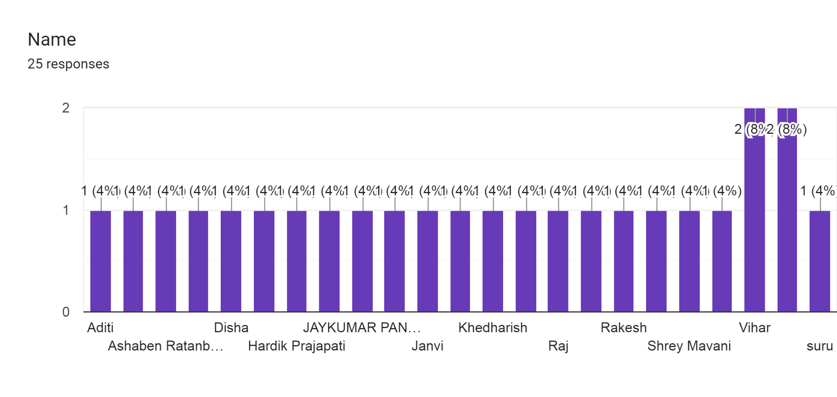

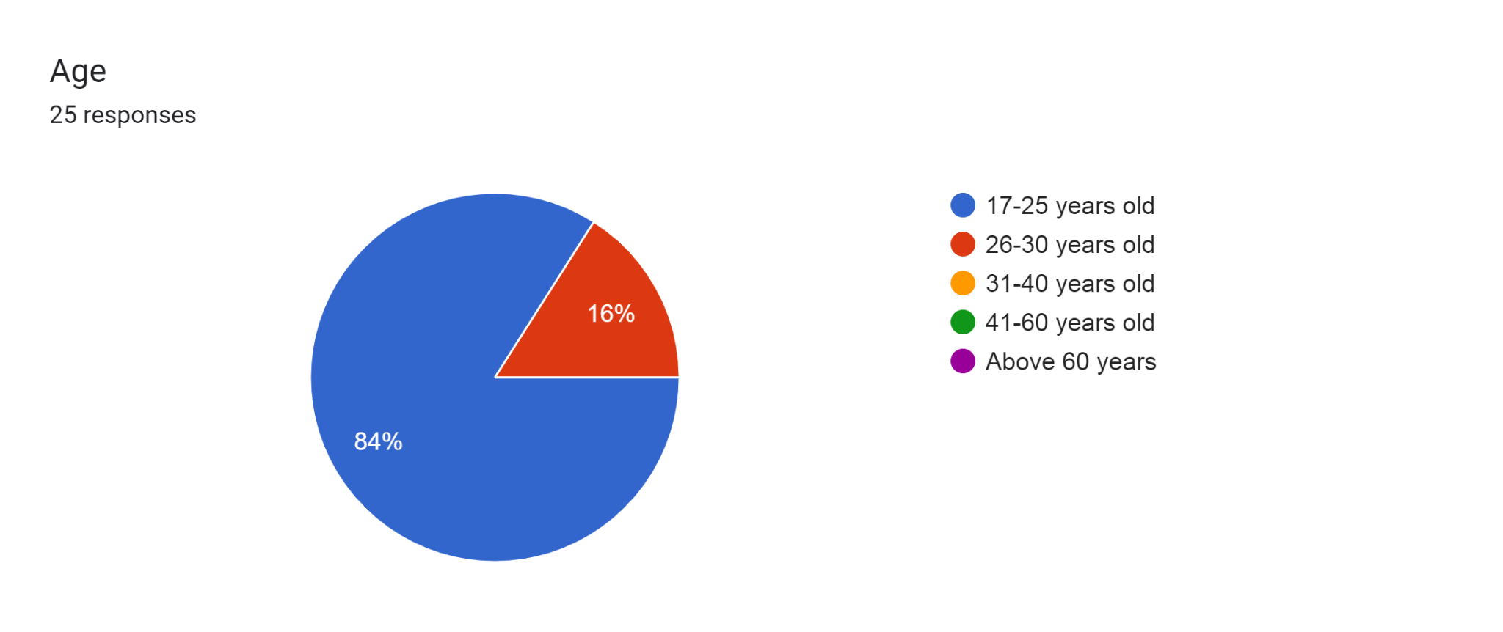



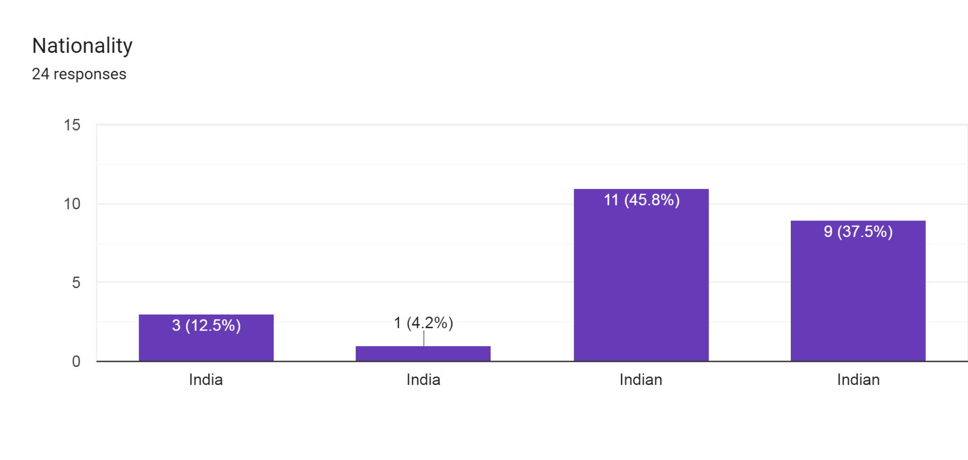

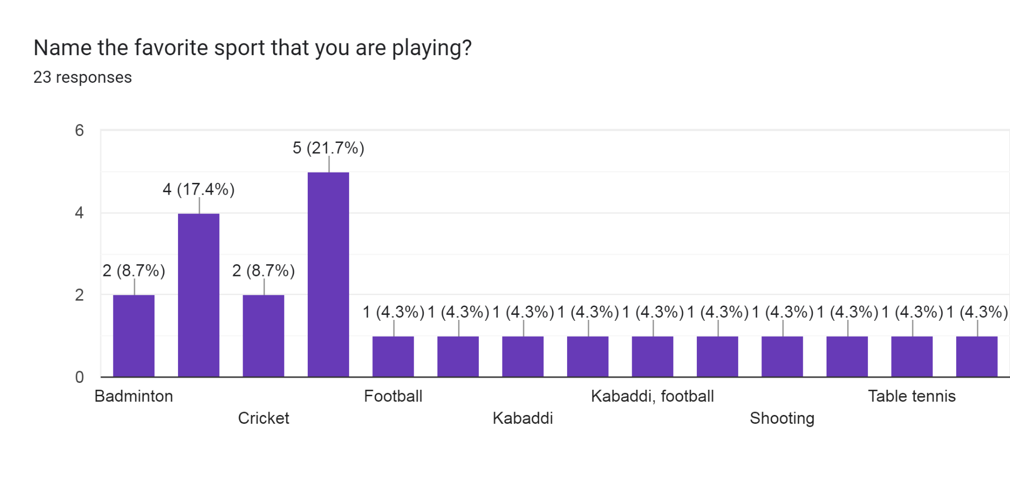

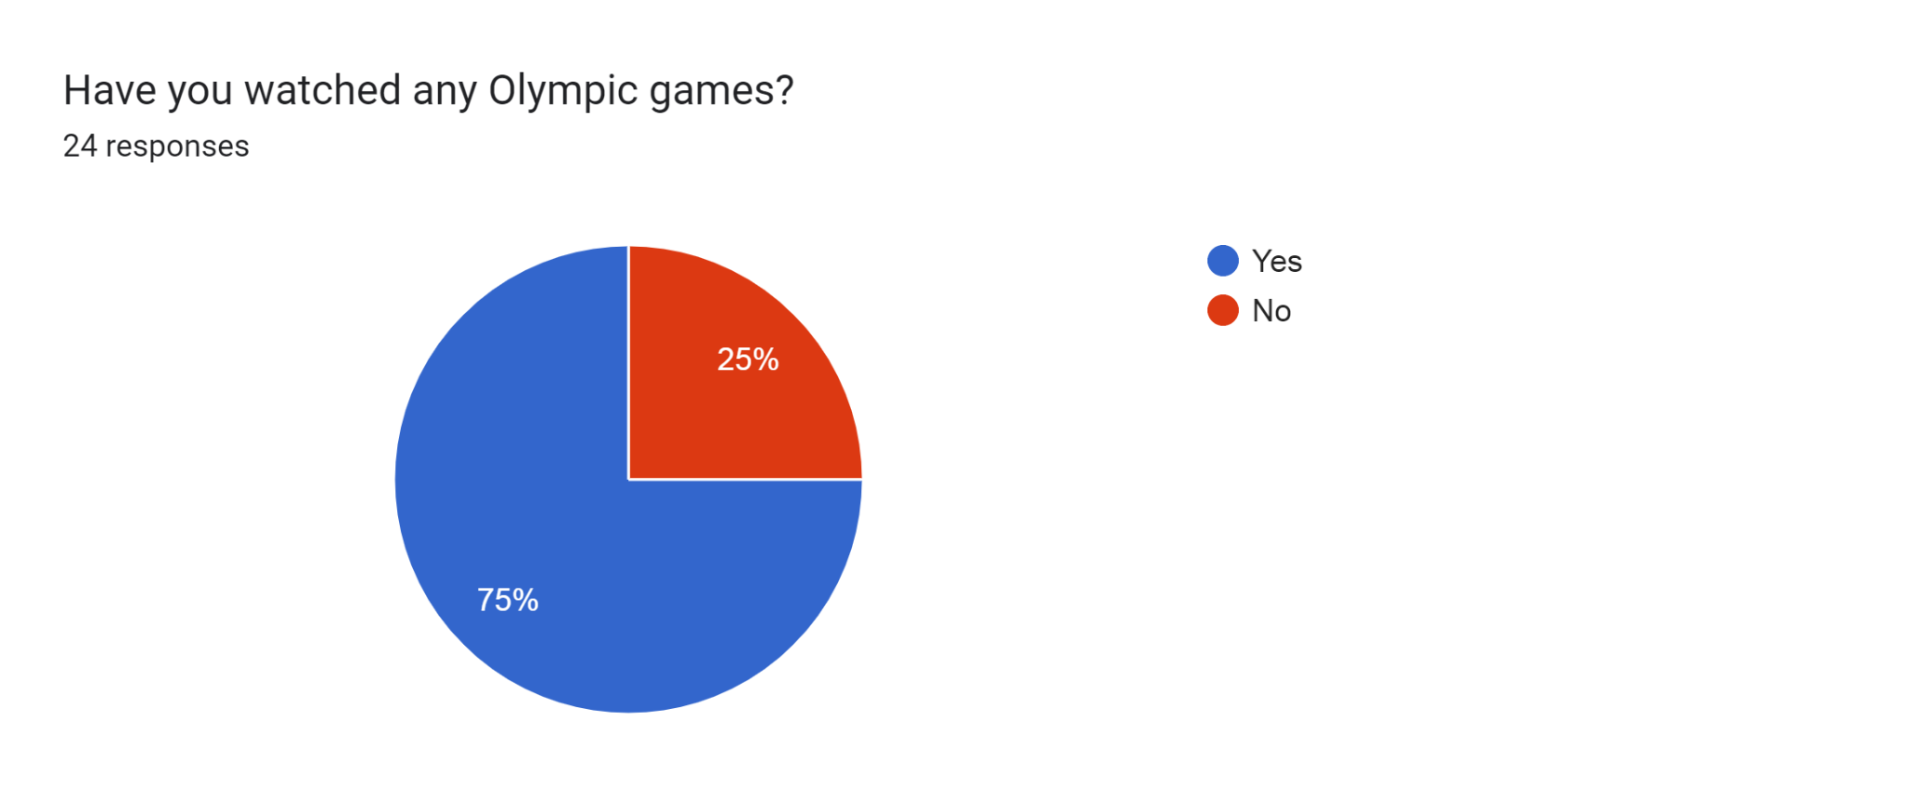

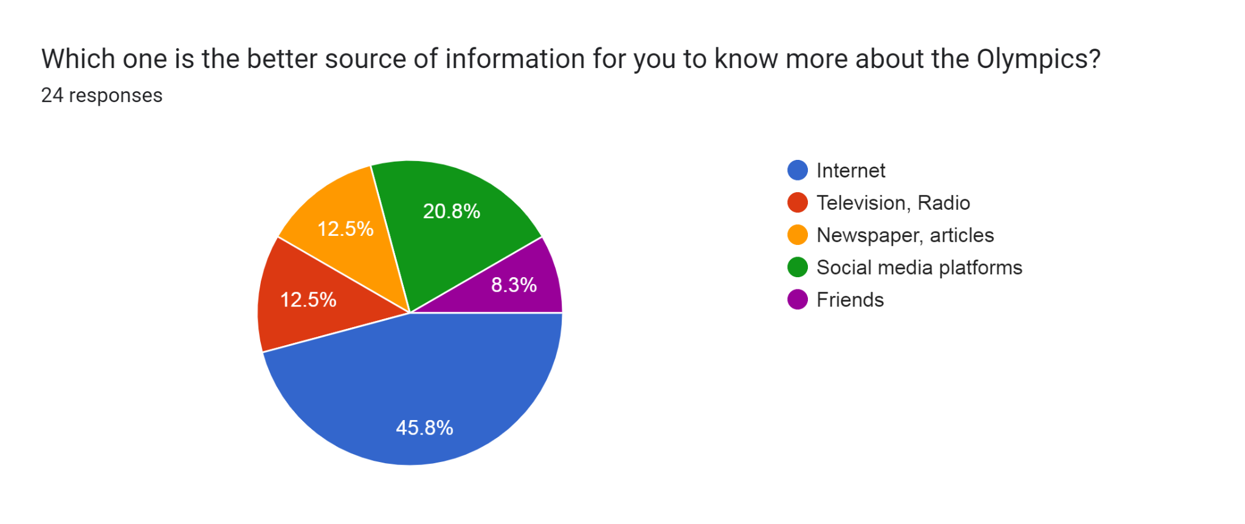

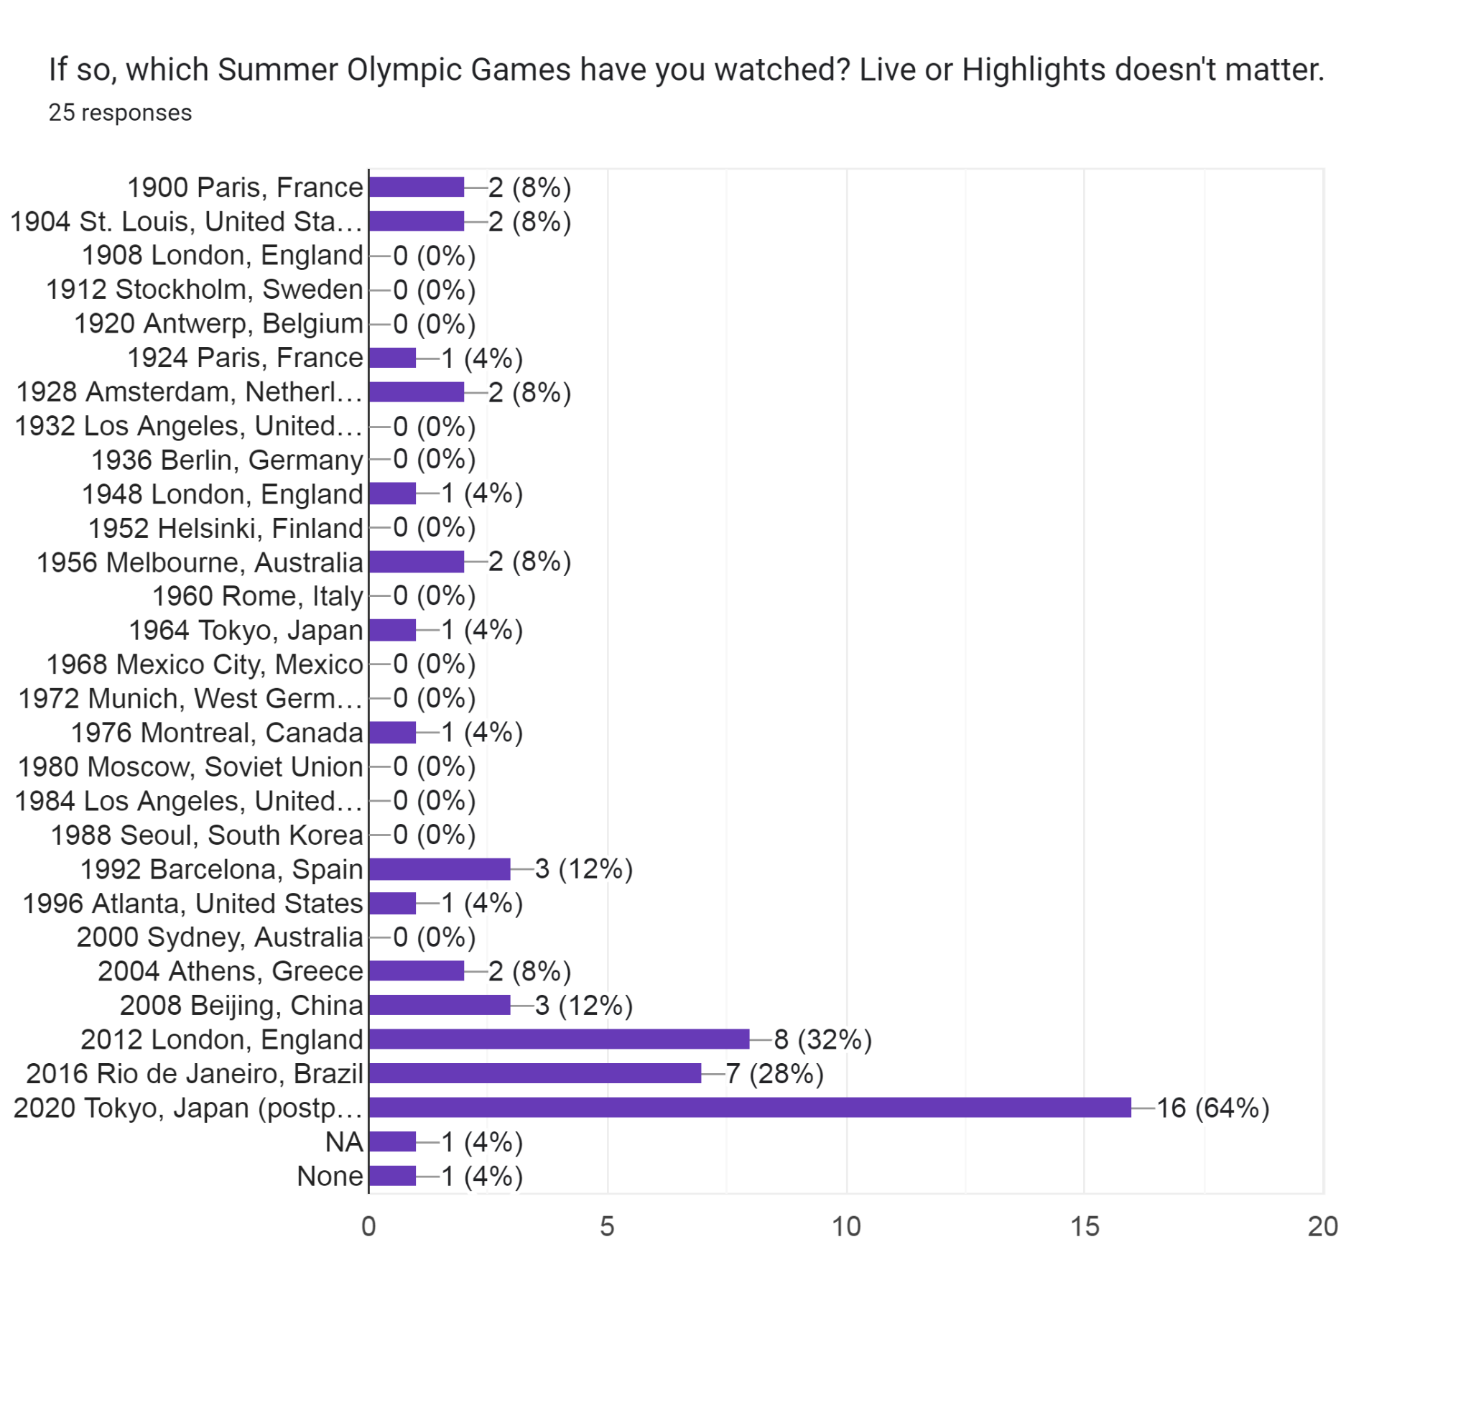

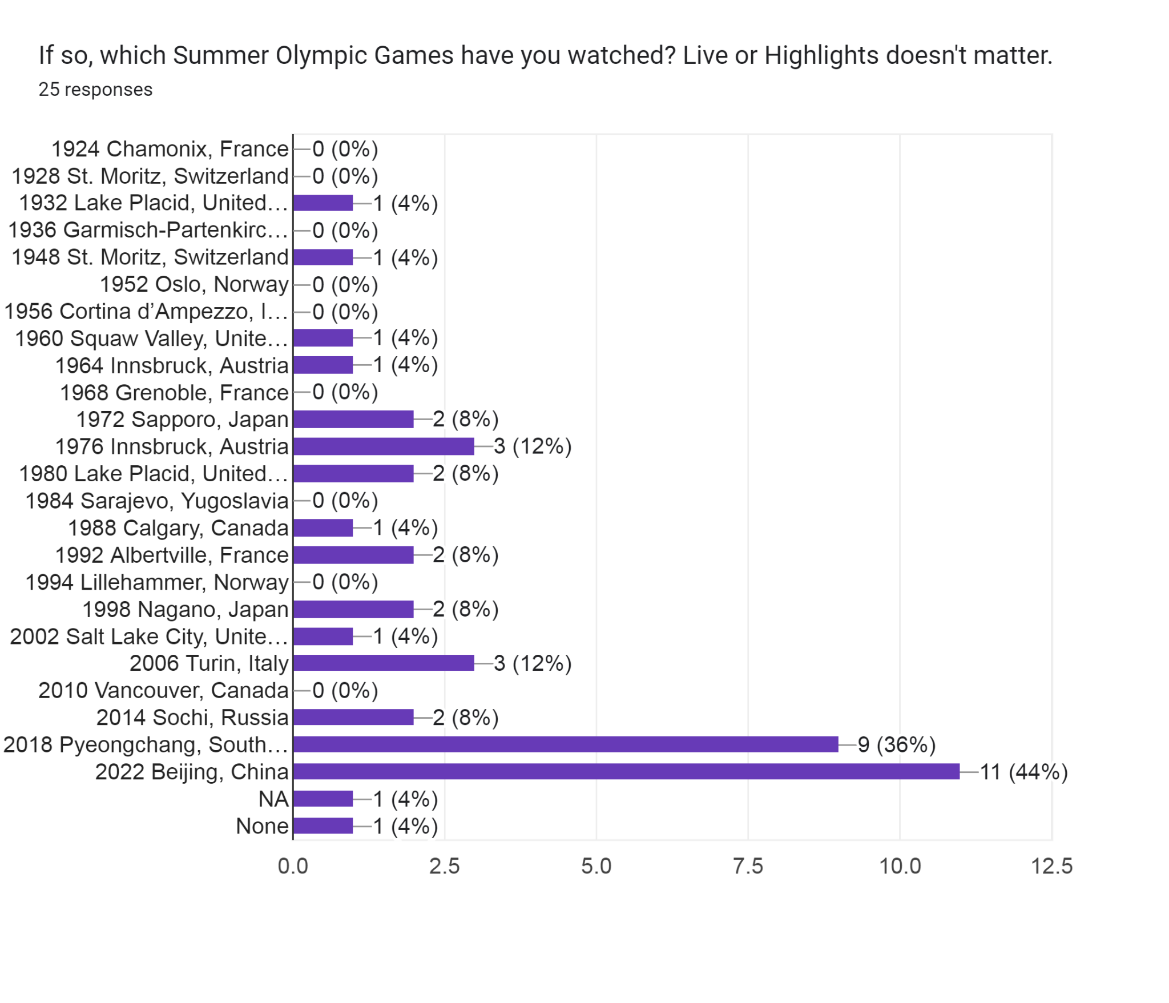

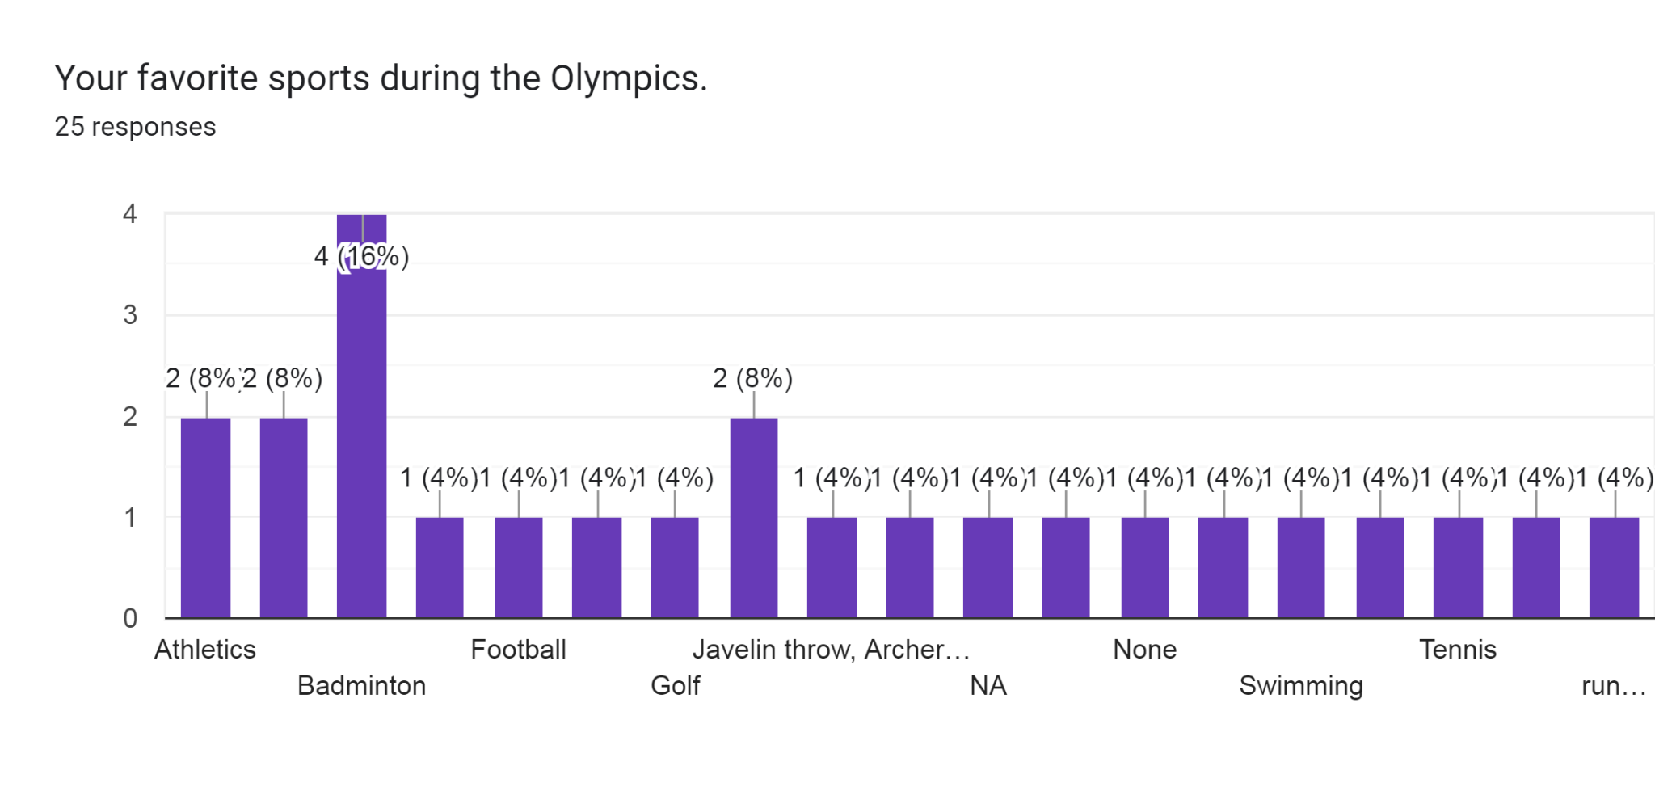

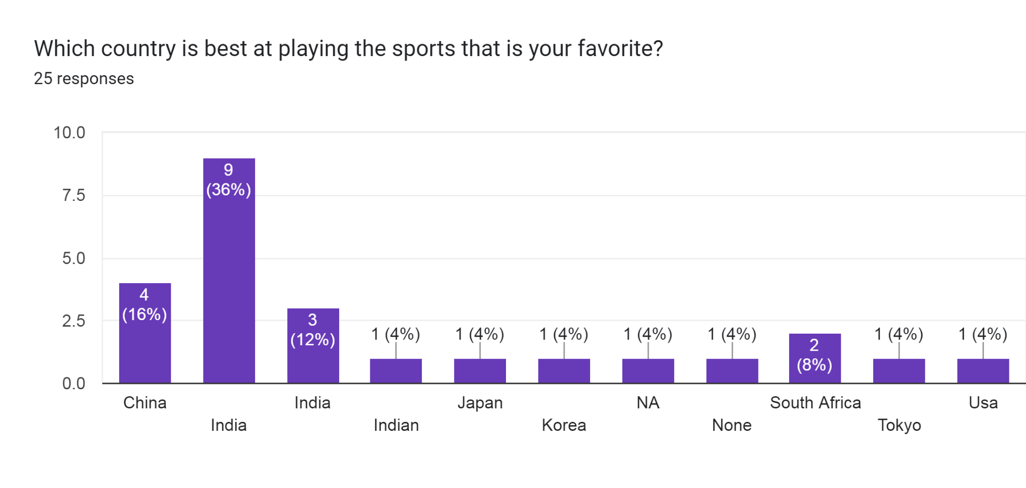

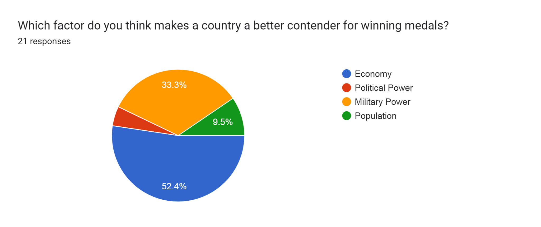

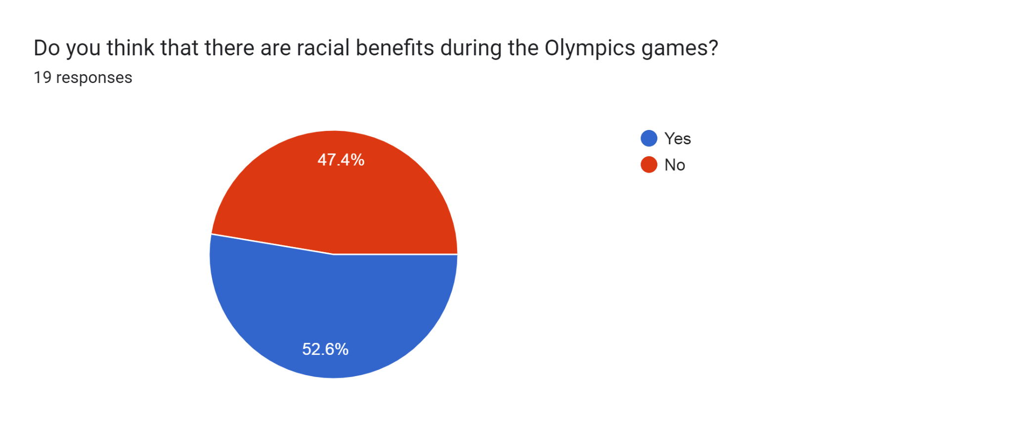

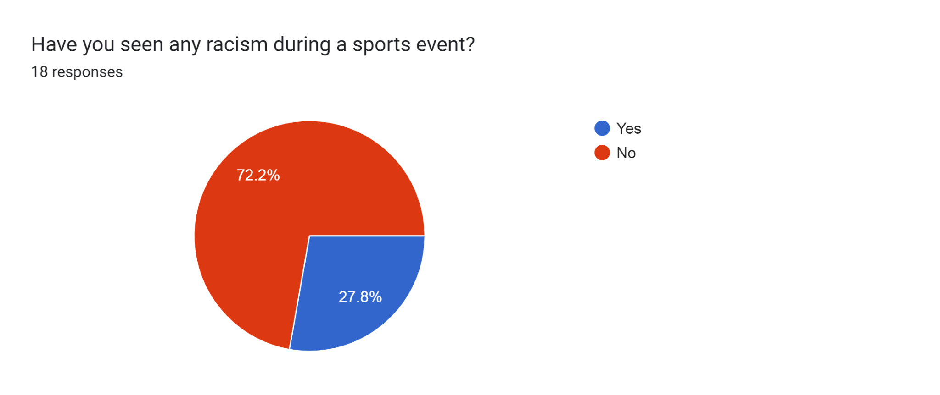

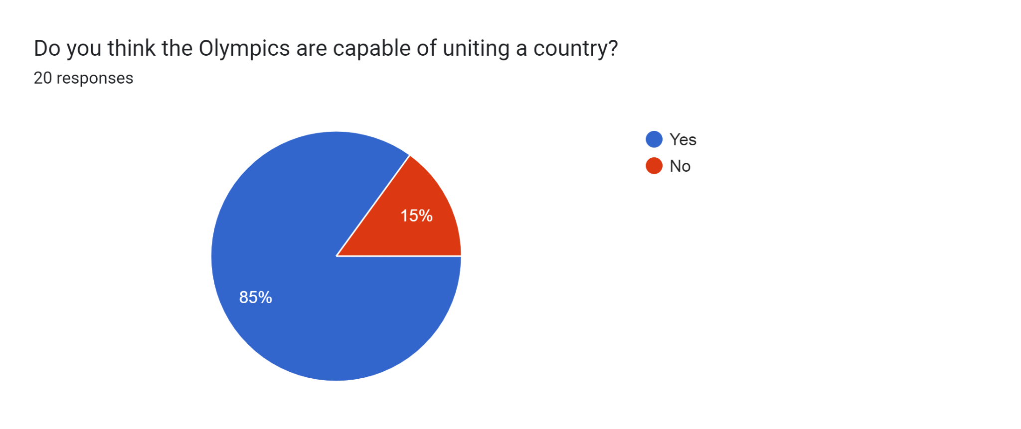

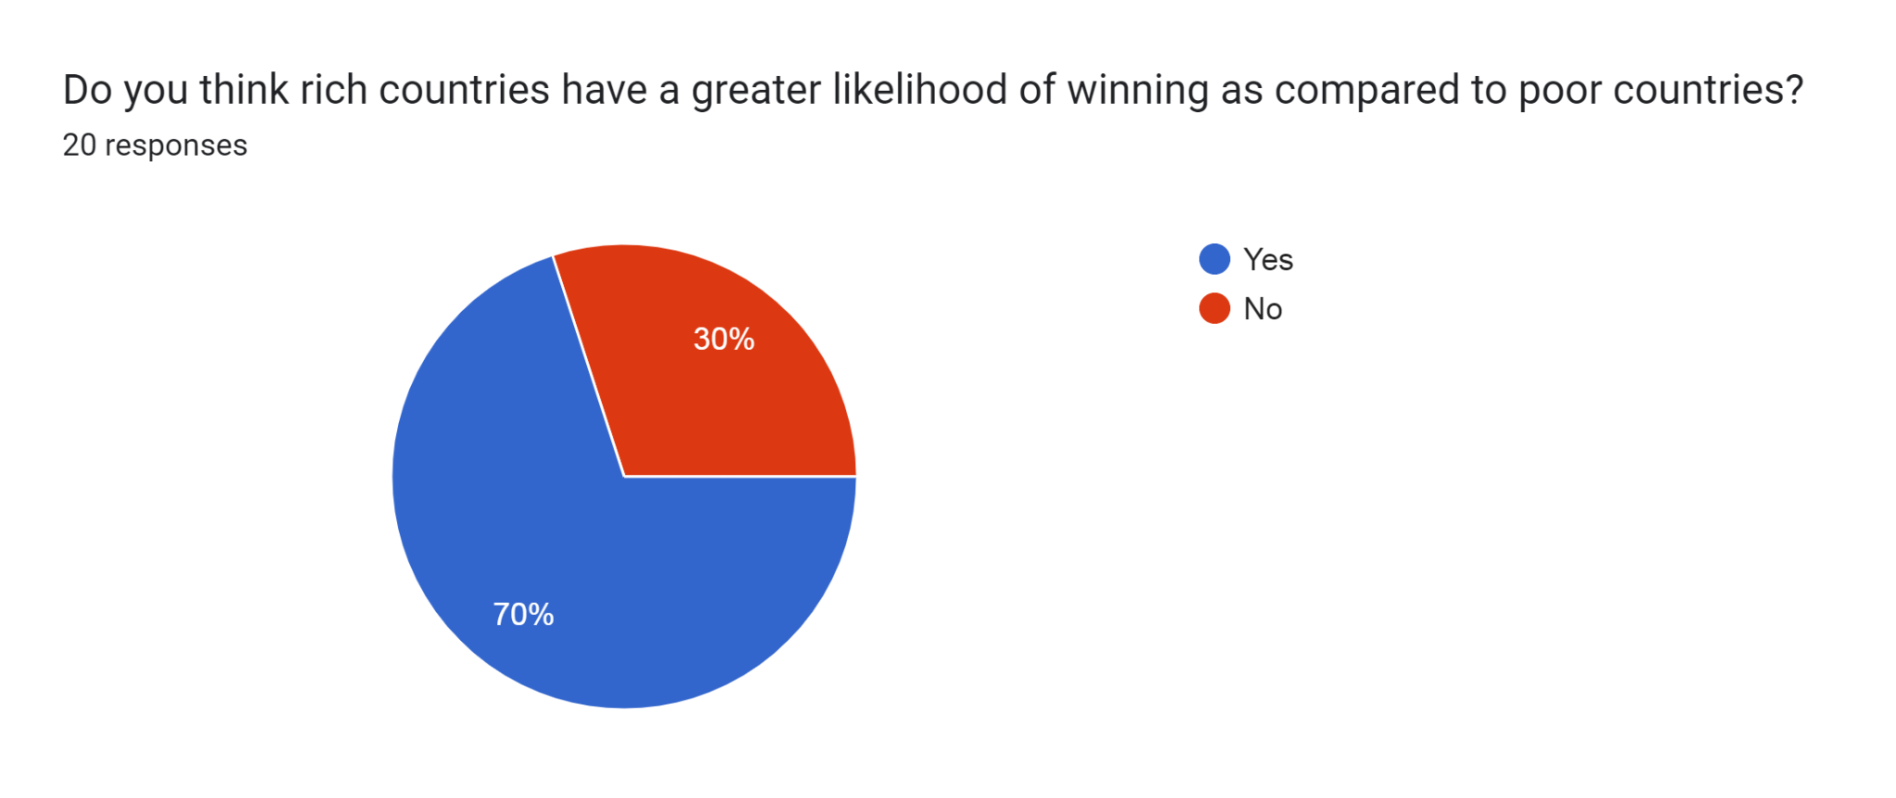

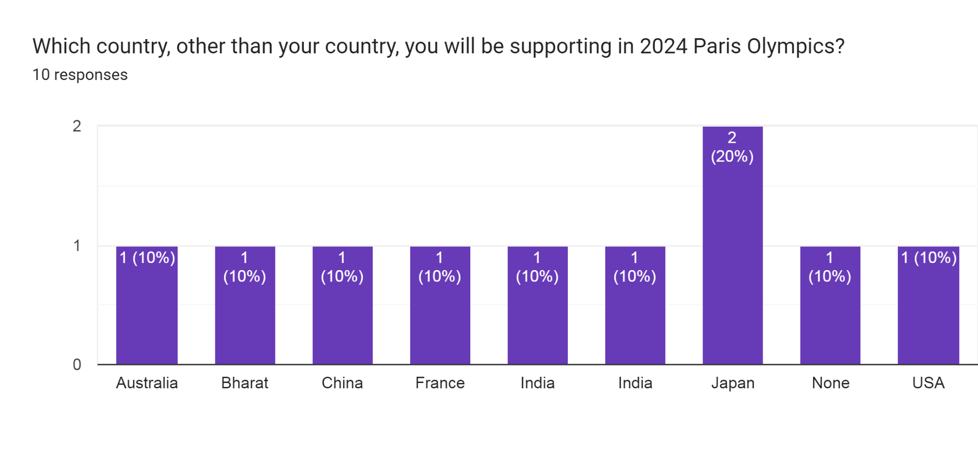

**Conclusion :**

* We found that most of them use the internet as a source of information.
* Majority of them do not find any racism, racial or religious discrimination in Olympic.
* Most of them think the economy can be a great contender for increasing sport participation in the Olympics.
* Many of them liked watching the Olympic games.
* Many of them believe that sport can unite people and countries.
* Most of them believe that rich countries would have a higher possibility to win rather than poor countries.

**Requirements :**

1. We can know player status rank how much times he won
2. We can know player availability status for a particular game
3. We can know why a country is lagging behind, whether the reason is training, equipment, governing sport events, training etc. so a particular country can analyze it.
4. Because of advances in technology nowadays, most people know about the Olympics through social media. People are more encouraged towards the sports when the player from their own Country wins at the international level. Ex. Neeraj Chopara .
5. The data will provide the approximate percentage of people aware about the national sport and the culture of the particular country represented at the international level.
6. All the data available on the internet is easier to access if it is available to all. More efficient and reliable data arrangement will be made for more clarity.

**4. Observations:**

**System:** Olympic database

**Participants:** Doshi shraddha (Olympic database)

Aniruddh damor (Olympic database)

Arth j shah (National level player in Karate)

**Date:** 30/09/2022  **Time:** 1:00

**Duration:** 30 Minutes **Place:** google meet

Users who regularly watch sports or Olympics will have great ideas about what has been missed in prior state.

1. The Olympics have a different route for candidates than for normal people which shows the security provided by the organizers.
2. India does not get a bid since we don’t have that much infrastructure.
3. Using player rating and quiz for having a better experience of a match at the stadium will help in increasing interaction and awareness among the people.
4. The Olympics provide the way to the country to showcase their culture in front of the world.
5. In today’s modern technology where a number of video games have been made, the Olympian database will provide the data of the number of participants from different countries which will encourage many of us to play outdoor games.
6. Host country has a contract with the IOC (International Olympic Committee) that defines certain restrictions and security.
7. Opening and closing ceremony will honour some artistic wonder; they will be given a medal that defines that they also honour art.
8. Media broadcasting newspapers will also have accommodation with candidates.
9. Mostly people do not use apps or do not follow news because it bores them and it is useless so we will create player rating ,economy level info, security level info to tempt them and also by trading.

**Requirements:**

1. This data will help aspiring athletes looking forward to pursuing a career in sports and they will also get to know the details about how Olympic events are managed like security, budget, accommodation etc.

1. We can know details about Olympic issues and riots, drugs that lead to a decreasing number of countries, participants which will help the media to make a halt on such situations.
2. This data can be used to help people in arranging big events, improvement in infrastructure like size of pitch and the ground, budget management, sponsorship and branding etc.
3. It can also be useful in providing general information about the Olympics that mostly every database provides to people.

**3.Fact finding chart :**

|  |  |  |  |
| --- | --- | --- | --- |
| **Objective** | **Subject** | **Technique** | **Time** |
| To get info of Olympic event | Wikipedia reading | Background reading | 2 hr |
| Info about medal won by country | Past record/ Olympic database | Background reading | 0.5 day |
| Finding info about participating country | Past record /olympic database | Background reading | 0.4 day |
| Finding all info about host country | Past record /Olympic database | Background reading | 0.3 day |
| Budget ,revenue details | Olympic fact file article | Background reading | 0.6 day |
| Opening /closing ceremony details | User who watches Olympic game frequently | Observation | 30 min |
| Sport added or removed | Olympic database/past record | Background reading | 0.5 day |
| Requirements/conclusion/summary for database | Sport committee member | Interview | 30 min |
| Olympic issues like drugs that affect database and Olympic | Reporter | Interview | 30 min |
| Info about bidding and why we are lagging | User of database | observation | 30 min |

**4.List of Requirements :**

1. We can organize the data and analyze the past performance which will help to improve in a particular area or sport.
2. Number of participants in the event will show how much the country is concerned and encourage the people to take part in the sports.
3. We can know how many sports have been removed and added and also we can know some athletes have to lose their medal because of drugs and even because of boycotting, war, political issues etc.
4. In the starting years of the Olympics women were not allowed to participate and when they were allowed, they were not significant. By this database we can know by gender or racial or religious discrimination happened in Olympics.
5. We can know how much of the revenue has gone to infrastructure, equipment , and training .
6. We can know player rating by asking the user who is his/her favorite player of a particular game, why they like the game or why they like the player and what can be their strategy to win the game.
7. From the database we will get to know why the country is lagging behind in the sports, whether the reason is training, equipment, governing sport events, training, less number of youth etc.
8. To know how the Olympics affect the economy of country how they divide them for infrastructure sport event or equipment
9. Most importantly, this data needs to be available and accessible to all, so we can have more users and this can also be helpful to others. The Internet can be the perfect medium for this as most people prefer the use of the internet for accessing the data.
10. We want to have some medal information like who is the designer and then how much diameter ,thickness and weight .
11. details about chief guest and opening ceremony brand promotion broadcast details
12. we want to have info of cost and revenue and profit of host country how he gained revenue from which source
13. having info of player ,game,countries ,past 3 winner ,medal basic info

**5. User Categories and Privileges**

Our database will have various kind of role

1.Provided to student ,college student

Just can see basic information but cannot change anything

They can see budget information, winners of the last 3 games and related information required for analysis purposes and projects.

2.Reporter /film script writer /author

They can see information about controversies, why certain country and people were removed but can not change anything

3.Sportperson is directly involved with Olympic

They can see every information available but cannot update delete insert it

4.The one who have license of database or owner of it like director

He should be able to update the database according to time and he can also give other people certain grants and he can insert or delete new Olympic information.

5. Event planner

They can see budget ,expenditure ,returns table for organizing but can not insert or delete it or update it

6.Sponsor

They can see broadcast right ,brand promotion table but just select operation nothing else

First three and fifth and sixth can only perform select and see the view but last can see ,update and delete and insert and even can give any user grant permission

**6. Assumptions**

1.My database can have an application which a certain browser can use.

2.We assume that in the Olympic maximum 10 countries will be participating

3.I assume that maximum 7 game has been played in Olympic

4.I assume Olympic will have at most 15 number of participant throughout every year

5.I believe that wind will not have that much effect on olympic game so no bother considering it

6.I believe my database will have certain kinds of restrictions that age below 7 will not be able to use it.

7.If I need to insert more data my database will provide flexibility.

8.I assume olympics occur every 6 years no bother having two seasons only one so like after 1990 first will come 1991,1997,2003,2009,20215,2021.

9.one chief guest per Olympic year

10.Medal weight ,thickness will be same in particular year

11.Every country is either host or participating

12.More than one company allowed for broadcastright

13.if field is different like medical or agriculture they can have same name of brand

14.like calcutta we can have state or city with same name but in different country

**7. Business Constraints**

**1.Hardware constraint**

How we will store our database and for that what kind of hardware we will use

How much money will be needed.

**2.Software constraint**

What type of software /application we will use and how much money can be needed,

What other installations need to be done.

**3.Memory constraint**

Like how much data can be stored and per data how much memory and how much money will be needed

**4.Different type of interface constraint**

What kind of interface the user will like and how much money and time will be needed for it.

**5.Safety constraint**

What kind of security and protection we will provide to our user so that their data will not be stolen.

**6.Socket programming protocol constraint**

What kind of protocol we will use for network communication and what kind of api will be needed and how much money, time and effort will be needed.

—---------------------------------------------------------------------------------------------------------------------------------------------------

**SEC 2 : Noun Analysis**

**Final description :**

Every country is either host or participating country and so we have divided it into 2 parts with attributes such as country id and country name.

Host country The database provides the information of the various countries that have hosted the Olympic Games after 1990 having country id, country name, year. We can know who the host country is, the number of participating countries, the year when the Olympics were held ,and the number of people who had participated in a particular game. Also the state and city of the host country are searchable.

Participating countriesThe countries that have participated in a particular year. We will have country id ,name ,particular year, and also we can know which country participated, number of players participated and how many games were played.

We can have details of prize or medal distribution like the Country with the highest number of medals and the type of Medal / prize like gold or silver or bronze and with total medals**.** They will be associated with country ,player ,game so we can know how many countries won and how many players won the medals

We can also see the properties of medal like its designer name, its thickness ,weight ,mint ,diameter etc . It will be helpful for the new host city organizer to design it so they can represent their culture.

Different sports that have been added or removed over the years:

For this we will have columns as added or removed which will provide the data of the game with the year in which it was added or removed.

We can know how much revenue the host country got, how we can efficiently divide it into infrastructure ,sport events, equipment and training so the new country can manage their budget.

We can also know about how many player participated in Olympic and so we can know people are getting more facilities to reach Olympic, they are having awareness towards the sports and want to pursue their career in it

Number of attendees in a particular year:

We will have year, player id, player name ,date of birth ,since, and personal information of players like gender, height, weight etc. we can know about a player 's professional information from these. We can have player id since join date of birth their rank or position overall in Olympic.

And even their personal information like height ,body so new aspiring athletes can be inspired to maintain their body ratio and work hard to reach their goals and we can have gender information too. We can know how much girls have evolved and have awareness so we can also check participation by checking this, either we can break it into two tables or combine it in one table.

Details about opening ceremony and closing ceremony:

When it started, date, country id, year for opening ceremony and closing ceremony .Chief Guest of the event in a particular year in an Olympics with attributes as Country id, chief guest name, particular year. In the opening ceremony host country has a torch bearer and even participating countries can also have their flag bearers too. It is known as a ritual but it is not important and desired in detail and by whom ceremony got inaugurated.

We could have info of team name who won, their status,

Winners of a particular sport and their past 3 winners Having last 3 winners as a relationship with attributes having player id, game id, year . We can know their player id, game id, particular year and Olympic season by performing join operations. We can also find the name of the player with the highest number of medals.

How much the host country has to pay for services ,security, prize distribution, accommodation, food, medical and other events so the new host country can predict their budget for future events.

Other than this, marketing team information such as which company sponsored the event and which brand etc.in particular Olympic year, the channel which got broadcast right and for how many hours we can know this type of information. Also how much the host country can earn using social media platforms. We can use broadcasting brand promotion for professional business purposes .

Games will have different games that have been held and we can know since when they were added or removed, which player got the win. We can have attributes such as game id, game name, year added, year removed so we can have information about how sport started and we can perform many operation on them.

**Noun analysis table :**

|  |  |
| --- | --- |
| **Noun** | **Verb** |
| Country | Participated |
| Host country | Informed |
| Participating country | Win |
| Game | Plays |
| Sport | Hosted |
| Player | Came |
| Athlete | Design |
| Medal | Earn |
| Reason | Spends |
| Winner | Divided |
| Event | Plays |
| Chief guest | Held |
| Returns | Add/remove |
| Medal info | Organized |
| budget | Inaugurate |
| Expenditure | Promote |
| Broadcast right | Train |
| Brand promotion | Keep |
| Distribution | Celebrate |

|  |  |
| --- | --- |
| Social media | Create |
| Business | Increased |
| Purpose | Get |
| Data | Give |
| Team name | Predict |
| Ritual | Sold |
| Professional | Made |
| Personal | Ask |
| Information | Associated |
| People | Lose |
| Prize | Maintain |
| Organizer | Checking |
| Culture | Performed |
| Performance | Used |
| Facility | Included |
| Awareness | Manage |
| Progress | Honour |
| Sport ecosystem | Analyzing |
| Body ratio | Look |
| Torch bearer | Accessed |

|  |  |
| --- | --- |
| Flag bearer | Progress |
| Detail | Provided |
| Qualification | Started |
| Foreign | Know |
| Tourism | Distribute |
| Marketing team |  |
| Operation |  |

| Country name |  |
| --- | --- |
| State |  |
| City |  |
| Venue |  |
| Address |  |
| Region |  |
| Designer name |  |
| Mint |  |
| Thickness |  |
| Diameter |  |
| Weight |  |
| Brand name |  |
| Company |  |

|  |  |
| --- | --- |
| Year |  |
| Hour coverage |  |
| Channel name |  |
| Ticket |  |
| Product |  |
| Broadcast /brand sponsor |  |
| Revenue |  |
| Services |  |
| Medal cost |  |
| Event organizer |  |
| Security |  |
| Cost |  |
| Infrastructure |  |
| Training |  |
| Sport event |  |

|  |  |
| --- | --- |
| Equipment |  |
| Opening ceremony |  |
| Closing ceremony |  |
| Date |  |
| Time |  |

|  |  |
| --- | --- |
| Name |  |
| Year added |  |
| Year removed |  |
| Gender |  |
| Height |  |
| Rank |  |
| Position |  |
| Date of birth |  |
| Since join |  |
| Bronze |  |
| Total |  |
| Gold |  |
| Silver |  |
| Reason |  |
| Status |  |
| Venue |  |
| Expense |  |
| Company info |  |
| Money |  |
| Account |  |
| Medical |  |
| Food |  |
| Participant |  |
| Game status |  |
| User rating |  |
| Accommodation |  |
| Result |  |

**Classification of noun and verb :**

1. **Duplicates:**

|  |
| --- |
| 1. Athlete, Player ,Participant attendees |
| Game, sport |
| Money ,expense ,cost |
| Prize ,medal |
| Data ,information |
| Rank ,position |
| Since ,date |
| City, region |
| Address ,venue |

**d. Irrelevant**

from noun and verb

|  |
| --- |
| Result |
| Accommodation |
| Food |
| Medical |
| Team name |
| Professional |
| Personal |
| Body ratio |
| Qualification |
| Progress |
| Performance |

|  |
| --- |
| Promote |
| Increased |
| Predict |
| Sold |
| Made |
| Associated |
| Lose |
| Performed |
| Manage |
| Honour |
| Progress |
| Provided |
| Distribute |

**e. vague**

from noun and verb

|  |
| --- |
| Account |
| Ritual |
| Game status |
| User rating |
| Information |
| Organiser |
| Culture |
| Facility |
| awareness |
| Torch /flag bearer |
| Detail |
| Qualification |
| Foreign |
| Tourism |
| Marketing team |
| Operation |
| Trained |
| Keep |
| Celebrate |
| Create |
| Get |
| Give |
| Ask |
| Maintain |
| Checking |
| Used |
| Included |
| Analyzing |
| Look |
| Accessed |
| Started |
| Know |

1. **General:**

|  |
| --- |
| Sport ecosystem |
| People |
| Olympic |

1. **Attributes:**

|  |
| --- |
| Country name |
| State |
| City |
| Venue |
| Address |
| Region |
| Designer name |
| Mint |
| Thickness |
| Diameter |
| Weight |
| Brand name |
| Company |

|  |
| --- |
| Year |
| Hour coverage |
| Channel name |
| Ticket |
| Product |
| Broadcast /brand sponsor |
| Revenue |
| Services |
| Medal cost |
| Event organizer |
| Security |
| Cost |
| Infrastructure |
| Training |
| Sport event |

f

|  |  |
| --- | --- |
| Equipment |  |
| Opening ceremony |  |
| Closing ceremony |  |
| Date |  |
| Time |  |

|  |
| --- |
| Name |
| Year added |
| Year removed |
| Gender |
| Height |
| Rank |
| Position |
| Date of birth |
| Since join |
| Bronze |
| Total |
| Gold |
| Silver |
| Reason |
| Status |

1. **Association**

|  |
| --- |
| Participated |
| Plays |
| Held |
| add/remove |
| Organized |
| Inaugurated |
| Informed |
| Divided |
| Spends |
| Earn |
| Design |
| Came |
| Win |
| Hosted |

**Accepted and rejected from noun analysis table**

entity/relationship Accepted :

|  |  |  |
| --- | --- | --- |
| **Entity set** | **Attribute** | **Relationship set** |
|  |  |  |
| Country | Ticket | Participated |
|  |  |  |
| Player | Country name | Plays |
| Game | Year | Held |
| Add/remove for player | State | Add/remove |
| Medal | City | Organized |
| Host country | product | Inaugurate |
| Participating country | Player name | Info(hour) |
| Medal info | Date of birth | Info(brand ) |

|  |  |  |
| --- | --- | --- |
| Brand promotion | Rank | Divide |
| Broadcast right | Since join | Spends |
| Budget | Broadcast /brand sponsor | Earn |
| Expenditure | Height | Design |
| Returns | Gender | Came (player) |

|  |  |  |
| --- | --- | --- |
| Event | Revenue | Win |
| Chief guest | Game name | Past3winner |
|  | Year added | Detailed info |
|  | Year removed | Hosted ( game ) |
|  | Reason |  |
|  | Status |  |
|  | Bronze |  |
|  | Gold |  |
|  | Total |  |

|  |  |  |
| --- | --- | --- |
|  | Silver |  |
|  | designer name |  |

|  |  |  |
| --- | --- | --- |
|  | Event organizer |  |
|  | Mint |  |
|  | Diameter |  |
|  | Thickness |  |
|  | Weight |  |
|  | Opening time |  |
|  | Closing time |  |
|  | First name |  |

|  |  |  |
| --- | --- | --- |
|  | Gender |  |
|  | Security |  |
|  | House coverage |  |
|  | Channel name |  |
|  | Cost |  |
|  | Brand name |  |
|  | Company |  |

|  |  |  |
| --- | --- | --- |
|  | Infrastructure |  |
|  | Sport event |  |
|  | Equipment |  |
|  | Training |  |
|  | Services |  |

|  |  |  |
| --- | --- | --- |
|  | Medal |  |

**Rejected :**

**Taken as attributes :**

|  |
| --- |
| Country name |
| State |
| City |
| Venue |
| Address |
| Region |
| Designer name |
| Mint |
| Thickness |
| Diameter |
| Weight |
| Brand name |
| Company |

|  |
| --- |
| Year |
| Hour coverage |
| Channel name |
| Ticket |
| Product |
| Broadcast /brand sponsor |
| Revenue |
| Services |
| Medal cost |
| Event organizer |
| Security |
| Cost |
| Infrastructure |
| Training |
| Sport event |

|  |
| --- |
| Name |
| Year added |
| Year removed |
| Gender |
| Height |
| Rank |
| Position |
| Date of birth |
| Since join |
| Bronze |
| Total |
| Gold |
| Silver |
| Reason |
| Status |
| Equipment |
| Closing ceremony |
| Opening ceremony |
| Date |
| Time |

**Irrelevant to database :**

**(wastage of space)**

|  |
| --- |
| Result |
| Accommodation |
| Food |
| Medical |
| Team name |
| Professional |
| Personal |
| Body ratio |
| Qualification |
| Progress |
| Performance |
| Promote |
| Increased |
| Predict |
| Sold |
| Made |
| Associated |
| Lose |
| Performed |
| Manage |
| Honour |
| Progress |
| Provided |
| Distribute |

**Vague to database :**

**(not giving any desirable info to database)**

|  |
| --- |
| Account |
| Ritual |
| Game status |
| User rating |
| Information |
| Organiser |
| Culture |
| Facility |
| Awareness |
| Torch /flag bearer |
| Detail |
| Qualification |
| Foreign |
| Tourism |
| Marketing team |
| Operation |
| Trained |
| Keep |
| Celebrate |
| Create |
| Get |
| Give |
| Ask |
| Maintain |
| Checking |
| Used |
| Included |
| Analyzing |
| Look |
| Accsessd |
| Started |
| Know |

**Duplicate for database :**

**(wastage of memory space ,data redundancy problem)**

|  |
| --- |
| 1. Athlete, Player ,Participant attendees |
| Game, sport |
| Money ,expense ,cost |
| Prize ,medal |
| Data ,information |
| Rank ,position |
| Since ,date |
| City, region |
| Address ,venue |

**General :**

**(not useful to database )**

|  |
| --- |
| Sport ecosystem |
| People |
| Olympic |

**Total 15 entity set and 17 relationship set get selected and**

**There were 105 entity sets and 44 relationship sets .**

**—--------------------------------------------------------------------------------------------------------------------**

**3.sec 3 final ER diagram**

**Weak entity set**

1. Reason
2. Medal

Reason and medal are weak entity set because and detailed info and player id are owner entity set ,both set are dependant on owner entity set and without this data does not make sense

**Specialization**

Country is either host country or participating country

**Reason for recursive vs specialization**

Here event ,chief guest table and many tables are only connected to host country

Host country will have different attribute like state city from participating country

**Association :**

Inaugurated ,organoised ,divide ,spends ,earn,design Are one to one relationship host country table joined with medal info ,event etc table

Info brand and info hour one to many relationship table joined with host country table to broadcast right and brand promotion

Player came hosted game are one to many relationship joined with host country to player and game

Participate having Country and player is 1 to many relationship

Plays ,held are many to many relationship

add/remove ,past 3 winner,win are one to one relationship

Detailed info is having one from country but many from player and game side

**Entity vs attribute**

Broadcast right ,brand promotion ,event ,chief guest can be attribute but broadcast right and brand promotion are multivalued and chief guest and event also having some special meaning to database

**Entity vs relationship** : add/remove

past 3 winner

Both can be entity but making it relationship we can have special attribute and it will be mistake to crete entity when we can have relationship resultant to data integrity problems.

**ternary** : player ,country ,game are joined with detailed info is a ternary relationship

**Aggregation** : we have make country ,player ,game relationship with detailed info and then with medal by win relationship it is better to use it that way then making 4 ary relationship

**partial :**

add/remove

past3winner

They both have player entity set who is having partial participation

**total :**

country ,player ,game with detailed info is total participation from every entity set

medal ,detailed info with win is also total participation

host country with player , host country with game and country with game ,country with player ,player with game are all total participation

medal info ,budget ,expenditure,returns ,brandpro motion ,broadcastright ,chief guest with host country they are all joined by total participation relationship

**Add missing attribute /entity** : I have added channel id ,brand id ,player id ,game id ,country id as attribute and medal info as a entity set

**3 . ER-diagram**

We have divided this er diagram into three parts so it does not overlap

Last event planner ,sponsor ,student , sportsperson, author/ reporter. script writer ,director as user of database

I have six roles in my system so I have shown their entity set in the diagram it is for authorization purpose

second shows that weak entity set ,aggregation ,partial participation and etc

first shows basic unique feature and all the table are joined with host country

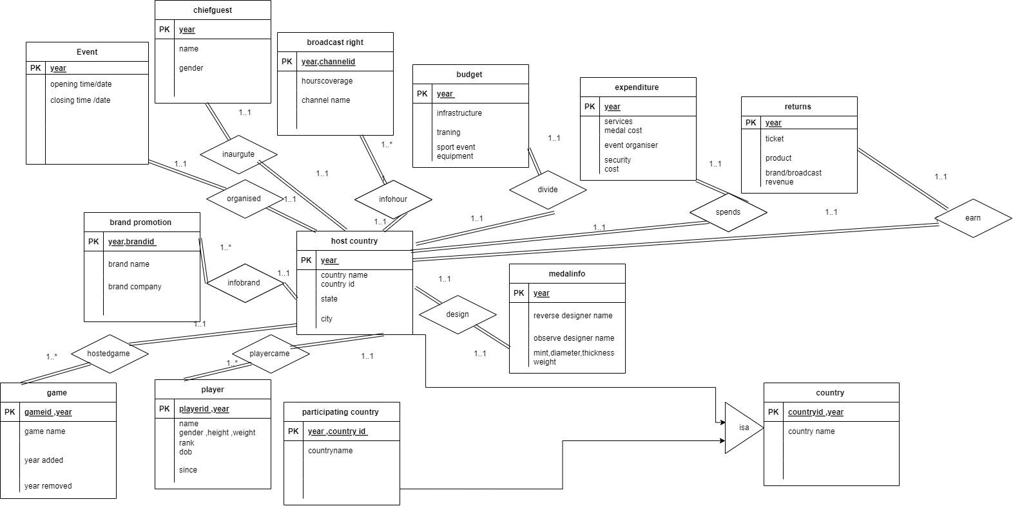

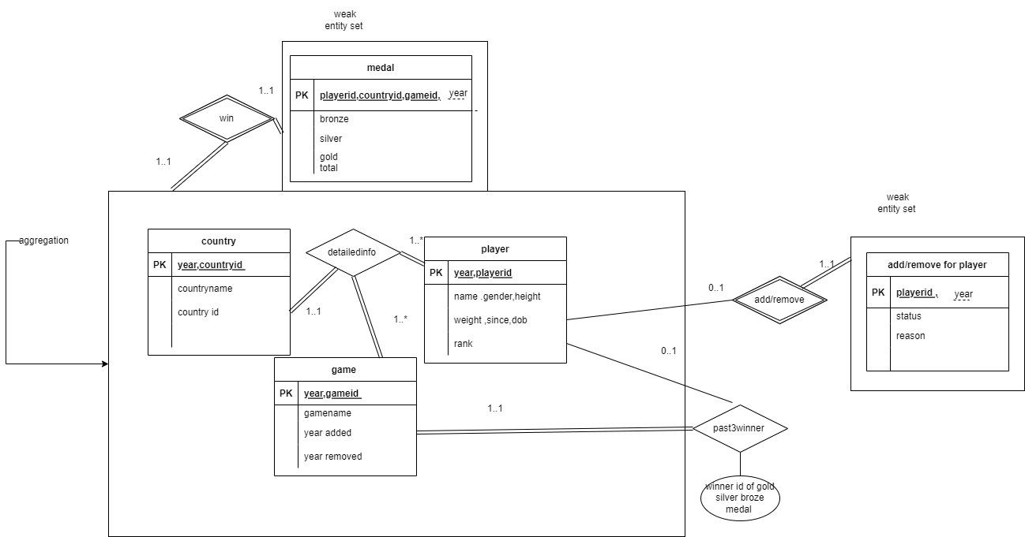

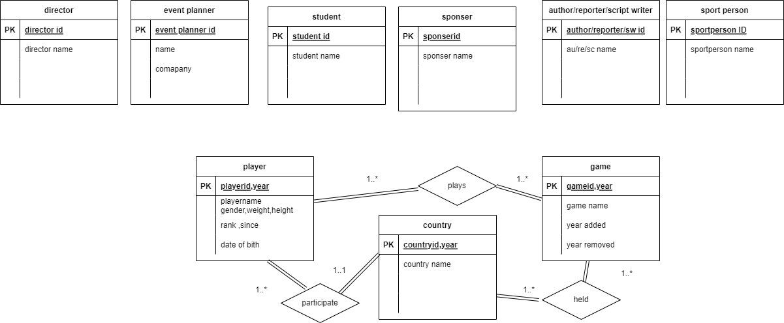

**—----------------------------------------------------------------**

**sec 4. ER model to relational model**

**relational schema :**

**1.add/removereason** (playerid,year,reason,status)

**2.Past3winner**

(gameid, year, gold/silver/bronze winner (winnerid is player id)

**3.Medal**

(countryid,playerid,gameid,year,bronze,total,gold,silver)

**4.Game**

(gameid,year,gamename,yearadded,yearremoved)

**5.Player** (playerid,year,rank,since,dateofbirth,gender,playername,height,weight)

**6.Chief Guest**

(year,chief guest name,gender,country id

**7.Brand Promotion** (year,brandid,brand name,brand company name,country id)

**8.Broadcastright** (year,channelid,channelname ,hours coverage,country id)

**9.Returns**

(year,countryid,revenue,brand broadcast,ticket,product)

**10.Expenditure**

(year,countryid,cost,security ,services,medal cost,event organiser)

**11.Budget**

(year,countryid,infrastructure,equipment ,sportevent ,training)

**12.Medal info**

(countryid,year,observrdesignername,reversedesignername,mint,thickness,weight,diameter)

**13.Event**

(country id,year,opening time,opening date,closing time,closing date)

**14.Host country**

(year,host country name,host country id,state ,city)

**15.Country/participating country** (country id,year,country name)

**table** :

|  |  |  |  |  |
| --- | --- | --- | --- | --- |
| sr.no | name | domain constraints | pk /fk | integrity  constraint |
| 1. | country | **country id** integer  **country name** varchar  **year**  integer | pk:  countryid,year | every attribute not null |
| 2. | host country | **country id** integer  **country name** varchar  **year**  integer  **state** - varchar  **city** - varchar | pk:  year  Fk:  countryid,year  from country | state and city can be null |
| 3. | medal info | **observe/reverse designer** varchar  **mint** - varchar  **weigh**t - numeric  **thickness**- numeric  **diameter**- numeric  **year** - integer  **country id** integer | pk:  year  Fk:  countryid,year  from country | other than year  countryid ,year  every attribute can be null |
| 4. | chief guest | **country id** integer  **year**  integer  **first name** varchar  **last nam**e varchar  **gender** varchar | pk:  year  Fk:  countryid,year  from country | other than year  countryid ,year  every attribute can be null |
| 5. | budget | **country id** integer  **year**  integer  **infrastructure** integer  **sportevent** integer  **training** integer  **equipment** integer | pk:  year  Fk:  countryid,year  from country | other than countryid and year every attribute can be null |
| 6. | expenditure | **country id** integer  **year**  integer  **services** integer  **security** integer  **medal cost** integer  **cost** integer  **event organizers** integer | pk:  year  Fk:  countryid,year  from country | other than countryid ,year every attribute can be null |
| 7. | returns | **country id** integer  **year**  integer  **revenue** integer  **brand /broadcast** integer  **ticket** integer  **product** integer | pk:  year  Fk:  countryid,year  from country | other than countryid ,year every attribute can be null |
| 8. | brand promotion | **country id** integer  **year**  integer  **brandid** integer  **brand name** varchar  **company name** varchar | pk:  year,brandid  Fk:  countryid,year  from country | company name can be null |
| 9. | broad  castright | **country id** integer  **year**  integer  **channel name** varchar  **channel id** integer  **hours** integer | pk:  year,channelid  Fk:  countryid,year  from country | hours can be null |
| 10. | game | **year**  integer  **year added** integer  **year remove**d integer  **game name** varchar  **game id** integer | pk:  year,gameid | apart from year and game id and game name any can be null |
| 11. | player | **year**  integer  **player id** integer  **playername** varchar  **height** integer  **weight** integer  **since** integer  **d.o.b** date  **gender** varchar  **rank** integer | pk:  year,playerid | apart from year player id player name any can be null  unique constraint on player id |
| 12. | medal | **country id** integer  **year**  integer  player id integer  game id integer  bronze integer  gold integer  silver integer  total integer | pk:  year,playerid,gameid,countryid  FK:  year,playerid  from player  gameid ,year  from game  countryid ,year from country | every attribute is not null |
| 13. | past3winner | **year**  integer  **game id** integer  **gold/silver/bronze winner id**  integer | pk :  game id ,year  Fk:  gold/silver/bronze winner id as player id from player  game id ,year from game | every attribute is not null |
| 14. | add/remove reason | **year**  integer  playerid integer  reason varchar  status varchar | pk:  year,plyerid  Fk:  playerid,year  from country | every attribute  should be not null |
| 15. | event | **country id** integer  **year**  integer  opening time time without timezone  closing time time without timezone  opening date date  closing date date | pk:  year  Fk:  countryid,year  from country | other than countryid ,year every attribute can be null |

**—----------------------------------------------------------------**

every foreign key should have on update cascade and on delete cascade

**Sec 5 . Normalization and schema refinement**

**Functional dependency**

**1)Country/participating country**

countryid->countryname

Country id,year->countryname

CK : countryid ,year

CK : countryname,year

**2)host country**

countryid->countryname

Country id,year->country name,state,city

state->country name

city->state,country,name

CK : countryid ,year

CK : countryname,year

**3)game**

gameid->game name

gameid->game name,state,city

CK : gameid ,year

CK : gamename,year

**4)player**

playerid->playername

playerid,year->playername,rank,since,dob,gender,

Height,weight

CK : playerid ,year

**5)brand promotion**

Brand id->brand name

brandid,year->brand name,company name

brand name->company name

CK : brandid ,year

CK : brandname,year

**6)broadcastright**

Channel id->channel name

Channel id,year->channelname,hours

CK : channelid ,year

CK : channelname,year

**7)medal**

Country id,playerid,gameid,year->total,bronze,gold,silver

CK : countryid ,year,playerid,gameid or countryname,gamename,playerid,year

**8)past 3 winner**

Game id,year->gold/silver/bronze winner id

CK : gameid ,year or CK : gamename,year

**9)addremovereason**

playerid,year->reason,status

CK : playerid ,year

**10)event**

year->opening time,closing time,opening date,closing date,

Country name

CK : countryid ,year

CK : countryname,year

**11)medal info**

year->mint,observe/reversedesignername,thickness,

weight,diameter,country name

CK : countryid ,year

CK : countryname,year

**12)chief guest**

year->name,gender,country name

CK : countryid ,year

CK : countryname,year

**13)budget**

year->country name,infrastructure,equipment,sport event,training

CK : countryid ,year

CK : countryname,year

**14)expenditure**

year-> country name,cost,service,security,medal,event organiser

CK : countryid ,year

CK : countryname,year

**15)returns**

year->country name,brand/broadcast,ticket,product,

revenue

CK : countryid ,year

CK : countryname,year

* **Redundancy analysis and Anomaly analysis**

**1)country**(country id,year,countryname)

1)There are two candidate keys

country id,year

country name,year

2)There are no transitive dependencies and there is no redundancy in table just one country can appear in different year so country id will be repeating

3)There are no anomalies

4)country is having specialisation with host country and participating country this is overlapping and total participation so we can remove participating country because they are having same data as country

**2)Host country**(year,host country id,host country name,state ,city)

1)Host country id ,year reference to country table

2)Here state and city having transitive dependency

There are three candidate keys

Host Country name,id ,year

3)That is why they are having redundancy because of

host country->host country name,state,city

city,state->country name

city->state

4)Delete anomaly :

If i delete city or state whole tuple will be deleted whole information will be lost so that is why they are not having not null constraint

5)there are no other anomalies

**3)Event** (country id,year,opening time,opening date,closing time,closing date)

1)Country id,year reference to country table

2)There are no transitive dependencies

3)Delete anomaly:

If i delete opening/closing time or date whole tuple will be deleted whole information will be lost so that is why they are not having not null constraint

4)there are no other anomalies

**4)medalinfo**(countryid,year,observrdesignername,reversedesignername,mint,thickness,weight,diameter)

1)Country id ,year reference to country table

2)There are no transitive dependencies so having no redundancy

3)Delete anomaly:

If i delete mint ,designer name,thickness or weight or diameter whole tuple will be deleted whole information will be lost so that is why they are not having not null constraint

4)there are no other anomalies

**5) Chief guest** (country id,year,chief guest name,gender)

1)Country id ,year reference to country table

2)There are no transitive dependencies so having no redundancy

3)Delete anomaly:

If i delete name gender whole tuple will be deleted whole information will be lost so that is why they are not having not null constraint

4)there are no other anomalies

**6)Budget**(year,countryid,infrastructure,equipment ,sportevent ,training)

1)Country id ,year reference to country table

2)There are no transitive dependencies so having no redundancy

3)Delete anomaly:

If i delete name training or infrastructure or other non prime attribute whole tuple will be deleted whole information will be lost so that is why they are not having not null constraint

4)there are no other anomalies

**7) Expenditure**(year,countryid,cost,security ,services,medal cost,event organiser)

1)Country id,year reference to country table

2)There are no transitive dependencies so having no redundancy

3)Delete anomaly:

If i delete services or other non prime attribute whole tuple will be deleted whole information will be lost so that is why they are not having not null constraint.

4)there are no other anomalies

**8)Returns** (year,countryid,revenue,brand broadcast,ticket,product)

1)Country id ,year reference to country table

2)There are no transitive dependencies so having no redundancy

3)Delete anomaly:

If i delete ticket or other non prime attribute whole tuple will be deleted whole information will be lost so that is why they are not having not null constraint

4)here are no other anomalies

**9)Broadcastright** (year,channelid,channelname ,hours coverage,country id)

1)Country id,year reference to country table and country id and year both are candidate keys

2)There are no transitive dependencies so having no redundancy

3)Delete anomaly:

If i delete hours or other non prime attribute whole tuple will be deleted whole information will be lost so that is why they are not having not null constraint

4)there are no other anomalies

**10)Brand Promotion** (year,brandid,brand name,brand company name)

1)Country id ,year reference to country table and country id and year both are candidate keys

2)There are no transitive dependencies so having no redundancy

3)Delete anomaly:

If i delete company name whole tuple will be deleted whole information will be lost so that is why they are not having not null constraint

4) there are no other anomalies

**11)Player** (playerid,year,rank,since,dateofbirth,gender,playername,height,weight)

1)there are no transitive dependencies

2)Delete anomaly:

If i delete rank,d .o .b or non prime attribute whole tuple will be deleted whole information will be lost so that is why they are not having not null constraint

3)there are no other anomalies

**12)Game** (gameid,year,gamename,yearadded,yearremoved)

1)there are no transitive dependencies

2)Delete anomaly:

If i delete year added or removed whole tuple will be deleted whole information will be lost so that is why they are not having not null constraint

3)there are no other anomalies

4)there are no transitive dependency

**13)Medal** (countryid,playerid,gameid,year,bronze medal,total medal,gold,silver)

1)playerid,year referencing to player table

2)game id,year referencing to game table

3)country id ,year referencing to country table

4)Delete anomaly:

If i delete bronze ,gold or non prime attribute whole tuple will be deleted whole information will be lost so that is why they are not having not null constraint

5) there are no other anomalies

6)there are no transitive dependency

**14)Past 3 Winner** (gameid, year, gold/silver/bronze winnerid (winnerid is player id)

1)goldwinner rid,year referencing to player table

2)bronze winner id,year referencing to player table

3)silver winner id ,year referencing to player table

4)There are no anomalies in this relation

5)there are no transitive dependency

**15)add/remove for player** (playerid,year,reason,status)

1)playerid,year referencing to player table

2)There are no anomalies in this relation

3)there are no transitive dependency

* **Normalization upto BCNF/3NF**

**Country** (country id,year,country name)

1)Here this relation it is in 1 NF form because every attribute is atomic

2)country id and name with year are overlapping candidate keys so only one of them necessary so i will be removing country id and it will be 2 NF form

3) after removing only two main attribute will be there so no other attributes then primary key it will be in 3 NF and BCNF form

**Host country**

(year,host country name,host country id,state ,city)

1)Here this relation it is in 1 NF form because every attribute is atomic

2)country id and name with year are overlapping candidate keys so only one of them necessary so i will be removing country id and it will be 2 NF form

3) country name ->city ->state -> country name there will be transitive dependency so it will be in 2 NF form but some place like calcutta is in america and in india too exceptional cities and states are in different country so by knowing this above mentioned transitive dependency is invalid so it is in now 3 NF form

**Event**

(country id,year,opening time,opening date,closing time,closing date)

As mentioned above country id and year are candidate keys so i can replace with country name ,year

1)Here this relation it is in 1 NF form because every attribute is atomic

2)there are no partial dependencies so it is in 2 NF form

3) there are no transitive dependency so it is in 3 NF form

**Medal info**

(countryid,year,observrdesignername,reversedesignername,mint,thickness,weight,diameter)

As mentioned above country id and year are candidate keys so i can replace with country name ,year

1)Here this relation it is in 1 NF form because every attribute is atomic and we will consider only first name of observe /reverse designer name

2)there are no partial dependencies so it is in 2 NF form

3) there are no transitive dependency so it is in 3 NF form

**Budget**

(year,countryid,infrastructure,equipment ,sportevent ,training)

As mentioned above country id and year are candidate keys so i can replace with country name ,year

1)Here this relation it is in 1 NF form because every attribute is atomic

2)there are no partial dependencies so it is in 2 NF form

3) there are no transitive dependency so it is in 3 NF form

**Expenditure**

(year,countryid,cost,security ,services,medal cost,event organiser)

As mentioned above country id and year are candidate keys so i can replace with country name ,year

1)Here this relation it is in 1 NF form because every attribute is atomic

2)there are no partial dependencies so it is in 2 NF form

3) there are no transitive dependency so it is in 3 NF form

**Returns**

As mentioned above country id and year are candidate keys so i can replace with country name ,year

(year,countryid,revenue,brand broadcast,ticket,product)

1)Here this relation it is in 1 NF form because every attribute is atomic

2)there are no partial dependencies so it is in 2 NF form

3) there are no transitive dependency so it is in 3 NF form

**Broadcastright** (year,channelid,channelname ,hours coverage,country id)

As mentioned above country id and year are candidate keys so i can replace with country name ,year

1)Here this relation it is in 1 NF form because every attribute is atomic

2)here brand id and brand name are equivalent to each other both are creating partial dependency so i will be removing them after removing it will be in 2 NF form

3) there are no transitive dependency so it will be in 3 NF form

**Brand Promotion** (year,brandid,brand name,brand company name,country id)

As mentioned above country id and year are candidate keys so i can replace with country name ,year

1)Here this relation it is in 1 NF form because every attribute is atomic

2)here channel id and channel name are equivalent to each other both are creating partial dependency so i will be removing them after removing it will be in 2 NF form

3) there is transitive dependency between brand name and company name

Here we are going to assume that two different field like agriculture or medical can have same brand name so it is no longer valid so it will be in 3 NF form

**Chief Guest**

(year,chief guest name,gender,country id)

As mentioned above country id and year are candidate keys so i can replace with country name ,year

1)Here chief guest name is not atomic so it is not in 2 NF form we will be breaking into first ,last name after that it will be in 1 NF form

2)there are no partial dependencies so it is in 2 NF form

3) there are no transitive dependency so it is in 3 NF form

**Player** (playerid,year,rank,since,dateofbirth,gender,playername,height,weight)

1)Here this relation it is in 1 NF form because every attribute is atomic and player name we will consider as only first name because we can distinguish by player id

2) player id and player name creating partial dependencies so we have to make two relation after removing player name from this table we do not have any partial dependency so it will be in 2 NF form

3)here this relation having no transitive dependency so after removing partial dependency it will be in 3 NF form

**Game**

(gameid,year,gamename,yearadded,yearremoved)

1)Here this relation it is in 1 NF form because every attribute is atomic

2)here game id and game name are creating partial dependency so i will be removing it after removing it will be in 2 NF form and same as country name,year game name ,year can be used as primary key

3)after removing partial dependency there are no transitive dependency so it is in 3 NF form

**Medal**

(countryid,playerid,gameid,year,bronze,total,gold,silver)

As mentioned above country id and year are candidate keys so i can replace with country name ,year

As mentioned above game id and year are candidate keys so i can replace with game name ,year

1)Here this relation it is in 1 NF form because every attribute is atomic

2)there are no partial dependencies so it is in 2 NF form

3) there are no transitive dependency so it is in 3 NF form

**Past3winner**

(gameid, year, gold/silver/bronze winner (winnerid is player id)

As mentioned above game id and year are candidate keys so i can replace with game name ,year

1)Here this relation it is in 1 NF form because every attribute is atomic

2)there are no partial dependencies so it is in 2 NF form

3) there are no transitive dependency so it is in 3 NF form

**add/removereason** (playerid,year,reason,status)

1)Here this relation it is in 1 NF form because every attribute is atomic

2)there are no partial dependencies so it is in 2 NF form

3) there are no transitive dependency so it is in 3 NF form

* **Final relation schema**

**1)Country** (country name,year)

**2)Host country** (year,host country name,state ,city)

FK : country name,year referencing to country table

**3)Event**(country name,year,opening time,opening date,closing time,closing date)

FK : country name,year referencing to country table

**4)Medal info**

(countryname,year,observrdesignername,reversedesignername,mint,thickness,weight,diameter)

FK : country name,year referencing to country table

**5)Budget** (year,country name,infrastructure,equipment ,sportevent ,training)

FK : country name,year referencing to country table

**6)Expenditure**(year,countryname,cost,security ,services,medal cost,event organiser)

FK : country name,year referencing to country table

**7)Returns** (year,country name,revenue,brand broadcast,ticket,product)

FK : country name,year referencing to country table

**8)Broadcastright** (year,channel name,country name ,hours coverage)

FK : country name,year referencing to country table

**9)Brand Promotio**n (year,brand name,country name,brand company name)

FK : country name,year referencing to country table

**10)Chief guest** (year,first name,last name,gender,country name)

FK : country name,year referencing to country table

**11)Player** (playerid,year,rank,since,date of birth)

**12)Game**

(game name,year,years added,years removed)

**13)Medal**

(country name,playerid,game name,year,bronze,total,gold,silver)

FK : country name,year referencing to country table

FK : game name,year referencing to gametable

FK : player id,year referencing to player table

**14)Past3winner**

(game name, year, gold/silver/bronze winners id (winnerid is player id)

FK : goldwinner id,year referencing to player table

FK : silverwinner id,year referencing to player table

FK : bronze winner id,year referencing to player table

**15)add remove reason**(playerid,year,reason,status)

FK : player id,year referencing to player table

**16)playerper**(playerid,gender,playername,height,weight)

FK : player id referencing to player table

**5. DDL SCRIPT**

**1)add remove reason table**

CREATE TABLE IF NOT EXISTS oly_db.addremovereason

(

playerid integer NOT NULL,

year integer NOT NULL,

status character varying COLLATE pg_catalog."default" NOT NULL,

reason character varying COLLATE pg_catalog."default" NOT NULL,

CONSTRAINT addremovereason_pkey PRIMARY KEY (year, playerid),

CONSTRAINT fk100 FOREIGN KEY (year, playerid)

REFERENCES oly_db.player (year, playerid) MATCH SIMPLE

ON UPDATE cascade

ON DELETE cascade

)

WITH (

OIDS = FALSE

)

TABLESPACE pg_default;

ALTER TABLE IF EXISTS oly_db.addremovereason

OWNER to postgres;

**2)brand promotion**

CREATE TABLE IF NOT EXISTS oly_db.brandpromotion

(

countryname character varying COLLATE pg_catalog."default" NOT NULL,

brandname character varying COLLATE pg_catalog."default" NOT NULL,

comapnyname character varying COLLATE pg_catalog."default",

year integer NOT NULL,

CONSTRAINT brandpromotion_pkey PRIMARY KEY (brandname, year),

CONSTRAINT fk FOREIGN KEY (countryname, year)

REFERENCES oly_db.country (countryname, year) MATCH SIMPLE

ON UPDATE cascade

ON DELETE cascade

)

WITH (

OIDS = FALSE

)

TABLESPACE pg_default;

ALTER TABLE IF EXISTS oly_db.brandpromotion

OWNER to postgres;

**3)broadcast right**

CREATE TABLE IF NOT EXISTS oly_db.broadcastright

(

countryname character varying COLLATE pg_catalog."default" NOT NULL,

channelname character varying COLLATE pg_catalog."default" NOT NULL,

hours integer,

year integer NOT NULL,

CONSTRAINT broadcastright_pkey PRIMARY KEY (channelname, year),

CONSTRAINT fk FOREIGN KEY (countryname, year)

REFERENCES oly_db.country (countryname, year) MATCH SIMPLE

ON UPDATE cascade

ON DELETE cascade

)

WITH (

OIDS = FALSE

)

TABLESPACE pg_default;

ALTER TABLE IF EXISTS oly_db.broadcastright

OWNER to postgres;

**4)budget**

CREATE TABLE IF NOT EXISTS oly_db.budget

(

countryname character varying COLLATE pg_catalog."default" NOT NULL,

infrastructure integer,

sportevent integer,

training integer,

equipment integer,

year integer NOT NULL,

CONSTRAINT budget_pkey PRIMARY KEY (year),

CONSTRAINT fkyui FOREIGN KEY (countryname, year)

REFERENCES oly_db.country (countryname, year) MATCH SIMPLE

ON UPDATE cascade

ON DELETE cascade

)

WITH (

OIDS = FALSE

)

TABLESPACE pg_default;

ALTER TABLE IF EXISTS oly_db.budget

OWNER to postgres;

**5)chief guest**

CREATE TABLE IF NOT EXISTS oly_db.chiefguest

(

countryname character varying COLLATE pg_catalog."default" NOT NULL,

firstname character varying COLLATE pg_catalog."default",

gender character varying COLLATE pg_catalog."default",

year integer NOT NULL,

lastname character varying COLLATE pg_catalog."default",

CONSTRAINT chiefguest_pkey PRIMARY KEY (year),

CONSTRAINT fk FOREIGN KEY (countryname, year)

REFERENCES oly_db.country (countryname, year) MATCH SIMPLE

ON UPDATE cascade

ON DELETE cascade

)

WITH (

OIDS = FALSE

)

TABLESPACE pg_default;

ALTER TABLE IF EXISTS oly_db.chiefguest

OWNER to postgres;

**6)country**

CREATE TABLE IF NOT EXISTS oly_db.country

(

countryname character varying COLLATE pg_catalog."default" NOT NULL,

year integer NOT NULL,

CONSTRAINT country_pkey PRIMARY KEY (countryname, year)

)

WITH (

OIDS = FALSE

)

TABLESPACE pg_default;

ALTER TABLE IF EXISTS oly_db.country

OWNER to postgres;

**7)event**

CREATE TABLE IF NOT EXISTS oly_db.event

(

countryname character varying COLLATE pg_catalog."default" NOT NULL,

openingtime time without time zone,

closingtime time without time zone,

openingdate date,

closingdate date,

year integer NOT NULL,

CONSTRAINT event_pkey PRIMARY KEY (year),

CONSTRAINT fkyuijh FOREIGN KEY (countryname, year)

REFERENCES oly_db.country (countryname, year) MATCH SIMPLE

ON UPDATE cascade

ON DELETE cascade

)

WITH (

OIDS = FALSE

)

TABLESPACE pg_default;

ALTER TABLE IF EXISTS oly_db.event

OWNER to postgres;

**8)expenditure**

CREATE TABLE IF NOT EXISTS oly_db.expenditure

(

countryname character varying COLLATE pg_catalog."default" NOT NULL,

services integer,

security integer,

medal integer,

eventorganiser integer,

cost integer,

year integer NOT NULL,

CONSTRAINT expenditure_pkey PRIMARY KEY (year),

CONSTRAINT fk FOREIGN KEY (countryname, year)

REFERENCES oly_db.country (countryname, year) MATCH SIMPLE

ON UPDATE cascade

ON DELETE cascade

)

WITH (

OIDS = FALSE

)

TABLESPACE pg_default;

ALTER TABLE IF EXISTS oly_db.expenditure

OWNER to postgres;

**9) game**

CREATE TABLE IF NOT EXISTS oly_db.game

(

gamename character varying COLLATE pg_catalog."default" NOT NULL,

yearadded integer,

yearremoved integer,

year integer NOT NULL,

CONSTRAINT game_pkey PRIMARY KEY (gamename, year)

)

WITH (

OIDS = FALSE

)

TABLESPACE pg_default;

ALTER TABLE IF EXISTS oly_db.game

OWNER to postgres;

**10)host country**

CREATE TABLE IF NOT EXISTS oly_db.hostcountry

(

countryname character varying COLLATE pg_catalog."default" NOT NULL,

year integer NOT NULL,

state character varying COLLATE pg_catalog."default",

city character varying COLLATE pg_catalog."default",

state_city character varying COLLATE pg_catalog."default",

CONSTRAINT hostcountry_pkey PRIMARY KEY (year),

CONSTRAINT fk FOREIGN KEY (countryname, year)

REFERENCES oly_db.country (countryname, year) MATCH SIMPLE

ON UPDATE cascade

ON DELETE cascade

)

WITH (

OIDS = FALSE

)

TABLESPACE pg_default;

ALTER TABLE IF EXISTS oly_db.hostcountry

OWNER to postgres;

**11)medal**

CREATE TABLE IF NOT EXISTS oly_db.medal

(

playerid integer NOT NULL,

countryname character varying COLLATE pg_catalog."default" NOT NULL,

gamename character varying COLLATE pg_catalog."default" NOT NULL,

total integer NOT NULL,

bronze integer NOT NULL,

silver integer NOT NULL,

gold integer NOT NULL,

year integer NOT NULL,

CONSTRAINT medal_pkey PRIMARY KEY (playerid, year, gamename, countryname),

CONSTRAINT fk FOREIGN KEY (countryname, year)

REFERENCES oly_db.country (countryname, year) MATCH SIMPLE

ON UPDATE cascade

ON DELETEcascade,

CONSTRAINT fk1 FOREIGN KEY (year, playerid)

REFERENCES oly_db.player (year, playerid) MATCH SIMPLE

ON UPDATE cascade

ON DELETEcascade,

CONSTRAINT fk2 FOREIGN KEY (gamename, year)

REFERENCES oly_db.game (gamename, year) MATCH SIMPLE

ON UPDATE cascade

ON DELETE cascade

)

WITH (

OIDS = FALSE

)

TABLESPACE pg_default;

ALTER TABLE IF EXISTS oly_db.medal

OWNER to postgres;

**12)medal info**

CREATE TABLE IF NOT EXISTS oly_db.medalinfo

(

year integer NOT NULL,

mint character varying COLLATE pg_catalog."default",

countryname character varying COLLATE pg_catalog."default" NOT NULL,

observedesignername character varying COLLATE pg_catalog."default",

reversedesignername character varying COLLATE pg_catalog."default",

thickness numeric(2,1),

weight numeric(3,1),

diameter numeric(2,1),

CONSTRAINT eventju_pkey PRIMARY KEY (year),

CONSTRAINT fkhyuikgb FOREIGN KEY (countryname, year)

REFERENCES oly_db.country (countryname, year) MATCH SIMPLE

ON UPDATE cascade

ON DELETE cascade

)

WITH (

OIDS = FALSE

)

TABLESPACE pg_default;

ALTER TABLE IF EXISTS oly_db.medalinfo

OWNER to postgres;

**13)past 3 winner**

CREATE TABLE IF NOT EXISTS oly_db.past3winner

(

goldwinnerid integer NOT NULL,

silverwinnerid integer NOT NULL,

bronzewinnerid integer NOT NULL,

gamename character varying COLLATE pg_catalog."default" NOT NULL,

year integer NOT NULL,

CONSTRAINT past3winner_pkey PRIMARY KEY (year, gamename),

CONSTRAINT fk12 FOREIGN KEY (year, goldwinnerid)

REFERENCES oly_db.player (year, playerid) MATCH SIMPLE

ON UPDATE cascade

ON DELETEcascade,

CONSTRAINT fk25 FOREIGN KEY (year, silverwinnerid)

REFERENCES oly_db.player (year, playerid) MATCH SIMPLE

ON UPDATE cascade

ON DELETEcascade,

CONSTRAINT fk5 FOREIGN KEY (gamename, year)

REFERENCES oly_db.game (gamename, year) MATCH SIMPLE

ON UPDATE cascade

ON DELETEcascade,

CONSTRAINT fk6 FOREIGN KEY (year, bronzewinnerid)

REFERENCES oly_db.player (year, playerid) MATCH SIMPLE

ON UPDATE cascade

ON DELETE cascade

)

WITH (

OIDS = FALSE

)

TABLESPACE pg_default;

ALTER TABLE IF EXISTS oly_db.past3winner

OWNER to postgres;

**14)player**

CREATE TABLE IF NOT EXISTS oly_db.player

(

playerid integer NOT NULL,

rank integer,

since integer,

dateofbirth date,

year integer NOT NULL,

player_availability_status character varying(10) COLLATE pg_catalog."default" DEFAULT 'null'::character varying,

CONSTRAINT player_pkey PRIMARY KEY (playerid, year),

CONSTRAINT player_playerid_key UNIQUE (playerid)

)

WITH (

OIDS = FALSE

)

TABLESPACE pg_default;

ALTER TABLE IF EXISTS oly_db.player

OWNER to postgres;

-- Trigger: player_status2

-- DROP TRIGGER IF EXISTS player_status2 ON oly_db.player;

CREATE TRIGGER player_status2

BEFORE INSERT

ON oly_db.player

FOR EACH ROW

EXECUTE PROCEDURE oly_db.player_availability();

**15)playerper**

CREATE TABLE IF NOT EXISTS oly_db.playerper

(

playerid integer NOT NULL,

playername character varying COLLATE pg_catalog."default" NOT NULL,

height integer,

weight integer,

gender character varying COLLATE pg_catalog."default",

CONSTRAINT playerper_pkey PRIMARY KEY (playerid),

CONSTRAINT fork FOREIGN KEY (playerid)

REFERENCES oly_db.player (playerid) MATCH SIMPLE

ON UPDATE cascade

ON DELETE cascade

)

WITH (

OIDS = FALSE

)

TABLESPACE pg_default;

ALTER TABLE IF EXISTS oly_db.playerper

OWNER to postgres;

**16)returns**

CREATE TABLE IF NOT EXISTS oly_db.returns

(

countryname character varying COLLATE pg_catalog."default" NOT NULL,

ticket integer,

product integer,

brandbroadcast integer,

revenue integer,

year integer NOT NULL,

CONSTRAINT returns_pkey PRIMARY KEY (year),

CONSTRAINT fkre FOREIGN KEY (countryname, year)

REFERENCES oly_db.country (countryname, year) MATCH SIMPLE

ON UPDATE cascade

ON DELETE cascade

)

WITH (

OIDS = FALSE

)

TABLESPACE pg_default;

ALTER TABLE IF EXISTS oly_db.returns

OWNER to postgres;

* **Data generation**

**set search_path to oly_db;**

**select * from medal;**

**Medal table**

(country name,playerid,game name,year,bronze,total,gold,silver)

Count of tuples :60

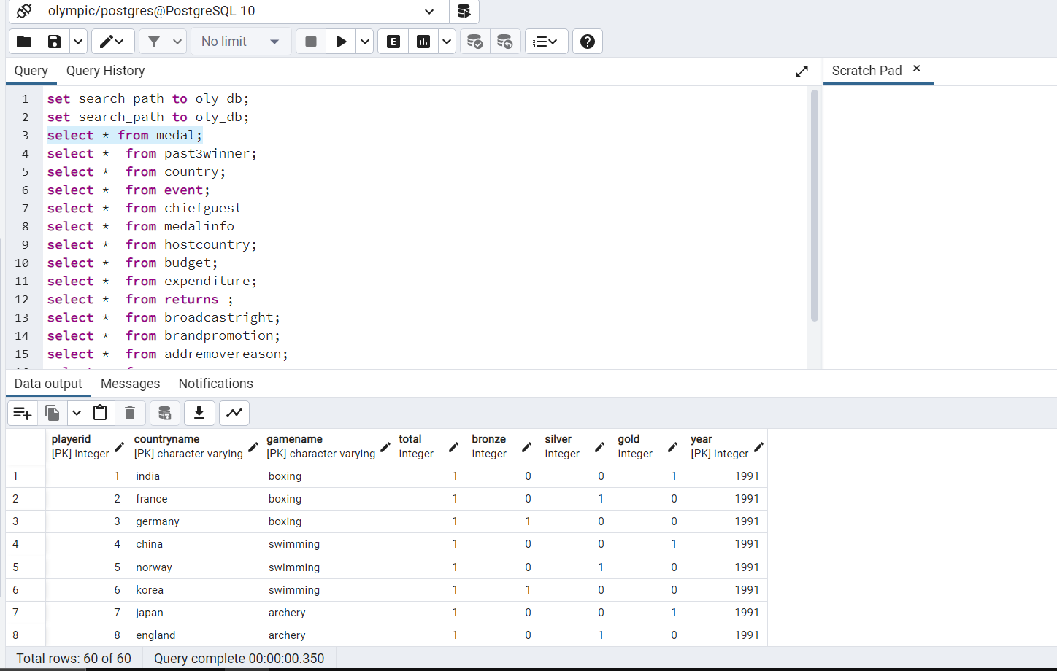

**Past 3 winner table** (game name, year, gold/silver/bronze winners id (winnerid is player id)

**set search_path to oly_db;**

**select * from past3winner;**

**Count of tuples : 42**

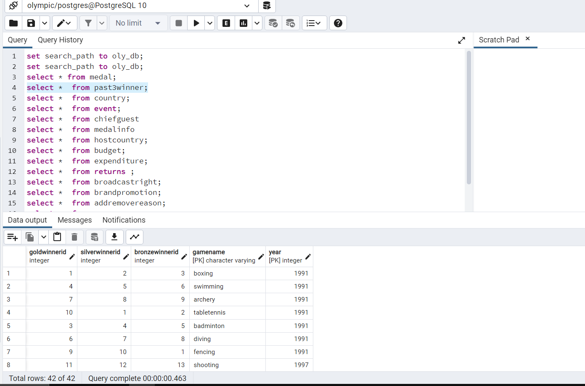

**Country table**

(country name,year)

**set search_path to oly_db;**

**select * from country;**

**Count of tuples : 45**

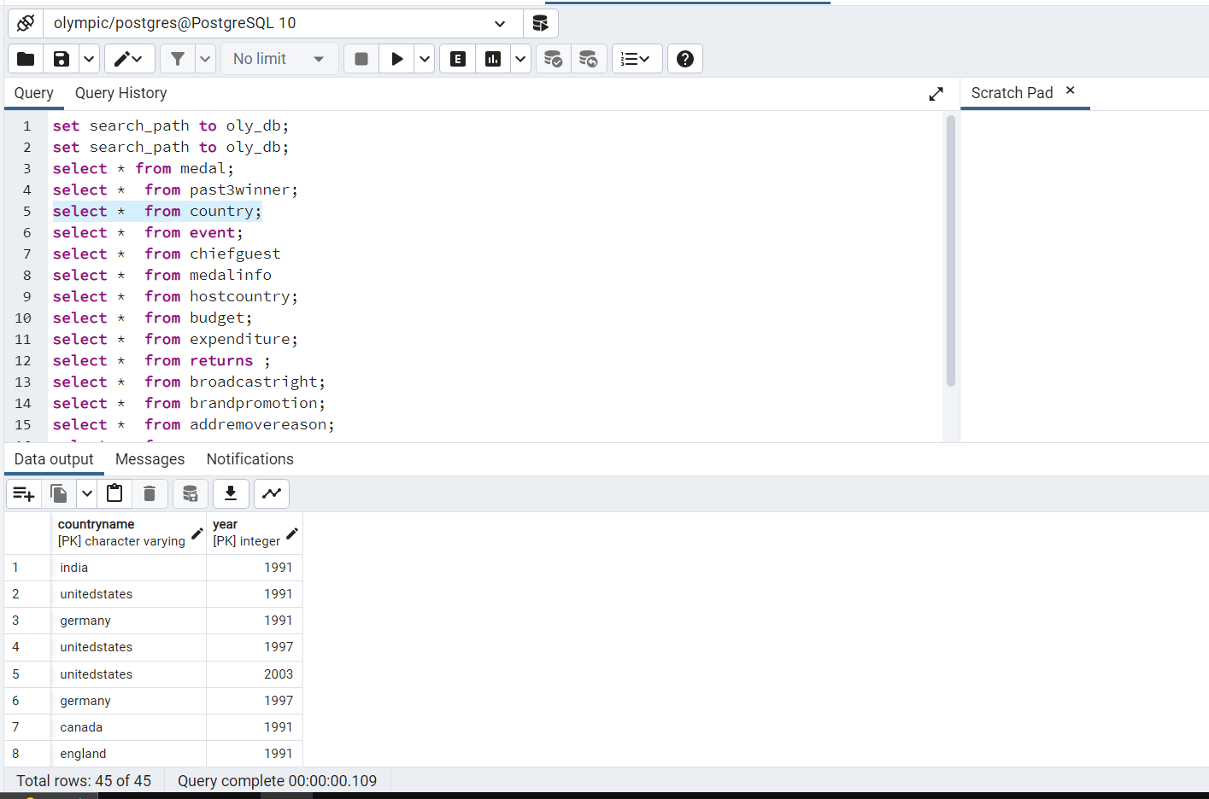

**Event table**(country name,year,opening time,opening date,closing time,closing date)

**set search_path to oly_db;**

**select * from event;**

**Count of tuples : 6**

**Reason : According to assumption, the srs olympics will be held after 6 years so I will have only 6 years when the olympics are held so I can have only 6 entries because this table is related to the host country .**

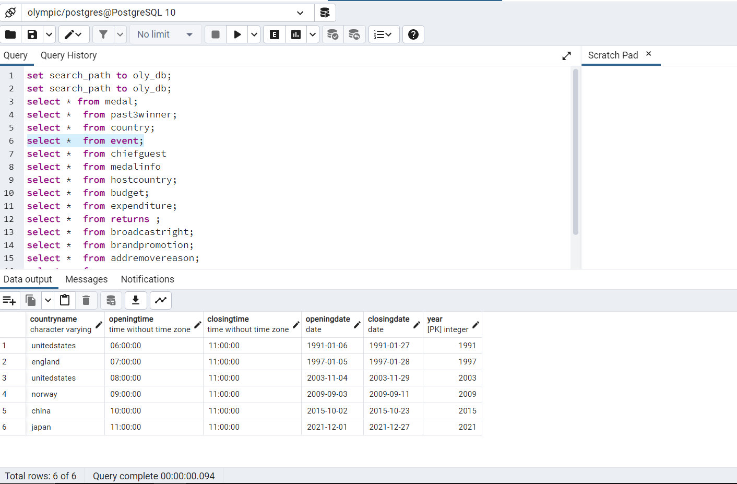

**Chiefguest table** (year,first name,last name,gender,country name)

**set search_path to oly_db;**

**select * from chiefguest;**

**Count of tuples : 6**

**Reason : According to assumption is srs olympic will be held after 6 years so i will have only 6 year when olympic held so i can have only 6 entries because this table is related to host country .**

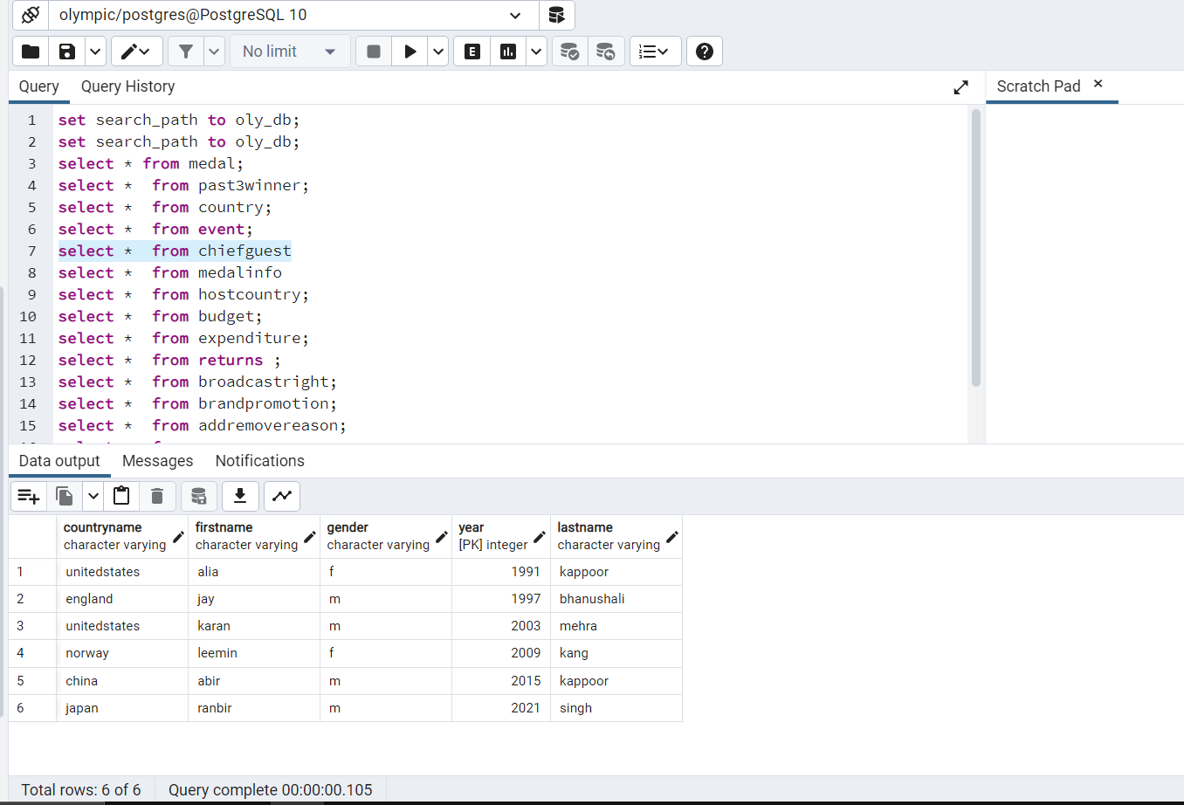

**Medal info table**(countryname,year,observrdesignername,reversedesignername,mint,thickness,weight,diameter)

**set search_path to oly_db;**

**select * from medalinfo;**

**Count of tuples : 6**

**Reason : According to assumption, the srs olympic will be held after 6 years so i will have only 6 year when olympic held so i can have only 6 entries because this table is related to host country .**

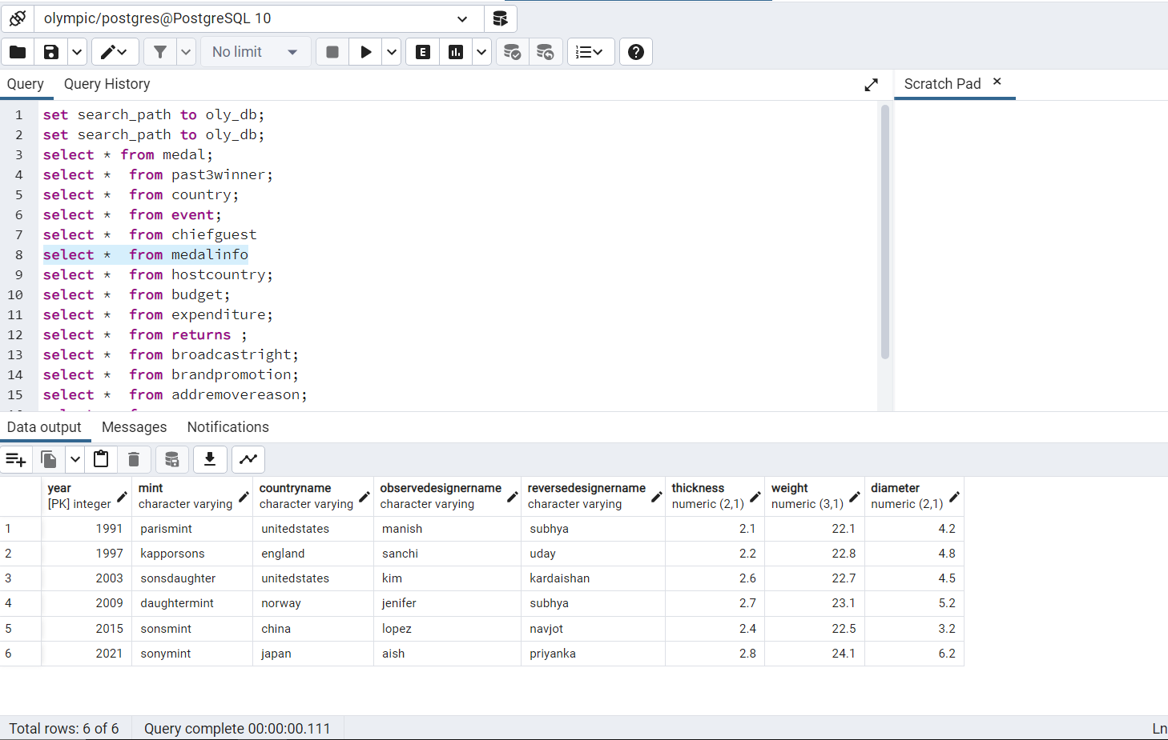

**Host country table** (year,host country name,state ,city)

**set search_path to oly_db;**

**select * from hostcountry;**

**Count of tuples : 6**

**Reason : According to assumption, the srs olympic will be held after 6 years so i will have only 6 year when olympic held so i can have only 6 entries**

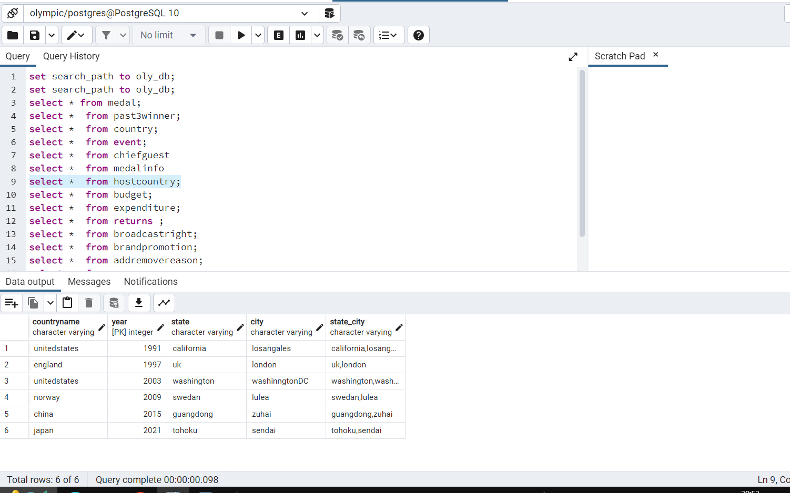

**Budget table** (year,country name,infrastructure,equipment ,sportevent ,training)

**set search_path to oly_db;**

**select * from budget;**

**Count of tuples : 6**

**Reason : According to assumption is srs olympic will be held after 6 years so i will have only 6 years when olympic held so i can have only 6 entries because this table is related to host country .**

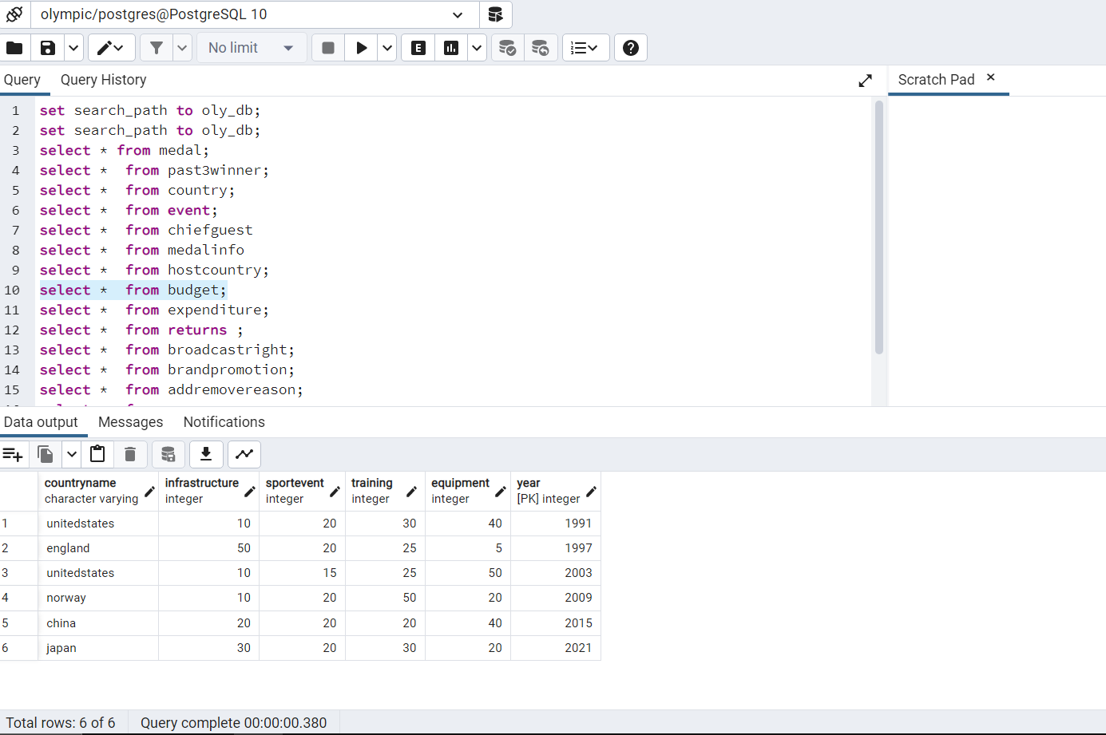

**Expenditure table**(year,countryname,cost,security ,services,medal cost,event organiser)

**set search_path to oly_db;**

**select * from expenditure;**

**Count of tuples : 6**

**Reason : According to assumption, the srs olympics will be held after 6 years so I will have only 6 years when the olympics are held so I can have only 6 entries because this table is related to the host country .**

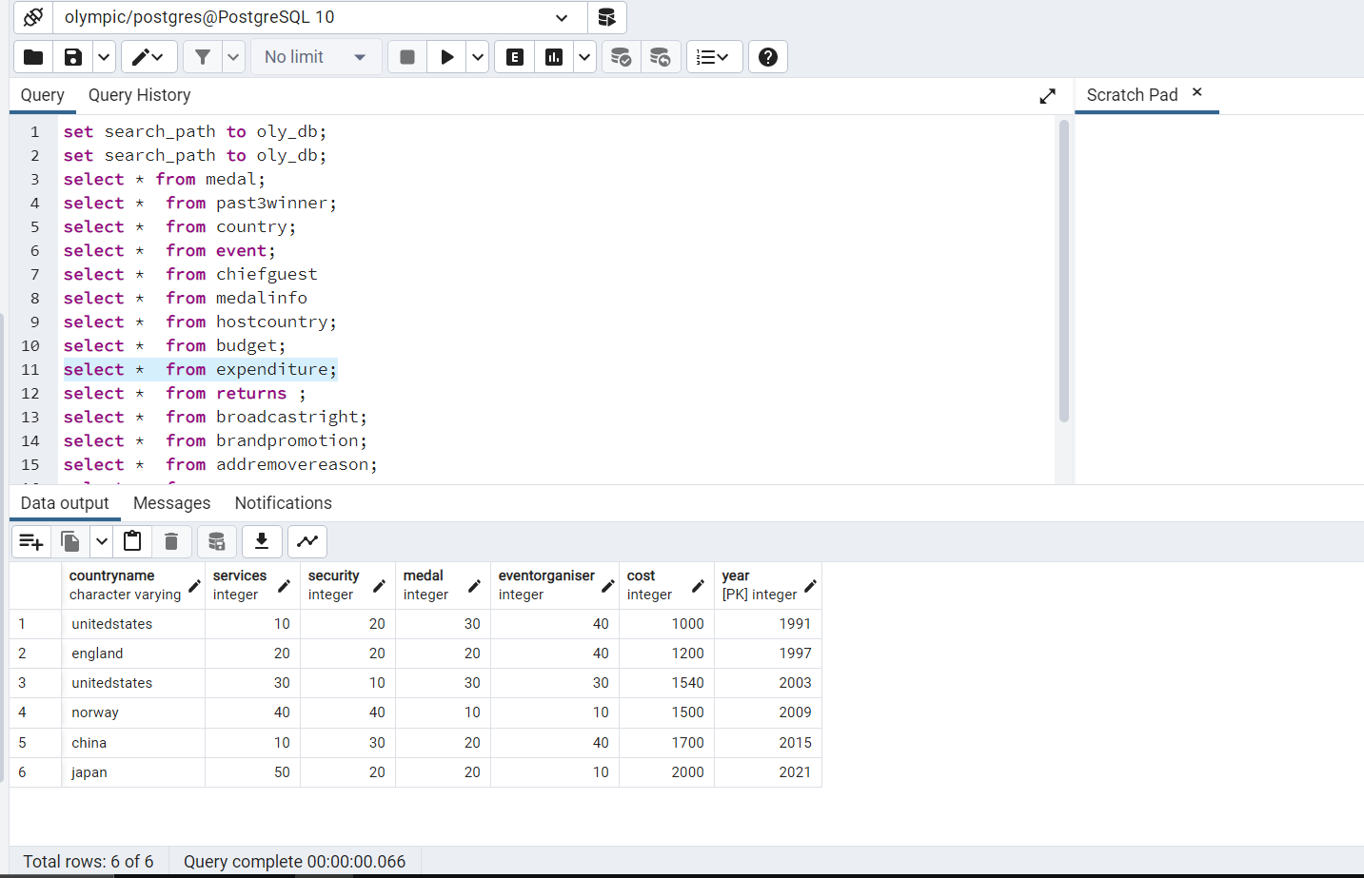

**Returns table**(year,country name,revenue,brand broadcast,ticket,product)

**set search_path to oly_db;**

**select * from returns ;**

**Count of tuples : 6**

**Reason : According to assumption, the srs olympics will be held after 6 years so I will have only 6 years when the olympics are held so I can have only 6 entries because this table is related to the host country .**

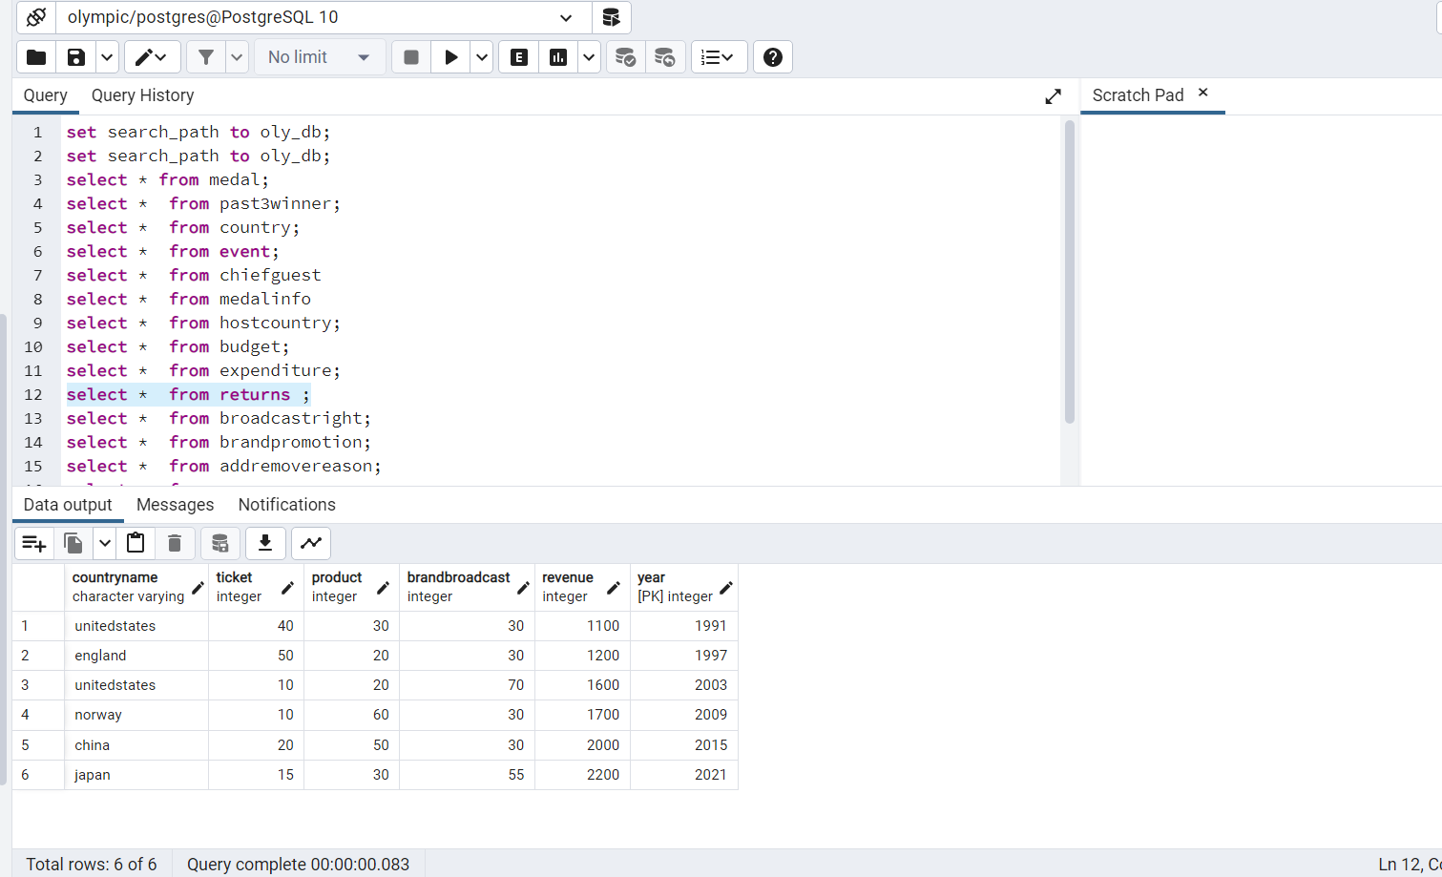

**Broadcast right table**(year,channel name,country name ,hours coverage)

**set search_path to oly_db;**

**select * from broadacstright;**

**Count of tuples : 40**

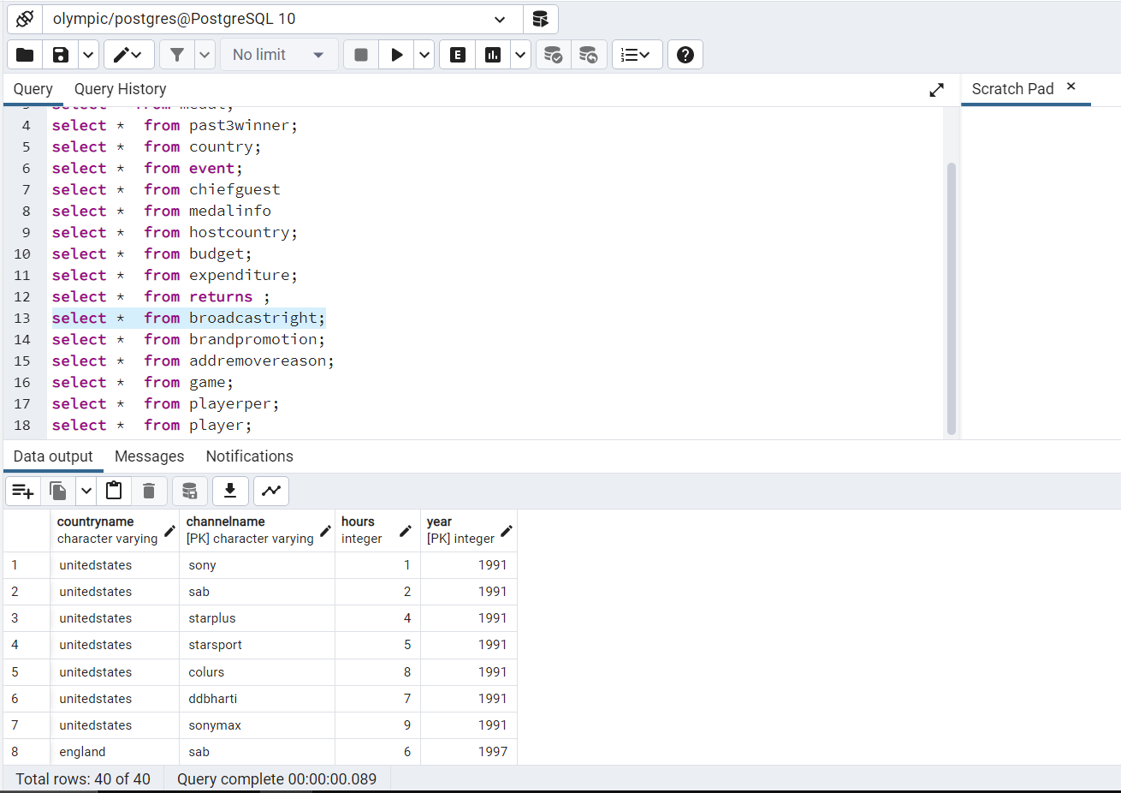

**Brand Promotion table**

(year,brand name,country name,brand company name)

**set search_path to oly_db;**

**select * from brandpromotion;**

**Count of tuples : 42**

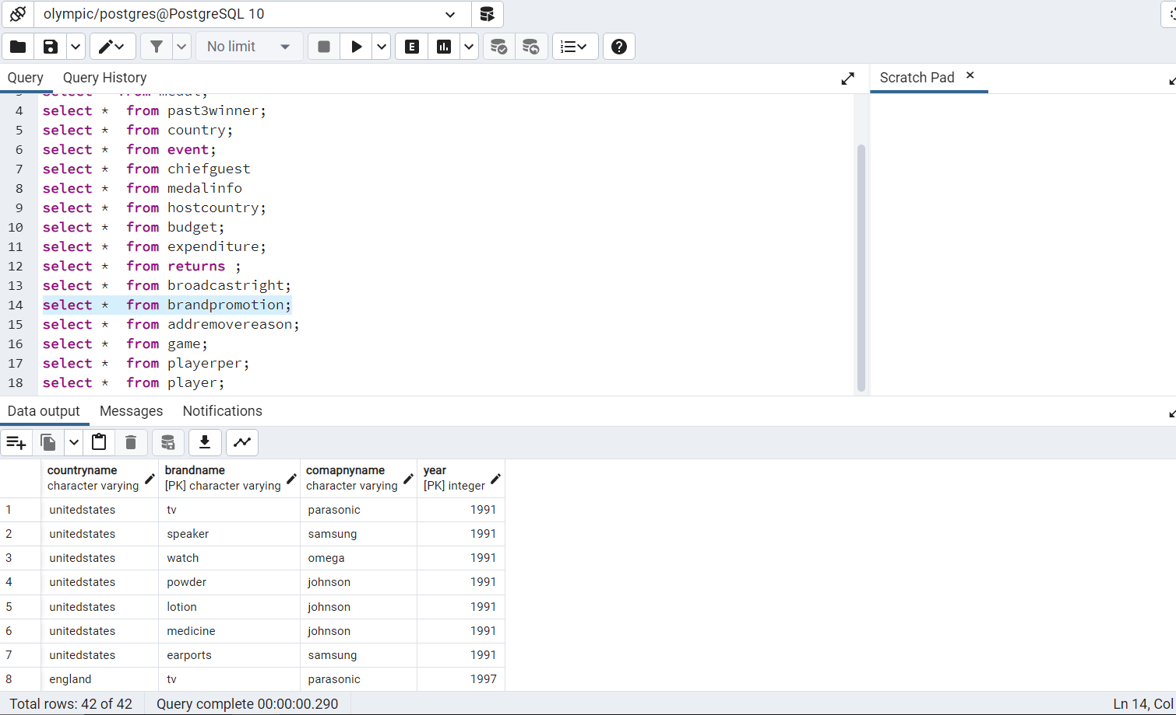

**Addremovereason table**

(playerid,year,reason,status)

**set search_path to oly_db;**

**select * from addremovereason;**

**Count of tuples : 42**

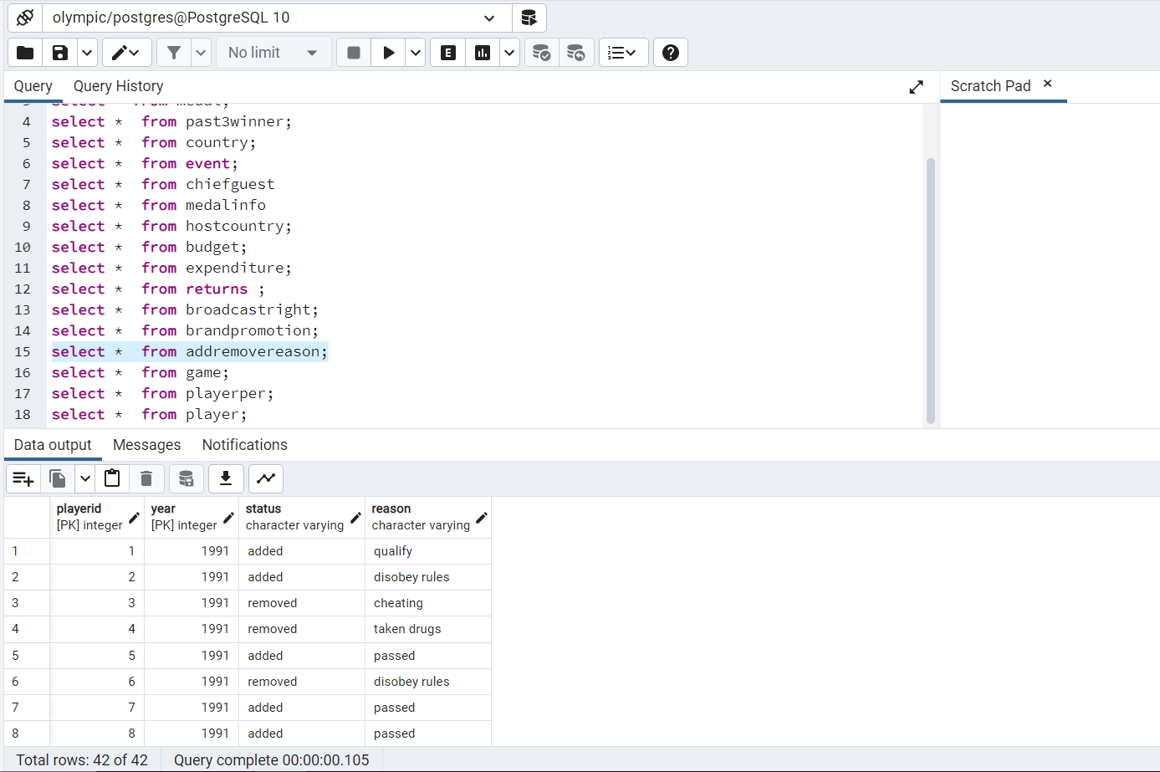

**Game table**(game name,year,years added,years removed)

**set search_path to oly_db;**

**select * from game;**

**Count of tuples : 42**

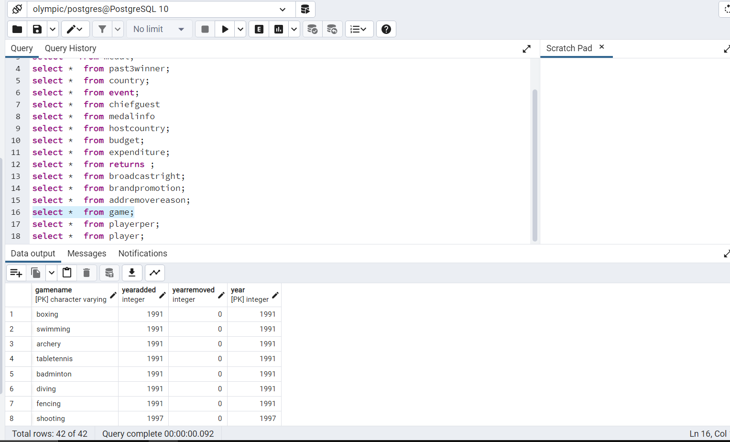

**Player per table**(playerid,gender,playername,height,weight)

**set search_path to oly_db;**

**select * from playerper;**

**Count of tuples : 60**

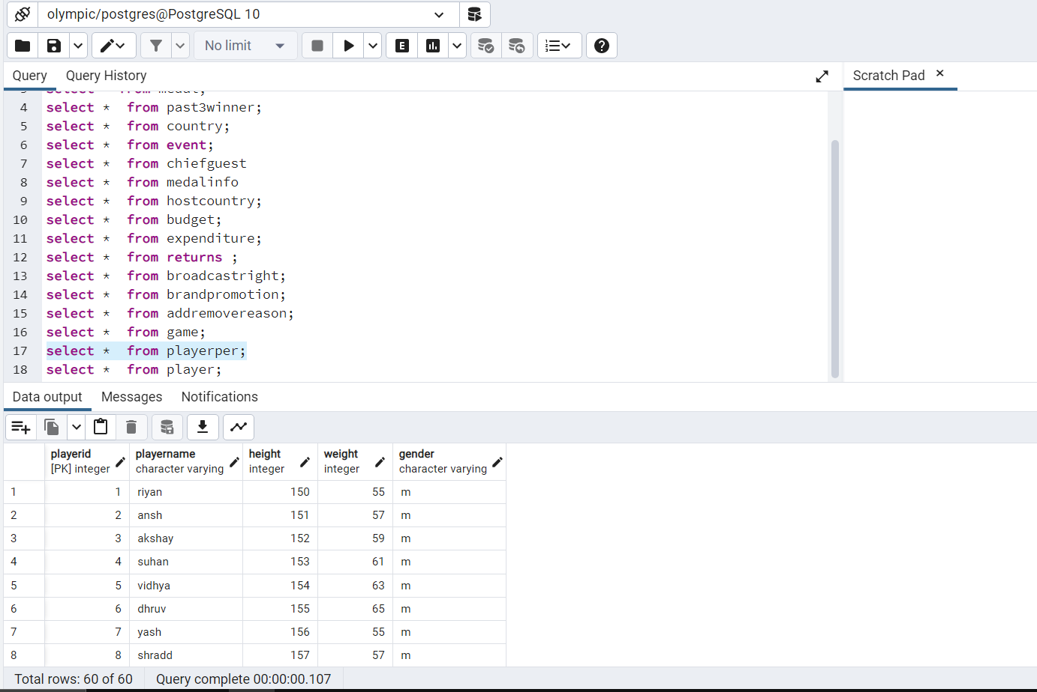

**Player table**(playerid,year,rank,since,date of birth)

**set search_path to oly_db;**

**select * from player;**

**County of tuples : 65**

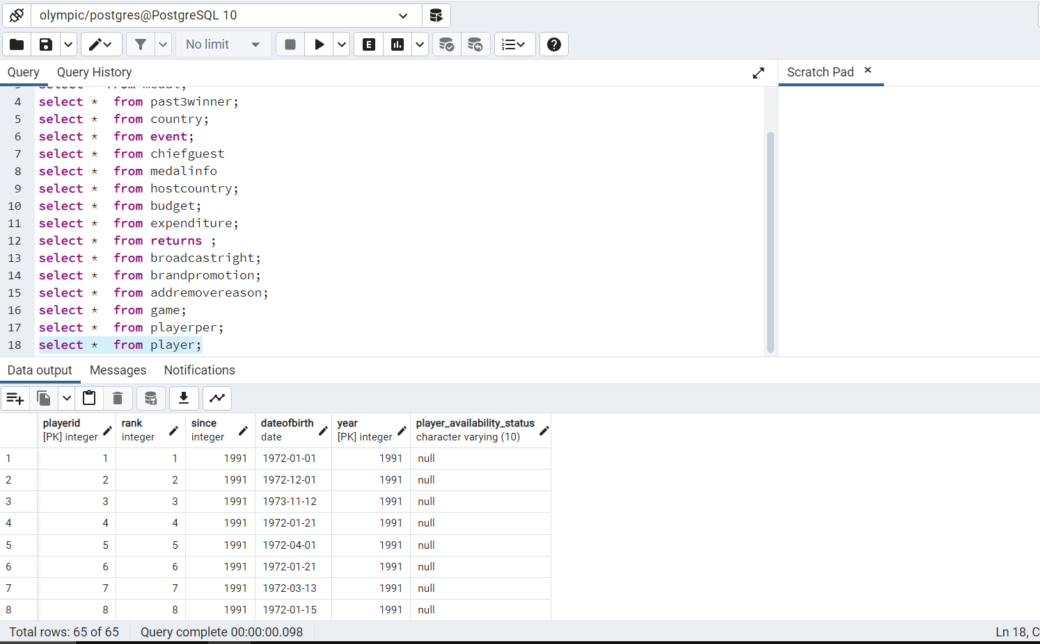

**select * from past3winner;**

**select * from country;**

**select * from event;**

**select * from chiefguest**

**select * from medalinfo**

**select * from hostcountry;**

**select * from budget;**

**select * from expenditure;**

**select * from returns ;**

**select * from broadcastright;**

**select * from brandpromotion;**

**select * from addremovereason;**

**select * from game;**

**select * from playerper;**

**select * from player;**

**6. Snapshots of Queries**

**1.Display the year added when it is greater than 1991 and year removed when it is less than 2003 in ascending order of year removed**

select yearadded,yearremoved

from "game"

where yearadded >=1991 and yearremoved <=2003

order by yearremoved;

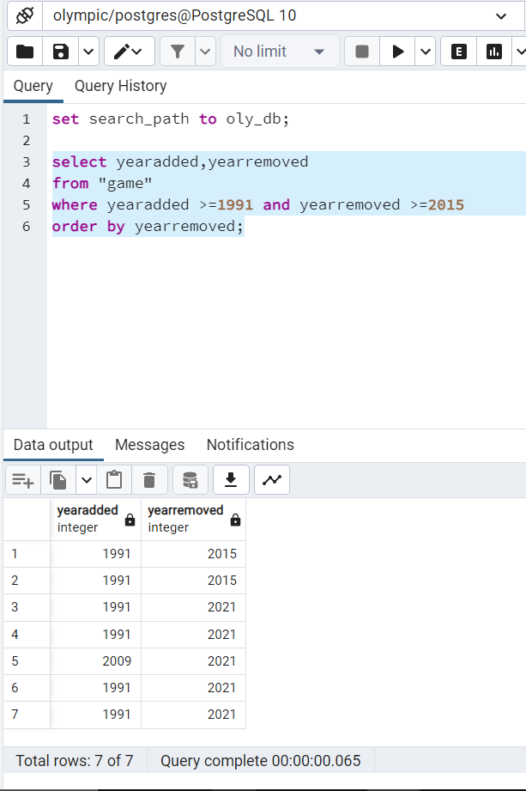

**2.Display rank player id and player name of player where player ‘s id = 46**

select p1.rank,p1.playerid,p2.playername

from"player" p1 join "playerper" p2 on p1.playerid = p2.playerid

where p1.playerid =46;

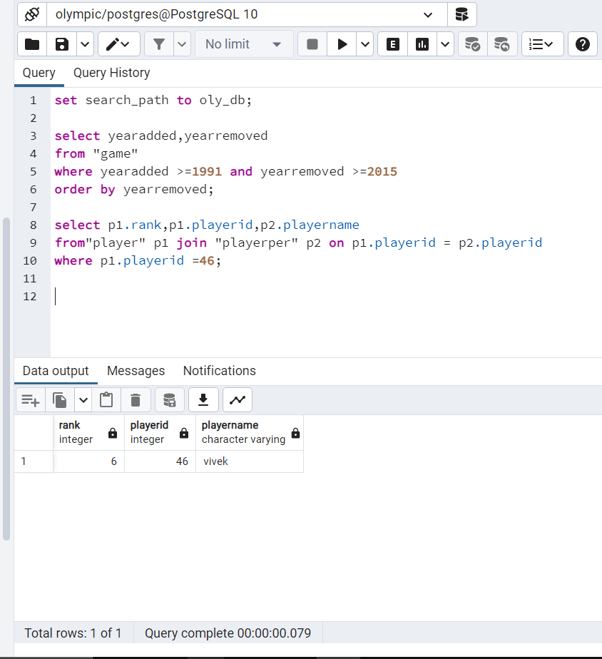

**3.Display the player id,game name,player name of player where she is female and participated in 1997 year**

select p2.playerid,p2.gamename,p1.playername,p1.gender

from "playerper" p1 join "medal" p2 on p1.playerid= p2.playerid

where p1.gender = 'f' and year=1997;

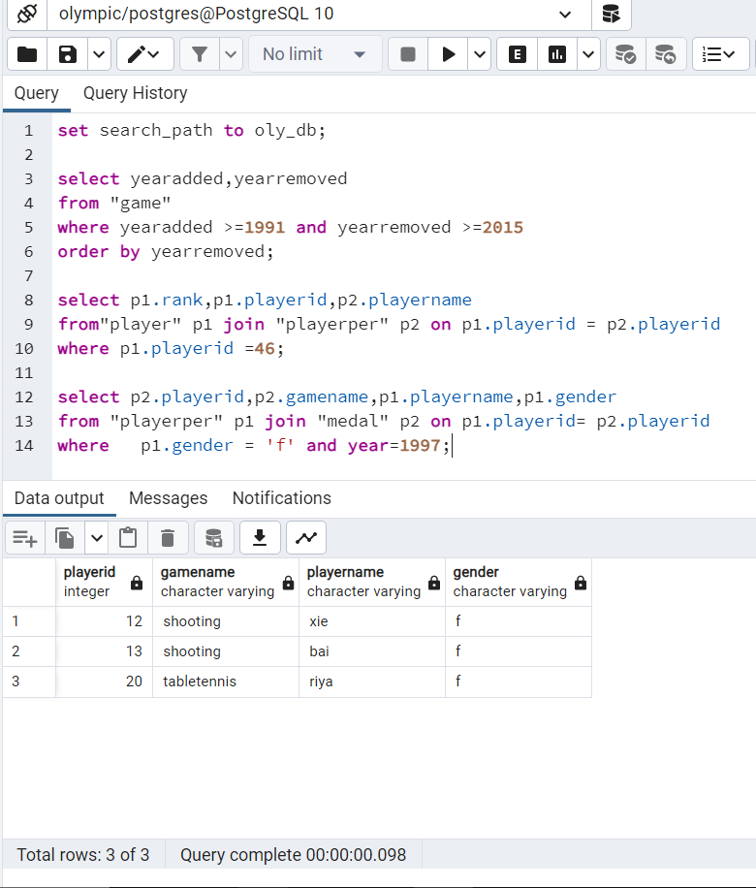

**4.How many female and male chiefguest attend the olympic throughout all years (having only two parts female or male)**

select count(firstname),gender from "chiefguest"

group by gender limit 2;

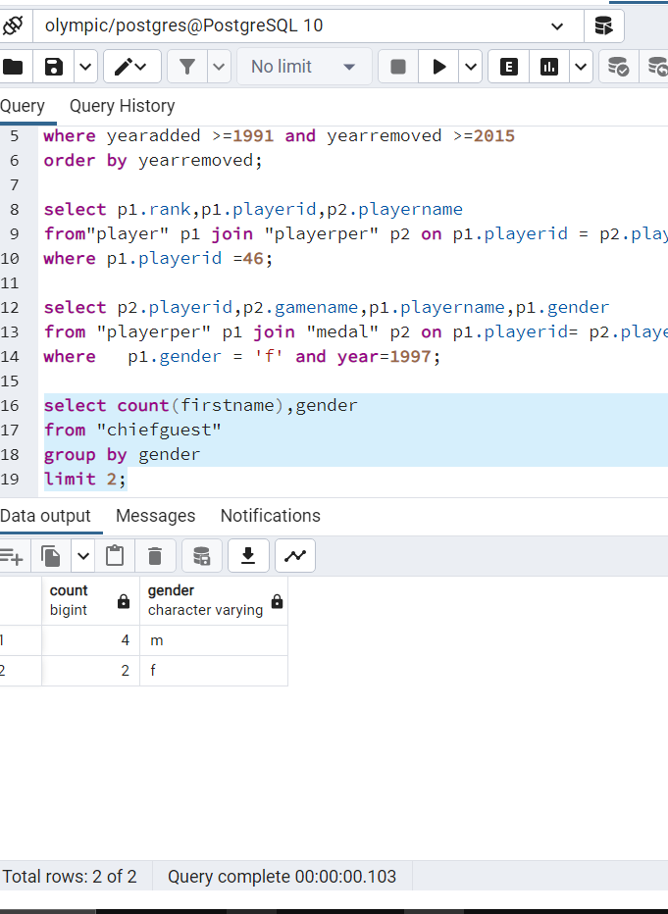

**5.who was host country of 1997 display the game name of that country has participated in how many games throughout years.**

select m1.gamename

from "hostcountry" h1 join "medal" m1 on h1.countryname=m1.countryname

where h1.year=1997;

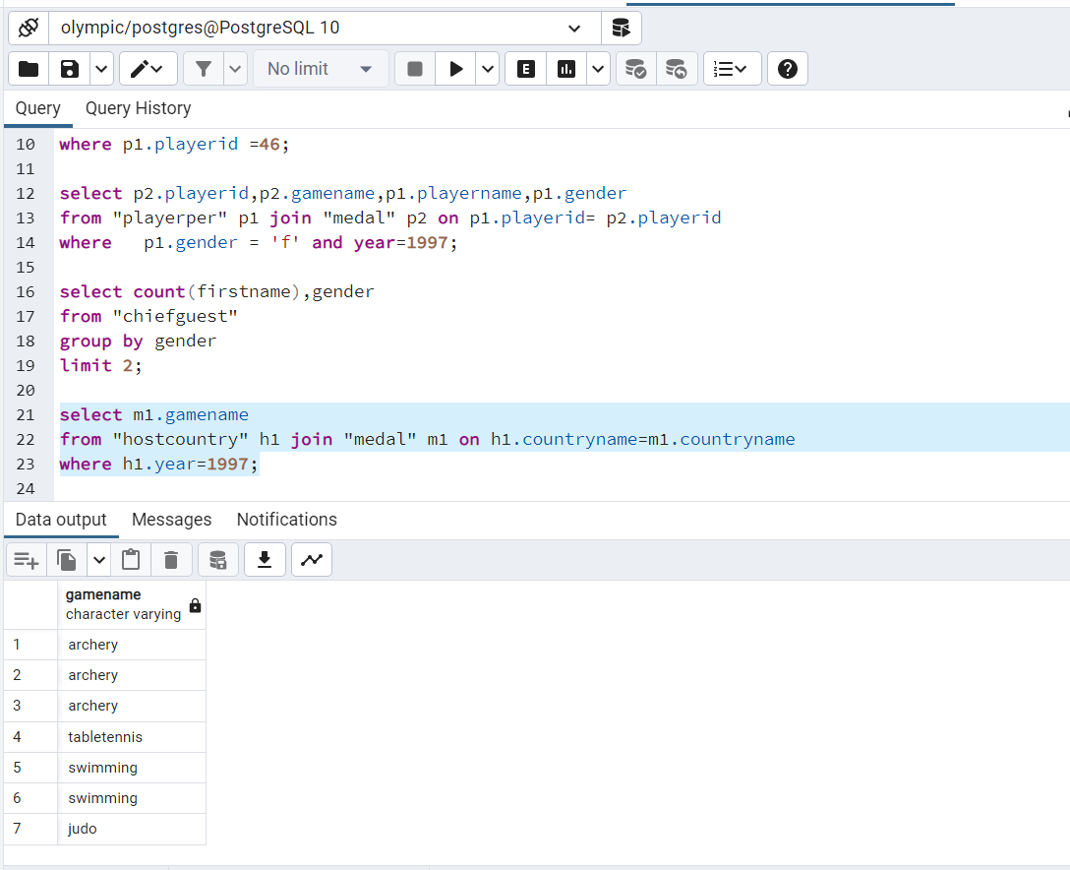

**6.Display the unique reason for getting add or remove in context of player**

select distinct reason from "addremovereason";

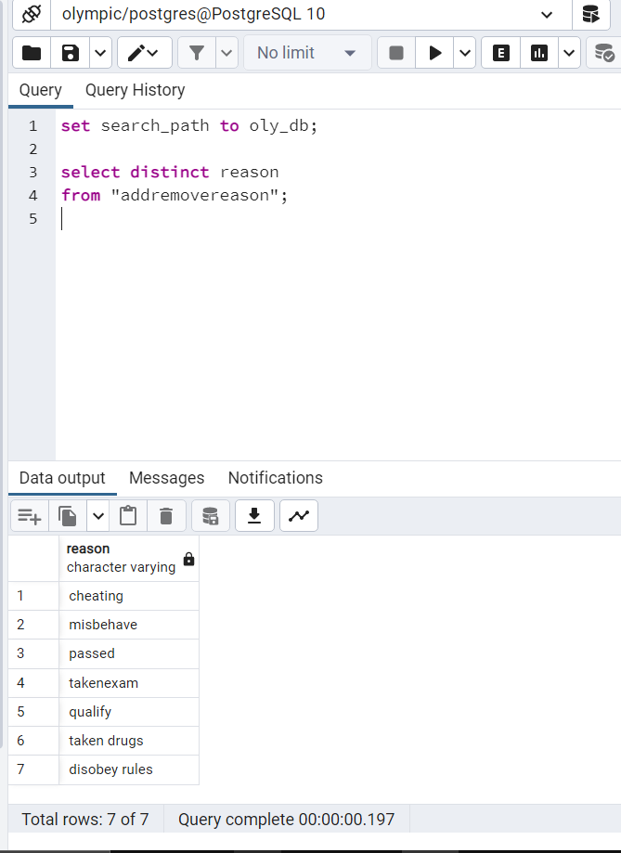

**7.Display how many medals one by every country throught all years**

select count(total), countryname,year from "medal" group by countryname,year order by year ;

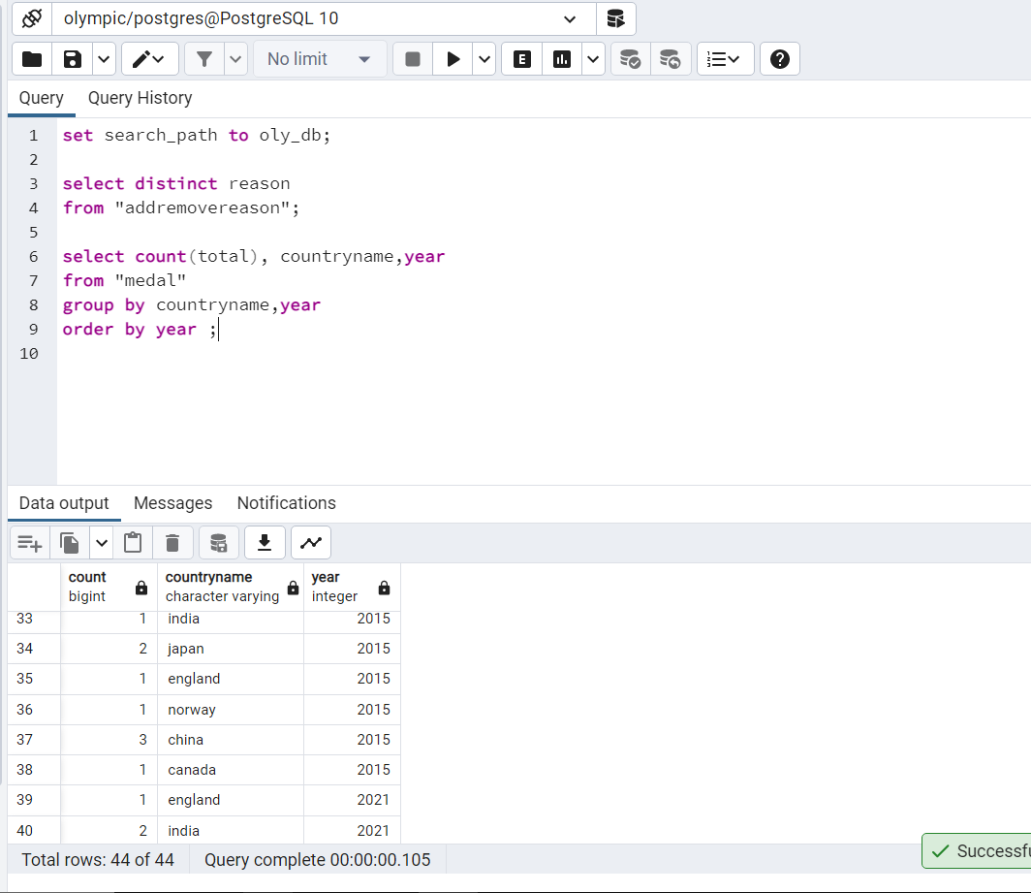

**8.Display the game name and year when gold winner id is maximum**

select goldwinnerid,gamename,year

from past3winner

where goldwinnerid = (select max(goldwinnerid) from past3winner)

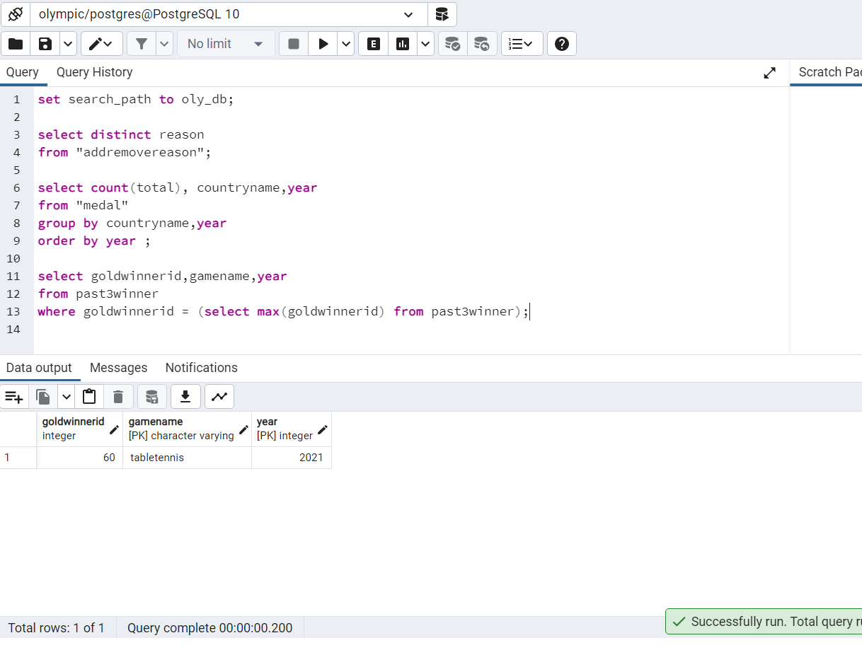

**9.Display the gold winner id of player of past 3 years like 1991,1997,2003 when game name is archery**

select goldwinnerid,year

from past3winner

where (gamename = 'archery' and year = 1991 )or (gamename = 'archery' and year= 1997) or (gamename = 'archery' and year= 2003);

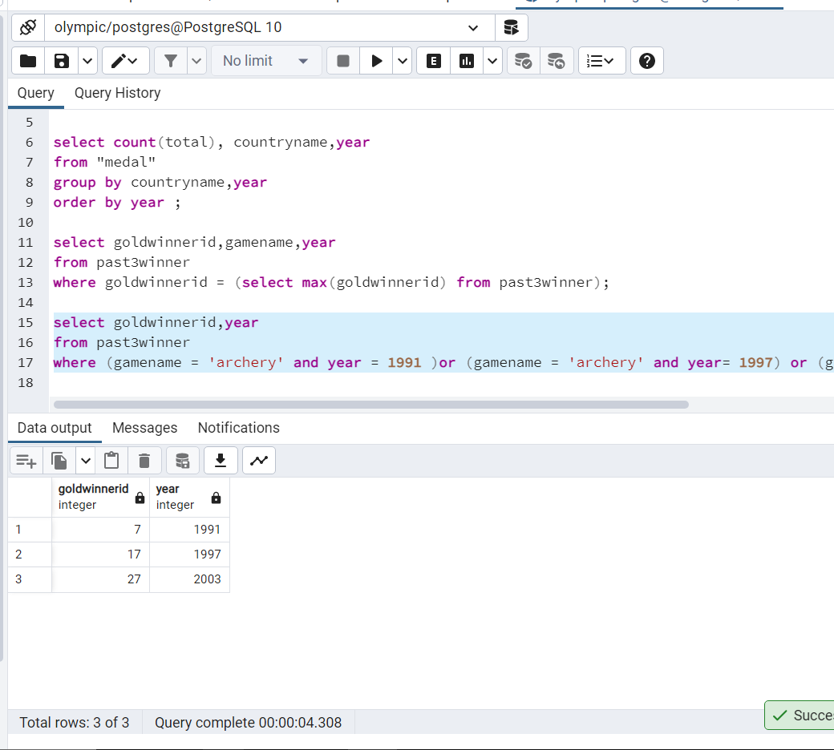

**10.Display the state and city of host country when year is 1997**

select state,city

from "hostcountry"

where year= 1997;

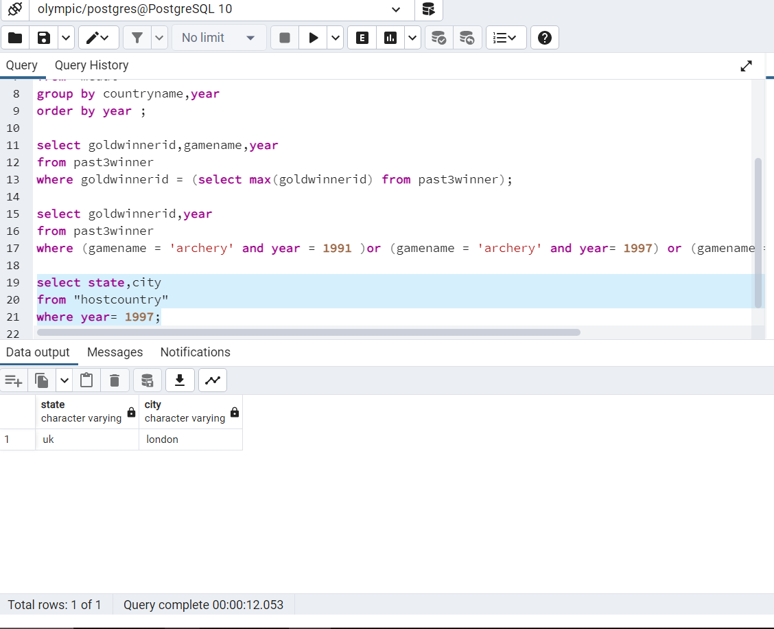

**11.Create a new column, state_city, in hostcountry table. Call the function to create the tuples with the format “state , city”. Display the updated table.**

CREATE OR REPLACE FUNCTION oly_db.fun2(

)

RETURNS void

LANGUAGE 'plpgsql'

COST 100

VOLATILE PARALLEL UNSAFE

AS $BODY$

declare tmp_rcd record;

begin

alter table "hostcountry" add column state_city character varying;

for tmp_rcd in (select h1.state,h1.city from "hostcountry" h1)

loop

update "hostcountry" h1 set state_city = concat(h1.state,',',h1.city);

end loop ;

end

$BODY$;

ALTER FUNCTION oly_db.fun2()

OWNER TO postgres;

Select * from “hostcountry”;

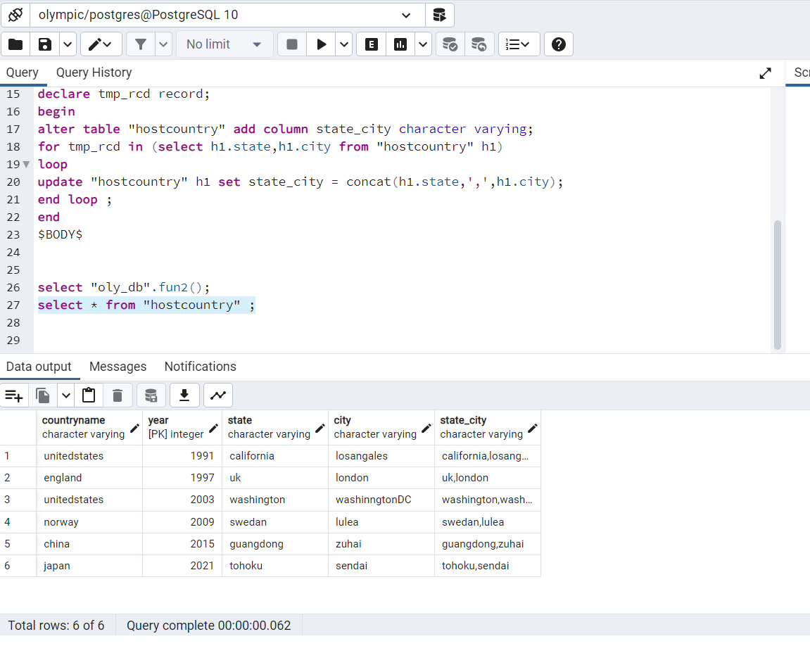

**12.Create a column ‘player_availability_status’ in player table. Create a trigger to put default value as ‘no’ for every new entry if nothing is given by user or given no by user only yes will be given yes . Insert new record and check the functionality of trigger.**

alter table "player" drop column if exists player_availability_status;

alter table "player" add column player_availability_status character varying(10) default 'null';

-- FUNCTION: oly_db.player_availability()

-- DROP FUNCTION IF EXISTS oly_db.player_availability();

CREATE OR REPLACE FUNCTION oly_db.player_availability()

RETURNS trigger

LANGUAGE 'plpgsql'

COST 100

VOLATILE NOT LEAKPROOF

AS $BODY$

begin

if(new.player_availability_status='null' or'no')then

new.player_availability_status='no';

end if;

return new;

end;

$BODY$;

ALTER FUNCTION oly_db.player_availability()

OWNER TO postgres;

insert into player(playerid,rank,since,dateofbirth,year) values

(63,1,1991,'1972-1-1',2021);

insert into player values

(62,1,2021,'1972-1-1',2021,'no');

insert into player values

(61,1,2021,'1972-1-1',2021,'yes');

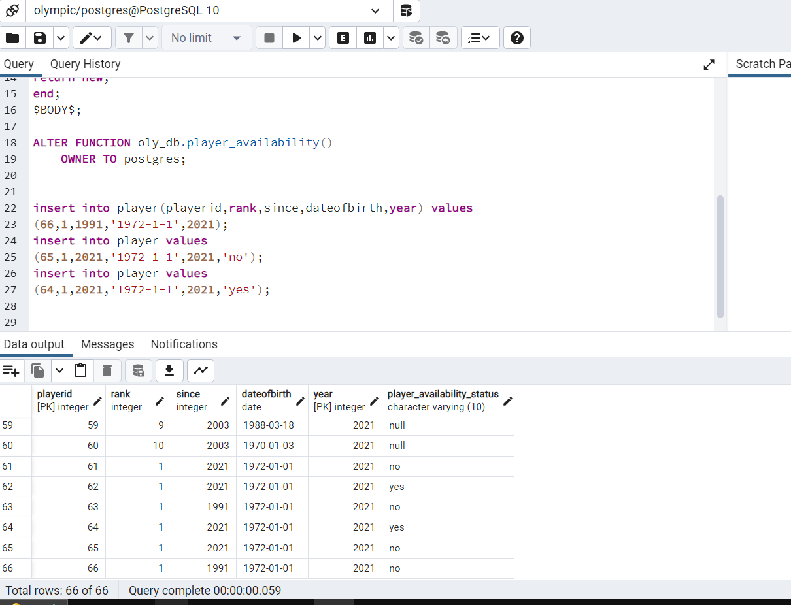

**13.Create a view who shows country name, playername,game name per year**

CREATE OR REPLACE VIEW detailedview_new as

select m1.playerid,countryname,gamename,playername,year

from "medal" m1 join "playerper" p1 on m1.playerid=p1.playerid;

select * from detailedview_new ;

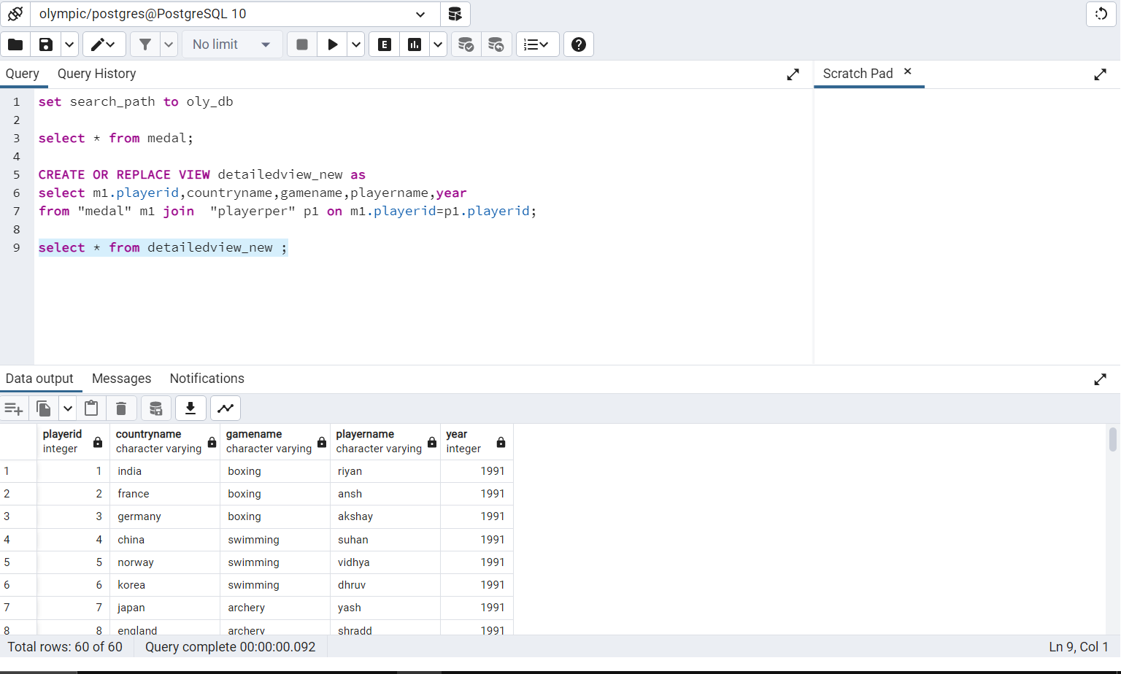

**14.creale view who shows profit how much profit won by host country**

CREATE OR REPLACE VIEW eventdi4_new as

select cost ,revenue,revenue-cost as profit

from "expenditure" m1 join "returns" p1 on m1.year=p1.year;

select * from eventdi4_new

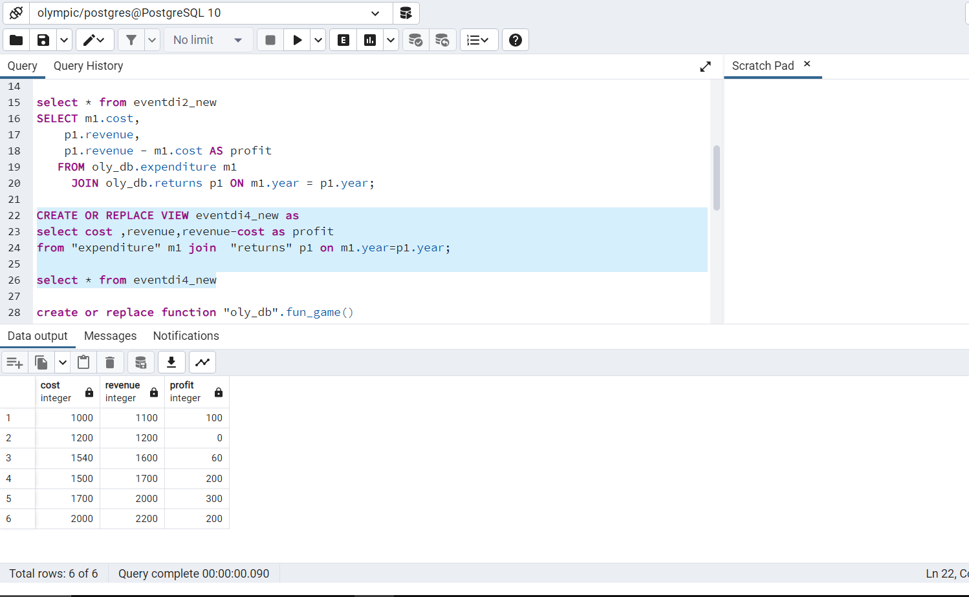

**15.shows brand name when he was promoted by host countries exactly 5 times**

select count(brandname),brandname

from "brandpromotion" b1

group by brandname

having count(brandname)=5;

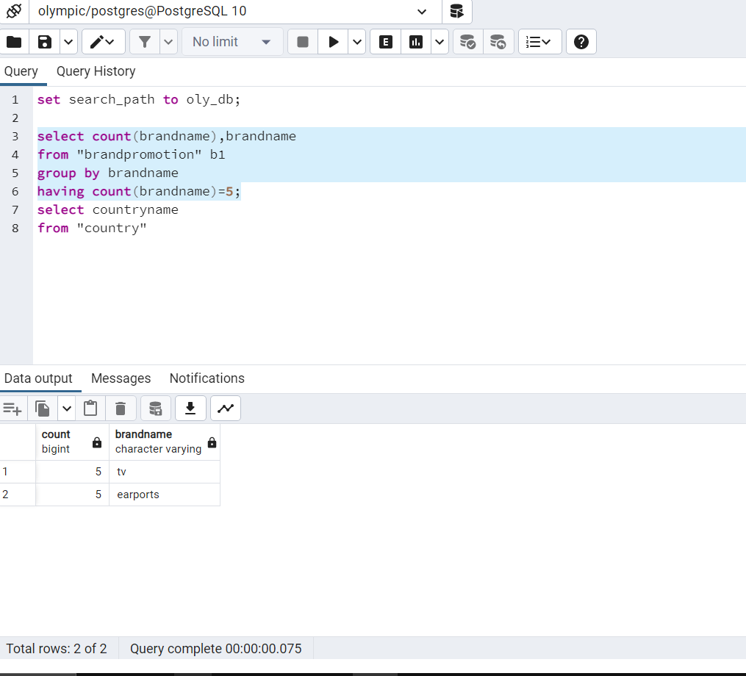

**16.shows diameter and thickness of medal if its respectively greater then minimum diameter and less than maximum thickness**

select year,diameter,thickness

from medalinfo

where (diameter>(select min(diameter) from medalinfo) and thickness<(select max(thickness) from medalinfo));

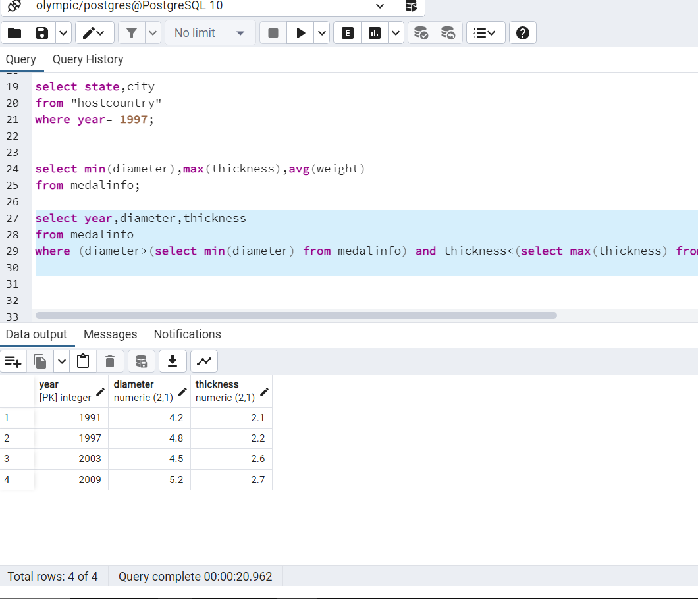

**17.shows minimum diameter maximum thickness and average weight of medal**

select min(diameter),max(thickness),avg(weight)

from medalinfo;

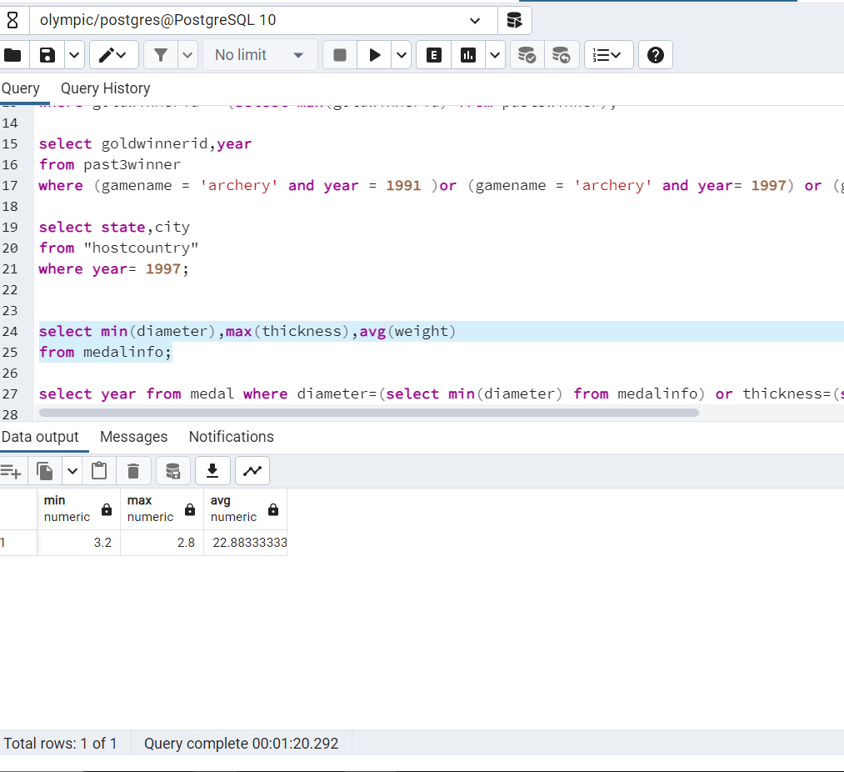

**18.display channel name if start with s throughout years**

select channelname

from "broadcastright"

where channelname like's%';

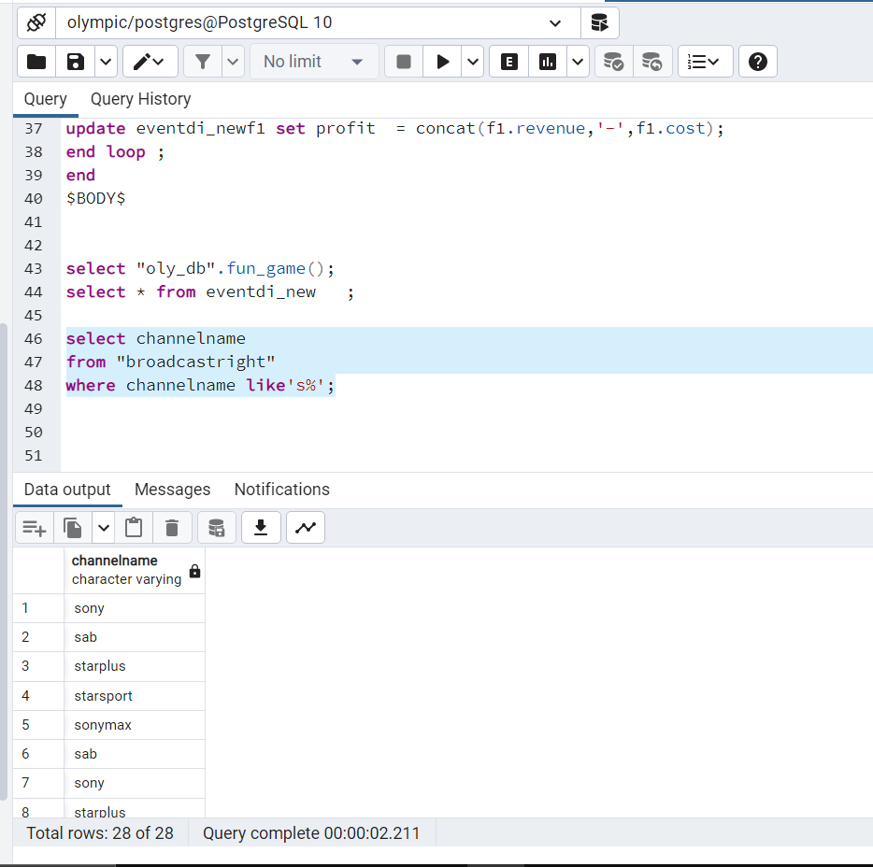

**19.Display the year if country is host country and infrastructure is maximum for that host country**

SELECT year

from "hostcountry" f1

where f1."year" in

(select t1."year" from "budget" t1

WHERE infrastructure = (select max(infrastructure) from "budget"));

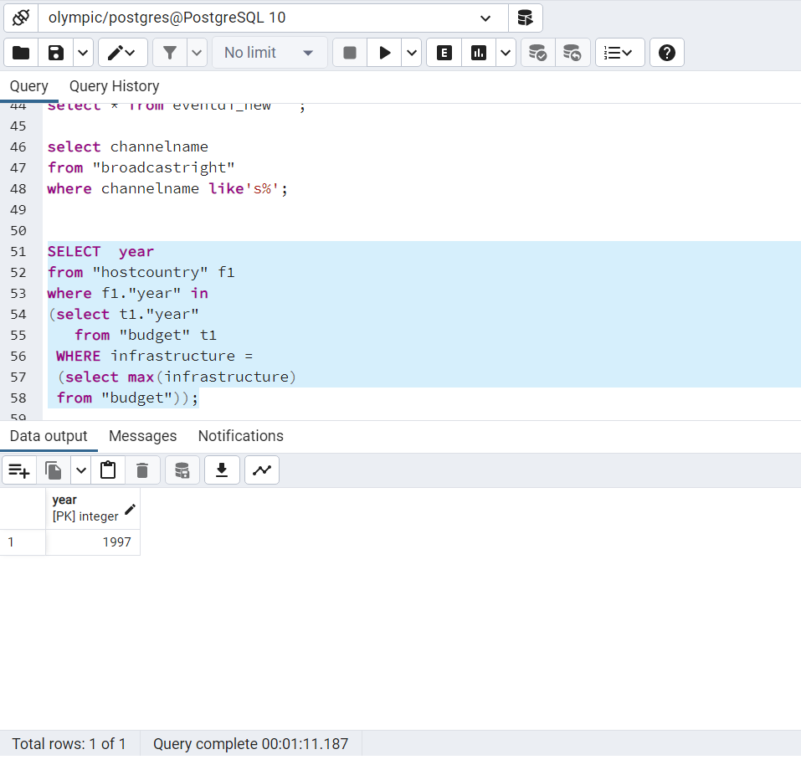

**20.Display How many games played in year 2003 by which host country ,opening ceremony time**

Select e1.countryname,g1.gamename,e1.openingtime,e1.year

from "event" e1 join "game" g1 on e1.year=g1.year

where e1.year= '2003';

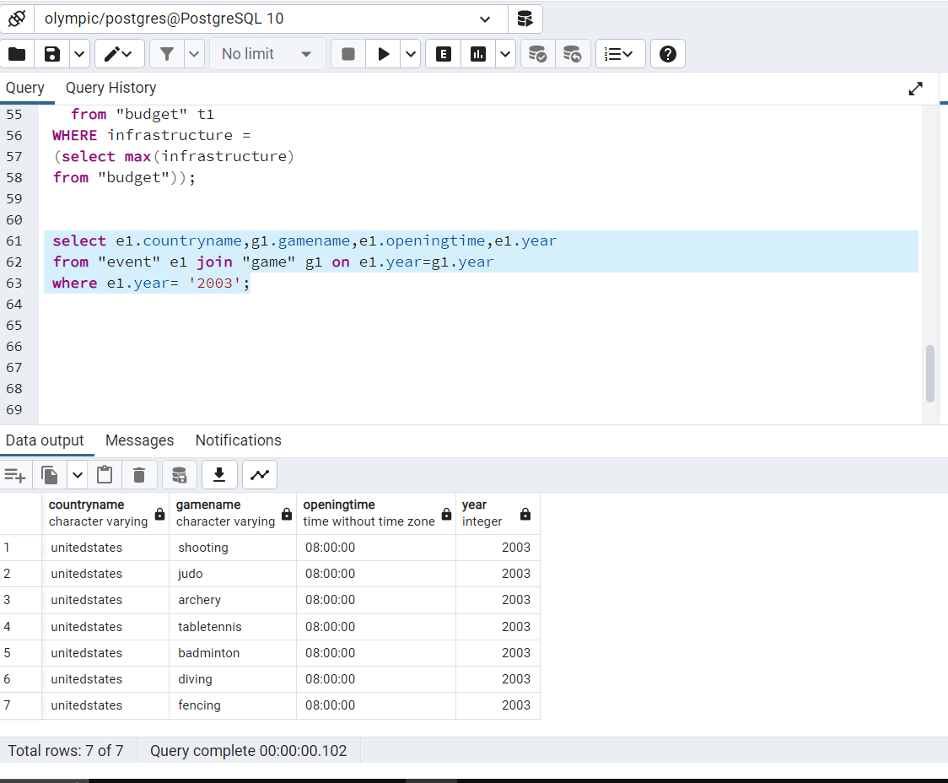

**7.Front end related and back end related document**

**1)** Create a small demo interface for your project using any development language.

It can be anything like a webpage, mobile application, or output window of

Python, Java, .Net, or C code compiler.

**2)** Use JDBC/ODBC connection from your code to connect to your project database built

in PostgreSQL or any other DBMS of your choice.

**3)** Create 2-3 functions that should be able to do the following things

Insert data into any 1-2 tables

Execute queries of your choice of few chosen once on the database

Show results on your output window or app or webpage

**front end connection with backend**

i have used Fask and psycopg2 to connect database

**from flask import Flask, render_template, request, redirect, url_for**

**import psycopg2**

**import psycopg2.extras**

**# create application route**

**app = Flask(__name__)**

**# create database connection**

**conn = psycopg2.connect(**

**host="localhost",**

**database="olympicdata2",**

**user="postgres",**

**password="admin")**

**cur = conn.cursor()**

**if __name__ == '__main__':**

**app.run(debug=True)**

**created path route 1) game database to show game page**

**2) country database to show country page**

**3) insert game to show game page**

**4) insert country to show country page**

**5) delete country to show country page**

**6) edit game to show game page**

**7) delete game to show game page**

**code for function for fetching updating inserting deleting data**

**from flask import Flask, render_template, request, redirect, url_for**

**import psycopg2**

**import psycopg2.extras**

**# create application route**

**app = Flask(__name__)**

**# create database connection**

**conn = psycopg2.connect(**

**host="localhost",**

**database="olympicdata2",**

**user="postgres",**

**password="admin")**

**cur = conn.cursor()**

**@app.route('/')**

**def homepage():**

**return render_template('homepage.html')**

**# create a route**

**@app.route('/insertcountry')**

**def forms():**

**return render_template('insertcountry.html')**

**# add post method**

**@app.route('/insertcountry', methods=['POST'])**

**def showcountry_post():**

**countryname = request.form['countryname']**

**year = request.form['year']**

**print(countryname, year)**

**cur = conn.cursor(cursor_factory=psycopg2.extras.DictCursor)**

**cur.execute("INSERT INTO country (countryname, year) VALUES (%s, %s)", (countryname, year))**

**conn.commit()**

**return redirect(url_for('display'))**

**# display data from database**

**@app.route('/showcountry')**

**def display():**

**cur = conn.cursor()**

**cur.execute("SELECT * FROM country")**

**rows = cur.fetchall()**

**return (render_template('showcountry.html', rows=rows))**

**# add post method**

**@app.route('/deletecountry', methods=['POST','GET'])**

**def deletecountry_post():**

**if request.method == 'GET':**

**return(render_template('deletecountry.html'))**

**else:**

**countryname = request.form['countryname']**

**year = request.form['year']**

**print(countryname, year)**

**cur = conn.cursor()**

**cur.execute("delete from country where countryname = %s and year = %s ", (countryname,year))**

**# database specific query**

**conn.commit()**

**return redirect(url_for('display'))**

**@app.route('/insertgame')**

**def forms_fun():**

**return render_template('insertgame.html')**

**# add post method**

**@app.route('/insertgame', methods=['POST'])**

**def showgame_post():**

**gamename = request.form['gamename']**

**yearadded = request.form['yearadded']**

**yearremoved = request.form['yearremoved']**

**year = request.form['year']**

**print(gamename, yearadded,yearremoved,year)**

**cur = conn.cursor()**

**cur.execute("INSERT INTO game (gamename, yearadded,yearremoved,year) VALUES (%s, %s , %s, %s)", (gamename, yearadded,yearremoved,year))**

**# database specific query**

**conn.commit()**

**return redirect(url_for('displaygame'))**

**# display data from database**

**@app.route('/showgame')**

**def displaygame():**

**cur = conn.cursor()**

**cur.execute("SELECT * FROM game")**

**rows = cur.fetchall()**

**return (render_template('showgame.html', rows=rows))**

**# add post method**

**@app.route('/editgame', methods=['POST','GET'])**

**def editgame_post():**

**if request.method == 'GET':**

**return(render_template('editgame.html'))**

**else:**

**gamename = request.form['gamename']**

**yearadded = request.form['yearadded']**

**yearremoved = request.form['yearremoved']**

**year = request.form['year']**

**print(gamename, yearadded,yearremoved,year)**

**cur = conn.cursor()**

**cur.execute("update game set yearadded = %s ,yearremoved = %s where gamename = %s and year = %s ", (yearadded,yearremoved,gamename,year))**

**# database specific query**

**conn.commit()**

**return redirect(url_for('displaygame'))**

**@app.route('/deletegame', methods=['POST','GET'])**

**def deletegame_post():**

**if request.method == 'GET':**

**return(render_template('deletegame.html'))**

**else:**

**gamename = request.form['gamename']**

**yearadded = request.form['yearadded']**

**yearremoved = request.form['yearremoved']**

**year = request.form['year']**

**print(gamename, yearadded,yearremoved,year)**

**cur = conn.cursor()**

**cur.execute("delete from game where gamename = %s and yearadded =%s and yearremoved =%s and year=%s", (gamename,yearadded,yearremoved,year))**

**# database specific query**

**conn.commit()**

**return redirect(url_for('displaygame'))**

**@app.route('/runquerygame')**

**def runquerygame_post():**

**cur = conn.cursor()**

**cur.execute("select gamename ,yearadded ,yearremoved ,year from game where year = 1991 ")**

**# database specific query**

**rows = cur.fetchall()**

**return (render_template('runquerygame.html', rows=rows))**

**@app.route('/runquerycountry')**

**def runquerycountry_post():**

**cur = conn.cursor()**

**cur.execute("SELECT countryname , year from country order by year")**

**# database specific query**

**rows = cur.fetchall()**

**return (render_template('runquerycountry.html', rows=rows))**

**# run the application**

**if __name__ == '__main__':**

**app.run(debug=True)**

**screen shots of olympic web app**

**homepage**

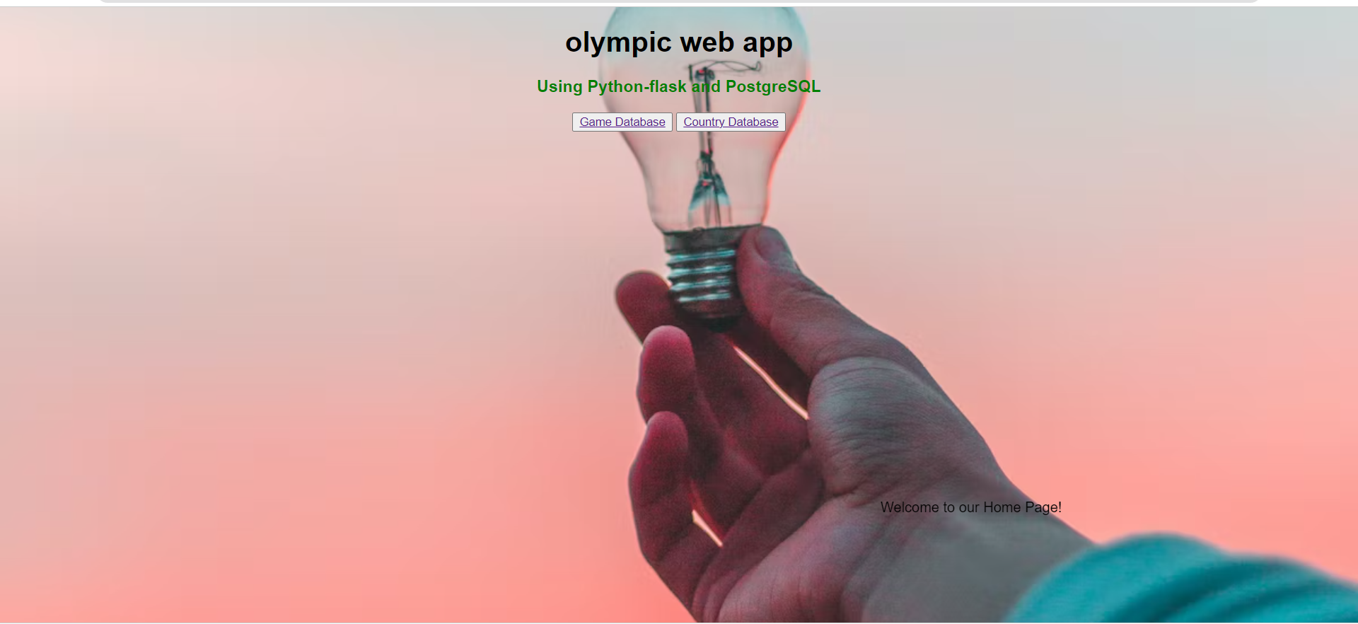

**country database**

**show country data**

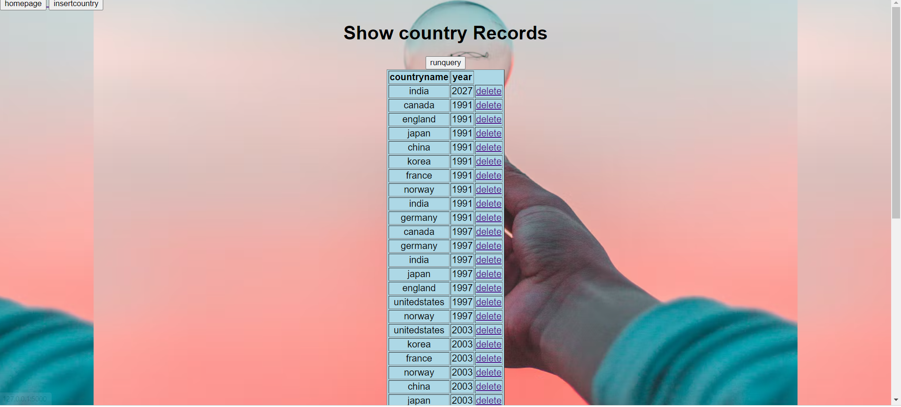

**Insert data in country**

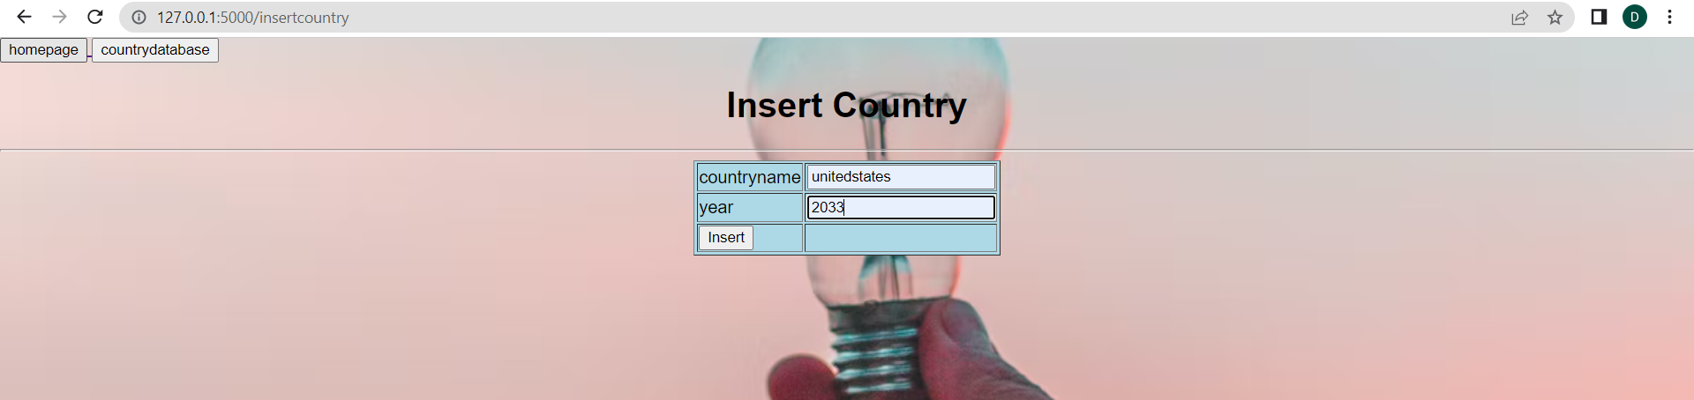

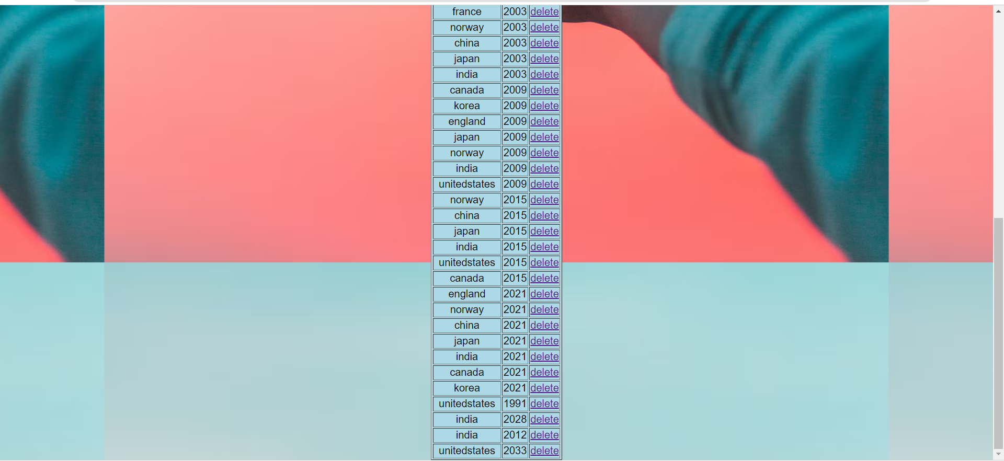

**as you can see data is inserted (‘united states’,2033)**

**delete country**

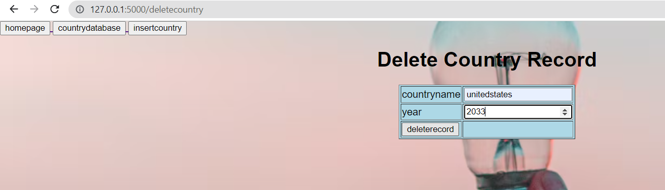

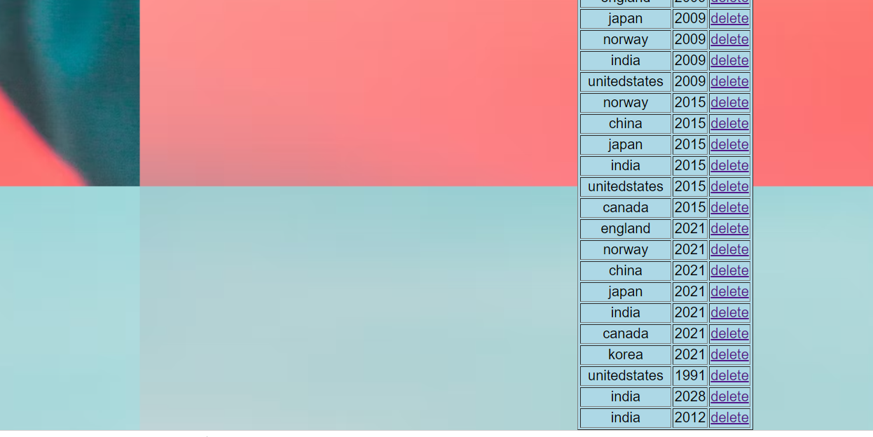

**as you can see (united states,2033) is deleted from database**

**query for country (show * from country order by year) sorting by year in country table**

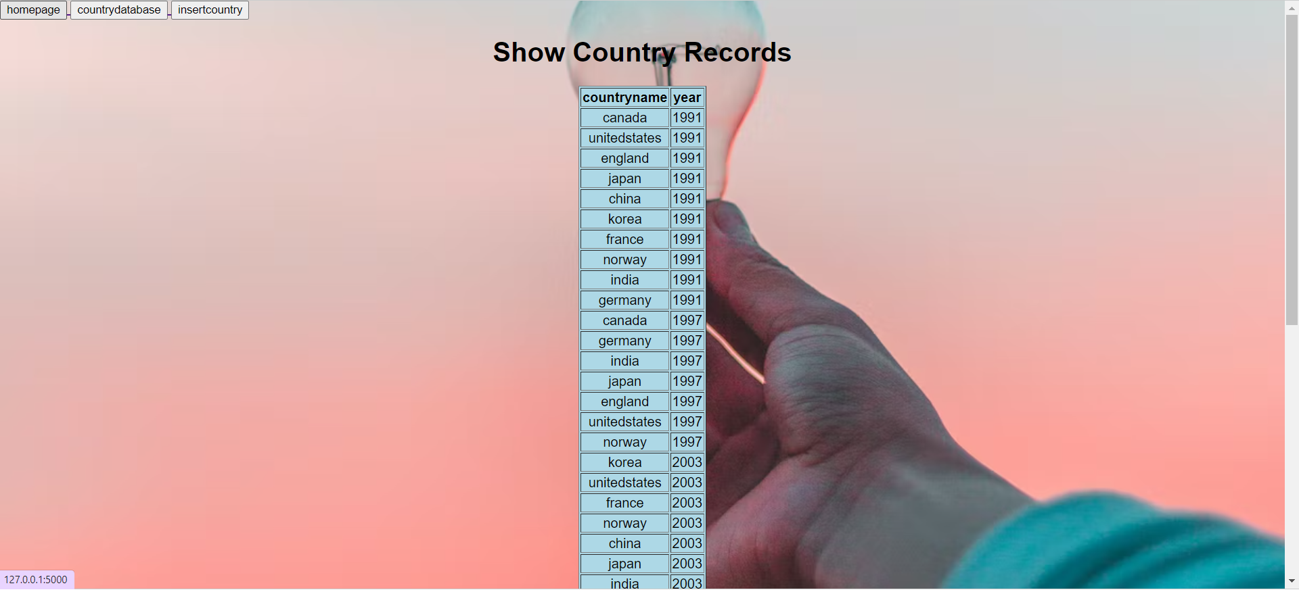

**game database**

**show data in game**

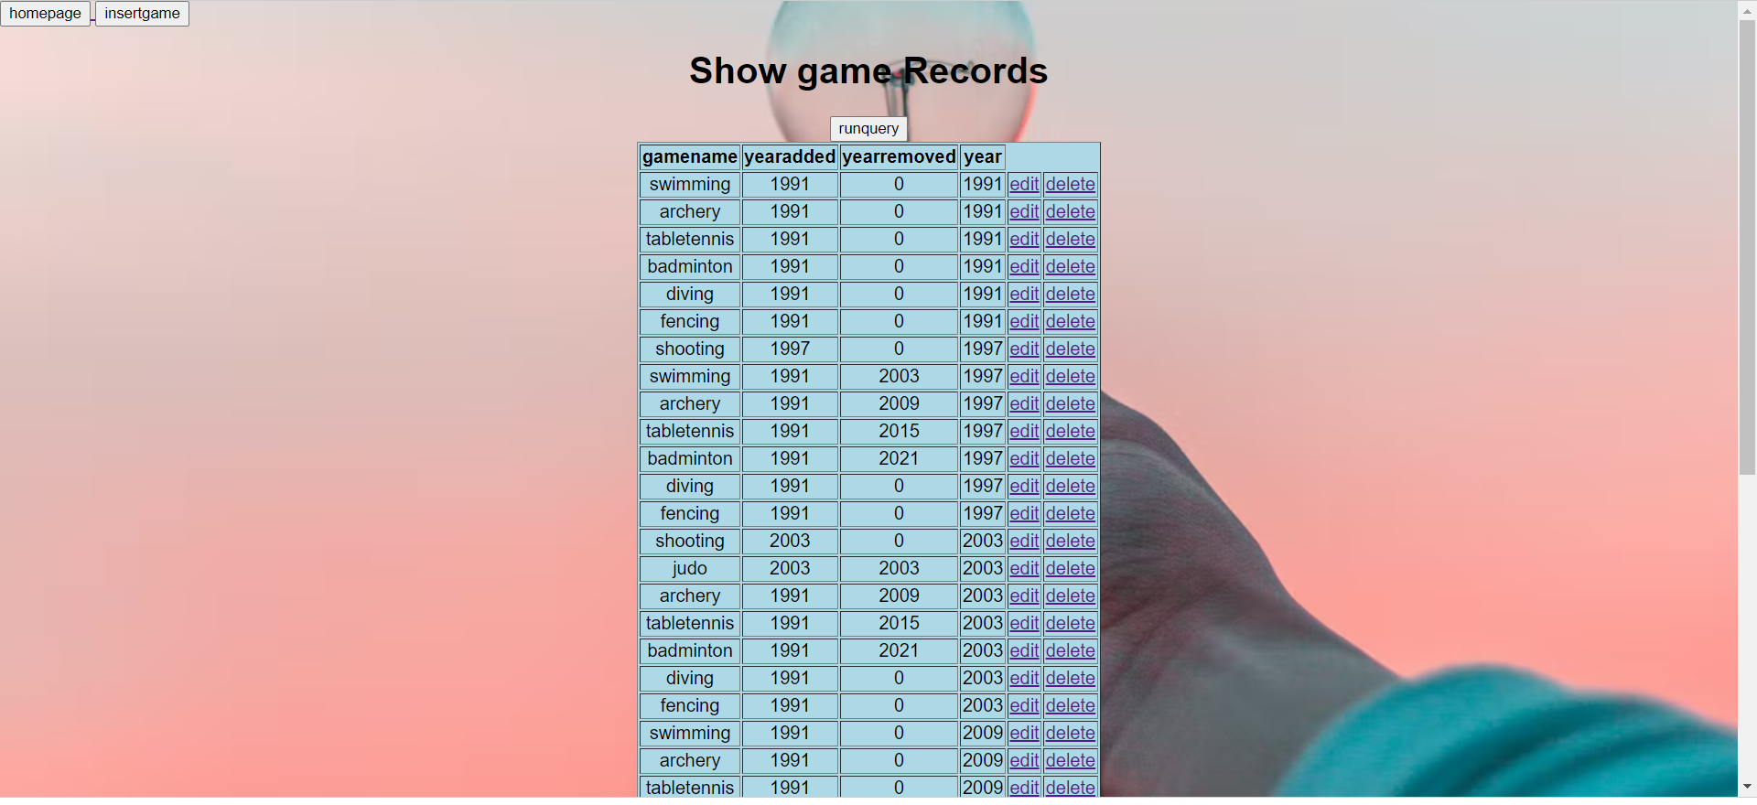

**insertion in game**

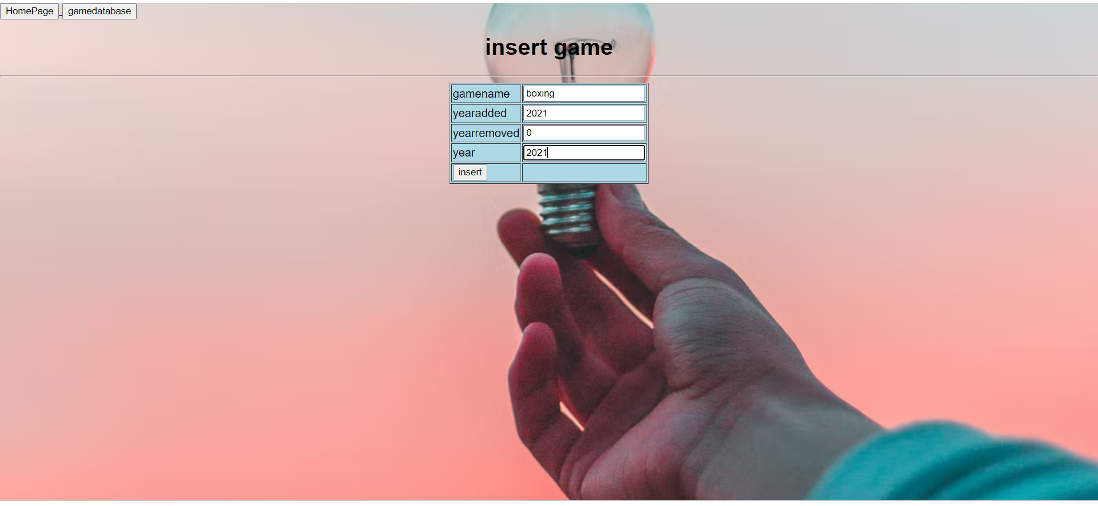

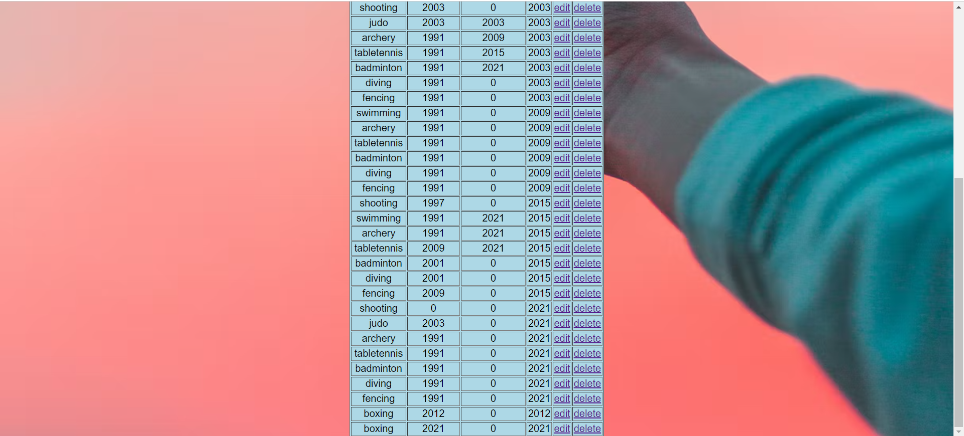

**as you can see( boxing 2021 0 2021) is inserted**

**edit game**

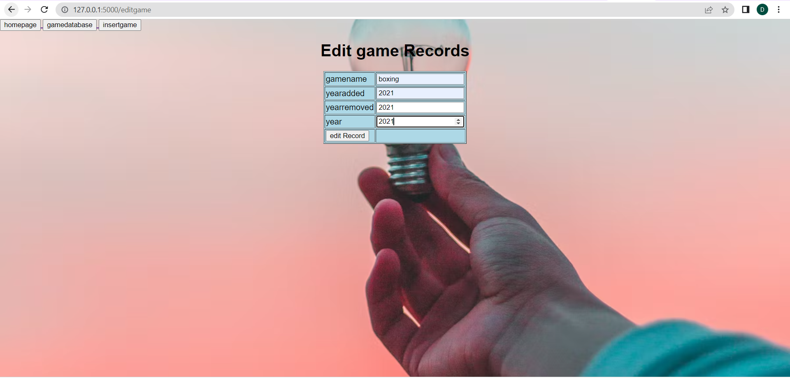



**as you can see 0 is update to 2021**

**delete game**

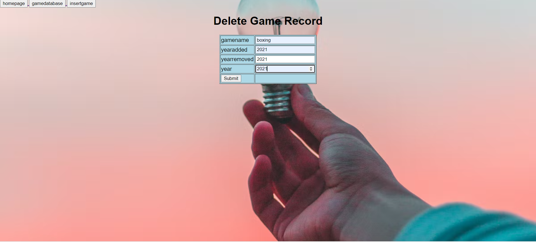



**as you can see (boxing 2021 2021 2021) is deleted**

**query for game database (show * from game where year = 1991 )**

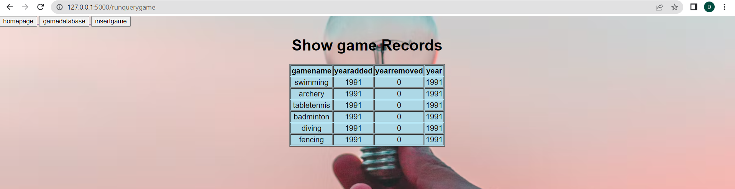

**workflow for web app : here first homepage will get opened then after selecting country or game you will see record of them in database then you can choose either edit or delete to delete then after insertion or after edit or after delete page will show the records with updated data basically redirect page to show game or show country and if you click on run query then you will see records with performed quey**

**i am having 10 templates**

1. **homepage**
2. **insert country**
3. **showcountry**
4. **delete country**
5. **runquery country**
6. **insert game**
7. **edit game**
8. **delete game**
9. **show game**
10. **runquery game**